Summary Steps:

- Login to MyWellesley with your Domain Username and Password.*
- Select the Employment Services tab at the top of your screen.
- Locate the Time Reporting channel in the center column and select the timesheet you want to submit.
- Enter exception hours only; click save or copy.
- Enter comment (if any).
- Click on Submit for Approval.
- Confirm timesheet with your Domain Password; click on submit button.
- Verify that the Time Sheet has been submitted for Approval by You.
1. Login

To enter your time via the Web, you must access Banner Self Service through MyWellesley (https://my.wellesley.edu/). This is also the same place where your paycheck information is available online.

After you login using your Domain Username and Password, click on the Employment Services tab at the top of your screen. Locate the Time Reporting channel in the center column to select the Payroll Timesheet you want to submit.

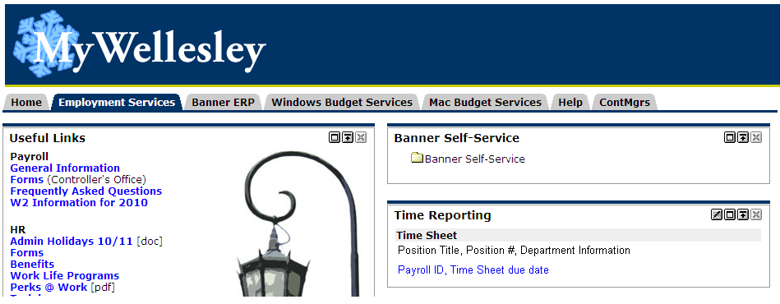
Click here

If you do not see the timesheet you are looking for, go in through the Banner Self-Service channel.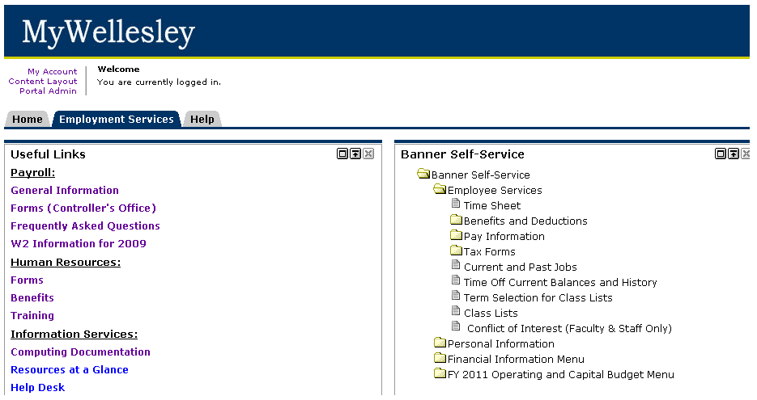
Click here
To access your time sheet, you must select a position and pay period. All active positions will appear. Many employees will only have one position. Choose the position for which you want to enter your time. From the pull down menu, choose the pay period. This menu also shows the status of your time sheet. Once a selection has been made, click the “Time Sheet” button.

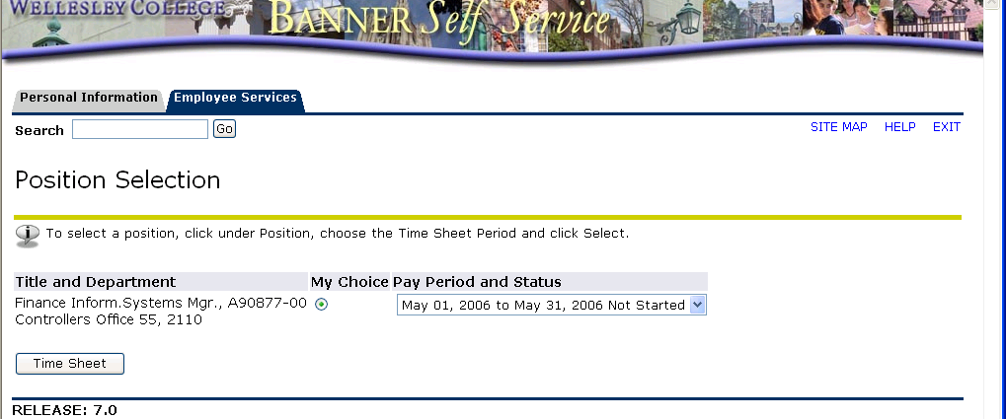
Position
Pay Period
Status
Click here

Status Definitions

Not Started: The time sheet has not been initiated by the employee. Once the employee selects the time sheet for a particular period and opens it, the status of the time sheet will change to “In Progress.”

In Progress: The time sheet has been initiated by the employee but is not completed and has not been submitted for approval.

Pending: The time sheet has been completed and submitted for approval by the employee. The record is waiting for the approver (usually the supervisor) to approve the time.

Approved: The time sheet has been approved and is ready to be submitted to the payroll office.

- Enter Exception Time
Time Sheet – Exempt Employee reporting exception time only

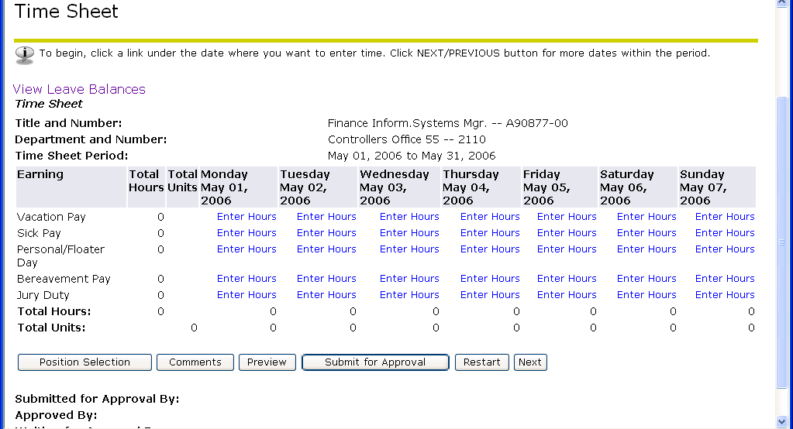
Click on the "Enter Hours" for the exception Earning you want to enter.

The time sheet is displayed by week. To see the next week, click on the “Next” button. Only Exception time must be entered. The system will assume that regular hours are worked if no time is entered.

To enter hours, click on the “Enter Hours” link under the day in which exception time needs to be reported. Time must be entered for each day that is taken but may be copied
Click on the "Enter Hours" for the exception Earning you want to enter.
from one day to another (i.e. taking 5 consecutive vacation days). 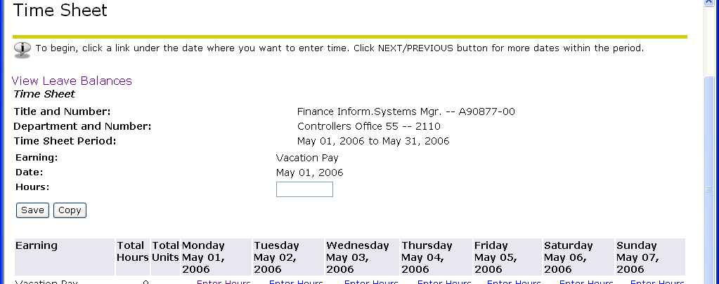
Enter hours here.
Click on Save or Copy

Once the desired hours are entered, you can either “Save Hours or Units” or “Copy Hours or Units.” Saving the hours will bring you back to the time sheet with the number of hours entered appearing on the selected day. Click on Save Hours if you are just entering the exception earnings for one day. Copying the hours will bring you to another screen where you will be able to check the days you want to copy the hours to. Click on Copy Hours if you are entering the same exception earnings for multiple days. Check the desired days and click on the “Copy” button. DO NOT CHECK OFF THE DAY THAT YOU ARE COPYING FROM.

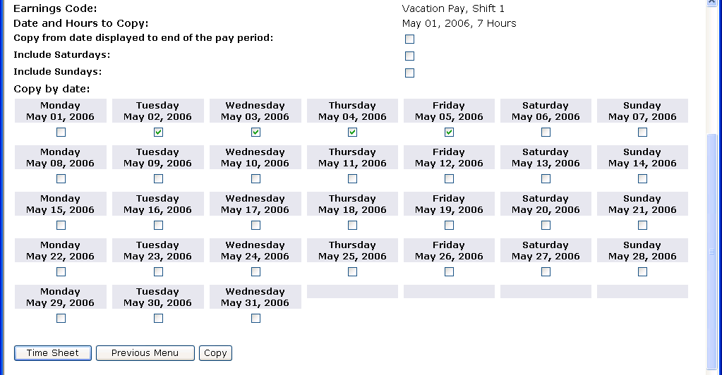

The following message will appear confirming the success of the copy:

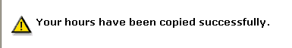

Click on the “Time Sheet” button to return to your time sheet. If there is more time that needs to be entered (i.e. sick time), you can continue to enter the hours.

4. Adjust Prior Pay Period

Since time sheets are due 5 business days before the paycheck date, there will be occasions where you will need to adjust a prior time sheet for exception time taken but not recorded on the time sheet. To adjust exception time for a prior pay period, follow the Enter time instructions in Step #3 and adjust the time for a weekend date (Saturday or Sunday). Enter a Comment in Step #5 below to explain the adjustment.

5. Enter Comment (not required)

Comments may also be added to your time sheet by clicking on the “Comments” button on the Time sheet page. Your approver will be able to read these comments when approving your time. Comments must be entered before submitting your time for approval.

6. Submit for Approval

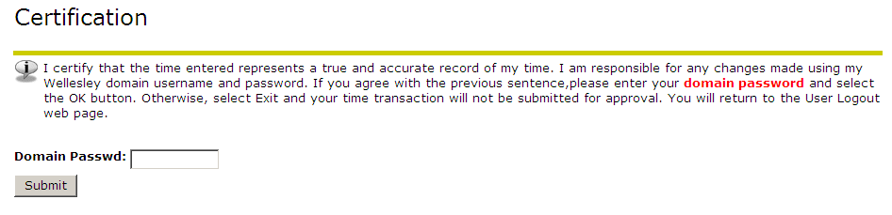
Enter DOMAIN Password here
Click on submit

Once you are finished entering your time, click on the “Submit for Approval” button. This will allow you to submit your time for approval to your supervisor and will also bring you to the Certification screen. On this screen, you will need to enter your DOMAIN Password certifying that the information entered is correct.

* If you do not know your Domain Password, please contact the Help Desk, X3333.

Click the “Submit” button and it will bring you back to the time sheet screen indicating that your time sheet was submitted successfully.
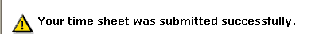
The bottom of the screen indicates that you submitted your time sheet and the date. It also indicates that the time sheet is waiting for approval by your supervisor. Once your supervisor has approved the time, it will be indicated in the Approved By box.



