French Department
Course Handbook
2014-2015

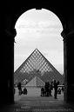

This course handbook is also available on the French Department’s website at
http://www.wellesley.edu/french


TABLE OF CONTENTS
Page

Course Descriptions 1 - 26
French 350 27
French 360/370 29 - 30
Linguistics and Related Course Descriptions 28, 31 - 32
French Advanced Placement Policies & Language Requirements 33
Requirements for the Major 33
The French Cultural Studies Major 33
Maison Française/French House 34
Wellesley-in-Aix 34
French Department Faculty 35 - 39
French Department Awards and Fellowships 40 - 43

French Department extensions:

Sarah Allahverdi (781) 283-2403
Hélène Bilis -2413
Venita Datta -2414
Pauline de Tholozany -2454
Sylvaine Egron-Sparrow -2415
French House assistantes -2413
Marie-Cecile Ganne-Schiermeier -2412
Scott Gunther -2444
Andrea Levitt -2410
Barry Lydgate, Chair -2404/-2439
Catherine Masson -2417
Codruta Morari -2479
James Petterson -2423
Anjali Prabhu -2495
Marie-Paule Tranvouez -2975

Faculty on leave during 2014-2015:
Venita Datta (Spring 2015)

Please visit us at:
http://www.wellesley.edu/french
http://www.wellesley.edu/ois/wellesleyprograms/aix
https://www.facebook.com/pages/Wellesley-College-French-Department/112088402145775

FRENCH 101-102 (Fall & Spring)
Beginning French I and II

Systematic training in all the language skills, with special emphasis on communication, self-expression and cultural insight. A multimedia course based on the video series French in Action. Classes are supplemented by regular assignments in a variety of video, audio, print and Web-based materials to give students practice using authentic French accurately and expressively. Three class periods a week. Each semester earns 1.0 unit of credit; however, both semesters must be completed satisfactorily to receive credit for either course. Written and oral work; sustained class participation; weekly quizzes; periodic oral exams; no midterm or final exam. Prerequisite: Open to students who do not present French for admission or by permission of the instructor.

Gunther
Ganne-Schiermeier

French 101-102 & 201-202 are year courses.
Students must complete both semesters to receive credit.



Basilique Notre Dame de Fourvière, Lyon
FRENCH 103 (Fall)
Intensive French I

Intensive training in French. The course covers the material of French 101-102 in a single semester. Five class periods four days a week. For students with little or no previous study of French. This is a demanding course designed for students interested in taking a junior year or semester abroad. Not recommended for students seeking to fulfill the foreign language requirement in French. Open by permission of the instructor to first-year students and sophomores who would like to prepare for study abroad their junior year in a Francophone country. Normally not open to students who present French for admission.

Students receive 1.25 credits for the course.

Students planning to study abroad in their junior year will need to elect French 203 in the spring semester. For details, consult the instructor.

Also there is no spring semester course to follow 103 other than 203.
(FREN 201 is not offered in the spring.)

Egron-Sparrow

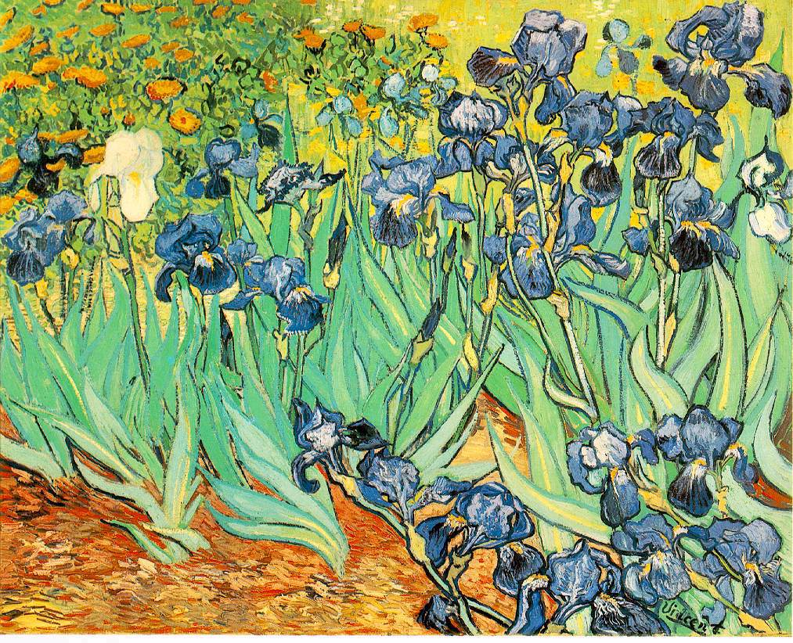

Iris 1889, Van Gogh

FRENCH 151 (Fall)
First-Year Seminar: Shipwrecks, Outlaws, and Wonderlands: Reading and Writing the Adventure Story (in English)

This first-year seminar plunges us into tales of jailbreak, shipwreck and time-travel—that is, into the many worlds of the adventure novel. Unlike pulp fiction, to which it is too often compared, the adventure novel raises compelling questions about the nature and limits of heroism. (If “adventure” means, “what must happen,” how can you be a hero when your heroism is contingent on circumstances?) We’ll consider this and other issues in adventure novels from the French and English traditions, concentrating on tales of castaways (Robinson Crusoe and his French counterparts), yarns of the sea, stories of solitary heroes who escape the law (Jean Valjean in Les Misérables) and fantastic fictions Alice in Wonderland). Participants will write adventure stories of their own modeled on our readings.
Prerequisite: None. Open to first-year students only. Mandatory credit/noncredit.

In this seminar, we will read from novels that rely heavily on a multiplicity of adventures in order to shape their characters into heroes. We will discuss a genre that has received less critical attention than others, but whose popularity in the nineteenth century helped shape national myths that persist to this day. Our study will center on major 19th-century French adventure stories and their Anglophone counterparts. We will seek to understand how adventure novels question and sometimes displace the boundaries between the subject and the world surrounding them, in a genre that stages both individual agency and collective missions. We will also discuss the links between the rise of the adventure novel and the emergence of the nation-state in the nineteenth-century.

Readings:
We will read excerpts from the following texts:
Tales of Castaways
Daniel Defoe, Robinson Crusoe
Michel Tournier, Friday
Yarns of the Sea
Herman Melville, Moby Dick
Victor Hugo, The Toilers of the Sea
Solitary heroes
Alexandre Dumas, The Count of Monte-Cristo
Victor Hugo, Les Misérables
Fantastic fictions
Lewis Carol, Alice in Wonderland
Jules Verne, Voyage to the Center of the Earth

Assignments:
The work of the seminar will focus on in-class discussions of assigned literary and critical texts. Written assignments for this class will include a midterm paper (3-4 pages) and a longer (7-8 page) final paper. Other written assignments will include short response papers on assigned readings and a semester-long creative project.

de Tholozany

FRENCH 201-202 (Fall & Spring)
French Language, Literature and Cultures

Reading, writing, speaking skills and critical thinking are developed through analysis and discussion of cultural and literary texts. Issues of cultural diversity, globalization and identity are considered. Thorough grammar review.

Three 70-minute periods a week.

Each semester earns one unit of credit; however, both semesters must be completed satisfactorily to receive credit for either course. Students are strongly advised to complete the 201-202 sequence within the same academic year and, in order to ensure they receive credit for the two courses, should consult the chair if they foresee a gap in their enrollment for the sequence.

A student who petitions to take 202 without having completed 201 must elect one of the following courses in order to complete the language requirement: French 205, 206, 207 or 209. Prerequisite: 102 or 103, SAT II score of 500-590, or an equivalent departmental placement score, or an AP score of 1 or 2 or permission of the instructor.

Prabhu
Morari
Tranvouez
Ganne-Schiermeier

French 101-102 & 201-202 are year courses.
Students must complete both semesters to receive credit.
Accelerating students may combine 201 and 205

FRENCH 203 (Spring)
Intensive French II

The continuation of French 103. Systematic training in all the language skills. Five class periods four days a week. The course is equivalent to French 201-202, and is designed to prepare students to qualify for study abroad after two further courses in French: a unit of French 206, 207 or 209, and French 211. Prerequisite: Open only to students who have completed French 103 or by permission of the instructor.

Students receive 1.25 credits for the course.

Egron-Sparrow

FRENCH 205 (Fall)

Literature and Film in Cultural Contexts

Discussion of modern literature and film in their cultural contexts. Training in techniques of literary and cultural analysis. Materials include novels, short stories, poetry, films, screenplays and videos from France and the Francophone world. Vocabulary building and review of key points of grammar. Frequent written practice. Attention to oral skills and listening comprehension as needed. Prerequisite: 202 or 203, an SAT II score of 600-640, an equivalent departmental placement score, or an AP score of 3.

Students who have taken French 202 and wish further language training should take French 205, emphasizing reading and writing, before moving on to other 200-level courses. French 205 is also recommended for incoming students who place as indicated above and who would benefit from some grammar review and special attention to writing prior to further literature or culture courses.

A transition course from basic language acquisition at the intermediate level to the study of literature, film and culture, French 205 provides a review of key points of grammar, vocabulary building and help with writing as well as an introduction to techniques of literary and cultural analysis. It will also help build reading skills. Although the emphasis is on reading and writing, oral comprehension and speaking will not be neglected. Active participation in class discussion is essential. Short papers will be assigned throughout the semester.

The literary, film and cultural selections will cluster around four pivotal moments or movements of the past century: la Belle Epoque, World War II and the Resistance, feminisms in France and other Francophone countries, colonialism and post-colonialism.

Works studied include:
François Truffaut: Jules et Jim (film and screenplay)
Poetry from La Belle Epoque (Guillaume Apollinaire, Nathalie Clifford Barney, Lucie Delarue-Mardrus)
Vercors: Le Silence de la mer (novella and film)
Pierre Sauvage: Les Armes de l'Esprit (film)
Colette: La Femme cachée (short stories), in conjunction with La Belle Epoque and feminism in the 1920’s and 1930’s
Feminist manifestoes of the 1970’s
Négritude and anti-colonial poetry from Africa
Albert Camus: L'Exil et le Royaume (short stories)
Gillo Pontecorvo: La Bataille d'Alger (film)
Assia Djebar: excerpts from Femmes d'Alger dans leur appartement

Datta

FRENCH 206 (Fall & Spring)
Intermediate Spoken French

Practice in conversation, using a variety of materials including magazine articles, short stories and films. This course is designed to develop oral proficiency and listening comprehension, with necessary attention to the other skills—reading, and writing. Prerequisite: 202, 203, or 205, an SAT II score of 650-680, an equivalent departmental placement score, or an AP score of 4.

Throughout the semester, special attention is given to the idiomatic expressions, forms of speech and pronunciation. In addition to the reading and study of magazine articles and short stories, extensive use is made of French short films. Class time is entirely devoted to conversation and a wide variety of activities is proposed to increase students’ vocabulary, improve pronunciation, fluency and comprehension. At the end of the course, students’ oral and listening skills are substantially developed.

Petterson
Tranvouez



Calanque d’en Vau, Cassis

FRENCH 207 (Spring)
Perspectives on French Culture and Society:
French Identity in the Age of Globalization

In this introduction to French society and culture, we will examine France's identity crisis at the beginning of the twenty-first century. From its historical position of political, economic, and intellectual leadership in Europe and the world, France is searching to maintain its difference as a defender of quality over mass appeal and the proud values of its national tradition in the face of increasing globalization. Topics covered include Franco-American relations, the European Union, immigration, the family, and the role of women in French society. Readings are drawn from a variety of sources: historical, sociological, and ethnographic. Magazine and newspaper articles along with television programs and films will provide supplementary information. Prerequisite: FREN 202, FREN 203, or FREN 205, an SAT II score of 650-680, an equivalent departmental placement score, or an AP score of 4.

Given the comparative perspective of this course, we will begin by studying American stereotypes of the French as well as French stereotypes of Americans. Next, we will explore the way in which the French define themselves, examining such topics as French attitudes toward their language, geography, and history, as well as toward the state, money, and food. We will then continue our survey of contemporary French society and culture, taking care to situate issues of current interest within an historical framework. The major challenge facing the French today is related to the globalization of their culture and economy. Franco-American relations as well as France’s role in the European Union are the product of French attitudes toward its past: witness the recent “hamburger wars” of a few years ago and even more recent debate about Iraq. The impact of immigrant culture, in particular, Islamic culture, has led to the emergence of a multicultural identity which challenges the traditional notion of “France, une et indivisible,” inherited from the French Revolution and reinforced by the republican school system, established in the 1880s. The meritocratic discourse of the republican schools still resonates today, although these schools seem to reinforce social inequalities rather than transcend them. Women, too, in spite of egalitarian rhetoric, lag behind their European sisters in terms of representation in French politics, although legislation has been passed recently to help rectify this situation. All in all, France faces many difficult problems in the twenty-first century.

Readings:
Wylie et Brière, Les Français (textbook)
Articles from the French and American press

Films: La Haine, Entre les murs, La Vie rêvée des anges; L’Auberge espagnole, Etre et avoir

Assignments: Three short papers on a film or text studied in class and a final research paper.

Gunther

FRENCH 209 (Fall)
Studies in Literature:
Topic: The Paris of Poets

A study of the city of Paris as urban inspiration for French poetry, with an emphasis on speaking and writing skills. This course explores the visual arts, culture and history of the City of Light as represented and celebrated through French poetry. Special attention is paid to Parisian artistic and poetic life from the late nineteenth-century to the present. Prerequisite: FREN 202, FREN 203, or FREN 205, an SAT II score of 650-680, an equivalent departmental placement score, or an AP score of 4.

Please note that the distribution for FREN 209 is Language and Literature or Arts, Music, Theatre, Film, Video.

The Paris of Poets explores French poetry directly inspired by the centuries of architectural, cultural, even political layers that compose the urban landscapes of Paris. Spiraling outward like some massive snail shell, each of Paris’s twenty arrondissements has been touched by the writings of the French poets that we will read: (among many others) Baudelaire, whose “Le Cygne” is set in the Tuileries Garden (1er arrondissement), Senegalese poet Léopold Senghor’s “Luxembourg 1939” (5e arrondissement), Théophile Gautier’s « L'Obélisque de Paris » (8e arrondissement), Raymond Queneau’s “Rue Paul-Verlaine” (13e arrondissement), and contemporary poet Jacques Réda’s « Hauteurs de Belleville » (20e arrondissement). Other poems we will read crisscross Paris and its banlieues. The poetry of Paris has equally inspired and been inspired by some of the greatest paintings and sculptures in the holdings of Paris museums, thus a part of our course is devoted to exploring the special relation between the painters, sculptors and poets of Paris through the ages. The course emphasizes learning how to read a poem (both out loud and analytically). Short papers will be assigned through the semester. Intensive participation in class discussion is expected. There will be one short final project.

Texts: A Reader will be made available for this course.

Petterson
FRENCH 210 (Fall)
French Literature and Culture Through the Centuries
Topic: From the Middle Ages through the Enlightenment

Major authors from the Medieval period through the Enlightenment studied in their historical and cultural contexts, with emphasis on close reading, critical analysis, and writing in French. Attention to literary genres, including the constraints and innovations they engender, and study of key notions that will inform students’ understanding of French literature and history—galanterie, courtoisie, mimesis, poetics, epistolarity, Salic law, French Wars of Religion, the Edict of Nantes, and Absolutism. We will end with consideration of pre-revolutionary works, anticipating the rise of the French Republic.
Prerequisite: At least one unit of FREN 206, FREN 207, FREN 208, FREN 209 or above, an SAT II score of 690-800, an equivalent departmental placement score, or an AP score of 5.

For students entering after 2014, FREN 210 and FREN 211 each fulfill the 200-level requirement for the major, for study abroad, and for all French Department courses at the 300 level. Majors should consult with a member of the French Department to determine which course best suits their needs

In tracing the literary portrayal of France’s turbulent emergence as a nation, we will begin with Charlemagne’s defeat of the invading Moors and end with Voltaire’s call for religious tolerance and the abolition of State-run torture. With these works marking our trajectory, we will explore how literature from the fifteenth to the eighteenth centuries shaped visions of the past—and the nostalgia for a past that perhaps never was—in order to organize the present.

Topics will include:
- the memory and misremembering of French foundational moments in La Chanson de Roland and Rivette’s Jeanne d’Arc.
- portrayals of civil war chaos and the glorification of military heroes in La Princesse de Montpensier and Cinna.
- the textual creation of monuments and eye-witness accounts in the essays of Montaigne and Voltaire and in l’Heptaméron.
- narratives of travel to and from the French kingdom’s borders in Les Regrets, Lettres portugaises, and L’Ingénu.

Our ultimate aims are, first, to familiarize students with texts from the early modern French canon; and, second, to better understand how fiction, in conversation with political ideology, religious doctrine, and literary genre can (re)create national history.

Texts:
La Chanson de Roland (excerpts)
Du Bellay, Les Regrets; Défense et Illustration de la langue française
Marguerite de Navarre, L’Heptaméron ( “Amadour et Floride”)
Montaigne: Les Essais “Des Cannibales,” “De la Clémence,” “De l’Utile et de l’honorable,” and “Des Coches”
Corneille, Cinna
Lafayette, La Princesse de Montpensier
Guilleragues, Lettres portugaises
Voltaire, L’ingénu and L’Affaire Calas (excerpts)

Film:
Jacques Rivette, Jeanne D’arc

Bilis
FRENCH 210 (Spring)
French Literature and Culture Through the Centuries
Topic: From the Enlightenment to the Present

Major authors from the eighteenth century to the twentieth studied in their historical and cultural contexts, with emphasis on close reading, analysis, and writing in French. Enlightenment writers like Montesquieu and Voltaire champion science and empiricism, and mount a frontal challenge to the authority of monarchy and church. Others (Diderot, Rousseau) foreground emotion, sensuality and aesthetic experience, explored later and in greater depth by Romantics like Hugo and Chateaubriand. The Realist writers Zola, Balzac, Flaubert and Maupassant reject the emotionalism of the Romantics and focus on the realities of everyday life in the 19th century. The twentieth century unveils its own revolutionary innovations—the Surrealists, Proust’s magnificent A la Recherche du Temps perdu, ground-breaking experiments in the theater (Beckett, Ionesco) and the stark responses of Sartre and Camus to the disillusionments of the Second World War. French writing from the newly liberated colonies (Algeria, Côte d'Ivoire) will bring our survey to a close. Prerequisite: At least one unit of 206, 207, 208, 209 or above, an SAT II score of 690-800, an equivalent departmental placement score, or an AP score of 5.

For students entering after 2014, FREN 210 and FREN 211 each fulfill the 200-level requirement for the major, for study abroad, and for all French Department courses at the 300-level. Majors should consult with a member of the French Department to determine which course best suits their needs.

This course aims to approach French literature from an historical perspective. We will examine significant works from major periods, allowing us to understand how society, and more specifically, literary sensibilities have changed throughout the centuries.

We will begin with selections from Montesquieu’s Lettres persanes, which contains acerbic criticism of the Ancien Régime that anticipates, in a way, the upheaval at the end of the 18th century. The works of the “Philosophers” (e.g. Voltaire’s Candide) and of other authors of the period (e.g. Beaumarchais’ Le Mariage de Figaro) will provide us with avenues to discuss the ideals of the French Revolution of 1789.

In our selections from the 19th century (Balzac’s Sarrasine and Flaubert’s Un Cœur simple), we will focus on various aspects of prose narrative. In poetry, we will discuss how Baudelaire’s aesthetic novelty influenced a whole new sensibility recognizable in other genres as well.

Finally, we will begin our study of 20th-century texts with poems by Apollinaire, the play Les Chaises by Ionesco, and Jean-Paul Sartre’s Le Mur. We will discuss Sartre’s idea of existentialism and his preoccupation with the individual’s responsibility in making choices.

From our own era, Mariama Bâ’s Une si longue lettre is a novel that implicates the personal, the female, and the autobiographical. We will also focus on colonial legacies in the former French colonies, and the issues of women’s struggles in a non-western context.

Texts:
Voltaire, Candide; Montesquieu, Lettres persanes; Beaumarchais, Le Mariage de Figaro
Balzac, Sarrasine; Flaubert, Un Cœur simple; Baudelaire (selections); Apollinaire (selections); Sartre, Le Mur; Ionesco, Les Chaises; Bâ, Une si longue lettre

Prabhu

The prerequisites for all 200-level French courses numbered from FREN 210 on up
are the same. These upper 200-level French courses may be taken in any order.
Students preparing to spend their junior year in France or a Francophone country
should take FREN 211 as soon as possible.

FRENCH 211 (Fall & Spring)
Studies in Language

Comprehensive review of French grammar, enrichment of vocabulary, and introduction to French techniques of literary analysis, composition, and the organization of ideas. Open to first-year students if they have taken one of the prerequisite courses. Prerequisite: At least one unit of 206, 207, 208, 209 or above, an SAT II score of 690-800, an equivalent departmental placement score, or an AP score of 5.

We will study fundamental concepts and techniques of analysis as they apply to French literature. Students will practice reading different literary genres in depth, including poetry, the short story and the novel. Students will learn to identify ways in which these texts are organized and the techniques an author uses to convey meaning. Students will be introduced to the techniques of the “explication de texte”, the “commentaire composé” of prose and poetical texts, and the “dissertation” (formal French essay).

Students will be acquiring a critical vocabulary for the analysis of texts and will learn to refine their writing style through intense practice. They will learn to write proper introductions and conclusions and to organize their ideas in a manner appropriate to each writing assignment. We will develop the linguistic means necessary for organizing the presentation of information, for putting ideas together, and for bringing more precision and nuance to writing. Finally, we will learn to improve writing style by incorporating new grammatical structures in compositions.

Chapters of the grammar book that introduce new notions will be thoroughly presented; grammar points students have learned at the intermediate level will be reviewed in detail and presented in the context of more complex analytical approaches. Students will learn how to use their grammar book as a reference guide—a “tool” to be used by each student according to her/his specific needs. Students will also learn how and where to find specific grammatical information.

Texts:
Grammar:
Contrastes by Denise Rochat
Grammar exercises:
Contrastes By Denise Rochat in My Frenchlab
French Composition:
Tâches d’encre by H.Jay Siskin, Cheryl L. Kruger, Maryse Fauvel
Novel:
La Place by Annie Ernaux

Petterson
Egron-Sparrow

FRENCH 213 (Fall)
From Myth to the Absurd: French Drama in the
Twentieth Century

An investigation of the major trends in modern French drama: the reinterpretation of myths, the influence of existentialism, and the theatre of the absurd. Special attention is given to the nature of dramatic conflict and to the relationship between text and performance. Study of plays by Anouilh, Cocteau, Giraudoux, Sartre, Camus, Ionesco, Beckett, and Genet. Prerequisite: At least one unit of FREN 206, FREN 207, FREN 208, FREN 209, or above, an SAT II score of 690-800, an equivalent departmental placement score, or an AP score of 5.

This course will first look at how modern drama appears with the revolutionary importance given to the “mise en scène” and then will offer students the opportunity to study some of the most important and influential works of French drama since 1900 and to acquire at the same time a knowledge of the major literary and philosophical trends of the twentieth century: symbolism, surrealism, existentialism, and the absurd.

The class will examine not only the ideas expressed in each play but also its “mise en scène” and the author’s use of theatrical language. Attention will be given to the particular social, political, and aesthetic context of the plays and to the formal qualities of different dramatic genres: tragedy, comedy, tragi-comedy, and farce.

Written and Oral work:
Regular preparation of an analysis of the plays and discussion in class. Two short papers (one on Anouilh and Cocteau, one on Sartre and Camus), one paper in class (Giraudoux), an oral exam for which the students will be encouraged to learn a part of a play (Beckett, Ionesco, Genet) or discuss a topic (Beckett, Ionesco, Genet) and a final exam (Claudel, Beckett, Ionesco, Genet).

Works to be studied:
Jean Cocteau, La machine infernale (LDP, 854)
Jean Anouilh, Antigone (Didier, La Table Ronde)
Jean Giraudoux, La Guerre de troie n’aura pas lieu (LDP 945)
Jean-Paul Sartre, Les Mains Sales (Gallimard, Folio))
Albert Camus, Les Justes (Gallimard, Folio)
Paul Claudel, L’Annonce faite à Marie (Gallimard, Folio)
Samuel Beckett, En attendant Godot (Macmillan)
Eugène Ionesco, La Leçon (Gallimard, Folio)
Jean Genet, Les Bonnes (Gallimard, Folio)

Secondary readings:
Fin XIXe début XX: importance de la mise en scène en Europe
Antonin Artaud: extraits de quelques écrits sur le théâtre
Alfred Jarry, Ubu roi, extraits

Masson

FRENCH 218 (Fall)
Women in Postcolonial "French" Africa: After Négritude

Male elites in postcolonial Africa dominated the independence era with liberation movements such as "négritude." Women's position in both public culture and private spaces was ambiguous, rapidly changing, even contentious. Our study of a variety of media, while placing literary texts at the center, will seek to understand more fully, the role of women in the Francophone context and in postcolonial nations more widely. Prerequisite: At least one unit of FREN 206, FREN 207, FREN 208 [2012-13], FREN 209 or above, an SAT II score of 690-800, an equivalent departmental placement score, or an AP score of 5.

“Négritude” is the term used to identify the poetics and politics of a group of young African and African diasporic writers who came together as university students in Paris in the early twentieth-century. The names associated most notably with that cohort are: Aimé Césaire from Martinique, Léon Damas from French Guyana, and Léopold Sédar Senghor, who went on to be Senegal’s first president. Studying these writers will provide the base for our critique of early Francophone literary creation and the politics of independence from a feminist perspective. The stark demarcations between white and black of the colonial period are played out in Ferdinand Oyono’s novel, Une vie de boy, whose central character tests out the meanings of being “French” African at the height of the colonial period. We will watch scenes from the film Chocolat to think about the actual subjective experiences of the contrast and contradictions of the white-black divide in colonial Africa.

Studying the writings and life of the revolutionary historical figure of Frantz Fanon will allow us to understand many aspects of the position of colonized women during his lifetime (1925-1961), and especially during the period leading up to the time when many French colonies were preparing for independence through revolutionary struggle. Fanon provides an interesting focal point for such a study: we will explore the place of women in both his native Martinique (which became a French Overseas Department) and in the space of his primary revolutionary activity, which was Algeria, when the war of independence broke out. In this section of the class we will read from Fanon, but also from a relatively unknown Martinican woman writer, Mayotte Capécia, whom he criticized in an effort to understand race relations under colonialism in the French Creole island of Martinique. Fanon analyzed the culture of his childhood and youth as being over-determined by colonial culture. While his early work attempts to revise and surpass such severe limits on his existence and that of the youth of his time, it is often ruthlessly gender blind. Our critique will focus on this blind spot as we explore the creativity of women in the Creolized colonial world. Alongside readings from Fanon and Capécia we will also watch the delightful film, Sugarcane Alley, which will allow us to explore, beyond Capécia’s biographical text, the multiple ways in which women were negotiating the same period. Our study of Caribbean culture and its relationship to metropolitan French culture will involve looking at French advertisements and some works on the history of the period. The classic film, Bataille d’Algiers, will allow us to focus on the events of the Algerian war of independence, while we will critique the historical representation made of those events and of the FLN (Front de Libération Nationale) in the film. The film gives us a dramatic scene from which will ensue our discussion of the role of women in the war and soon after. Fanon’s famous essay on the veil provides textual entry into the question. Assia Djebar’s Les enfants du nouveau monde provides a fictionalized literary account of the role of women in that war. We will end the class with two less serious contemporary films that raise these issues in France. In Café au lait, the métisse (mixed-race), Lola, is pregnant and one of her two lovers is the father: is it Jamal, the son of African immigrants, or Félix, a young Jewish Frenchman? In Banlieu 13, which includes many chases, stunning parkour scenes, and a plot that does not rely on the spectator’s belief, a ruffian of North African descent, Leito, and a white undercover cop, Damien Tomaso, team up to infiltrate a ghetto which is mostly inhabited by immigrants and the poor. The two characters are to diffuse a bomb that would destroy the entire community. The films allow us to open up the question of colonization in contemporary France
alongside issues of gender and immigration.

Novels/Essays
Aimé Césaire Cahiers d’un retour au pays natal
Oyono, Ferdinand. Une vie de boy
Fanon, Frantz. Peau noire, masques blancs (extracts)
Fanon, Frantz. L’An V de la révolution algérienne (extracts)
Capécia, Mayotte. Je suis martiniquaise
Djebar, Assia. Les enfants du nouveau monde

Filmsenter
de Ponteverco Gillo. Bataille d’Algiers (1966)
Vir Parminder. Algeria: Women at War (1992)
Denis, Claire. Chocolat (1988)
Kassovitz Matthieu. Café au lait (1994)
Morel, Pierre. Banlieu 13 (2004)

Supplementary Reading
Schloss, Rebecca Hartkopf. Sweet Liberty: The Final Days of Slavery in Martinique.
Hargreaves, Alec. Multi-Ethnic France: Immigration, Politics, Culture, and Society.
Horne, Alistair. A Savage War of Peace: Algeria 1954-1962.

Prabhu

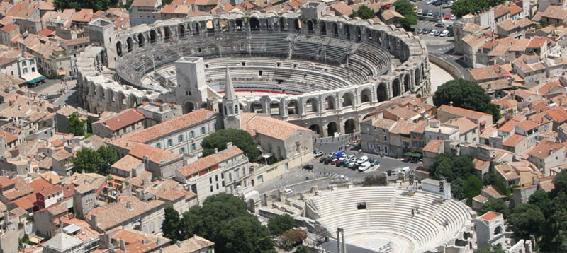

Les Arènes d’Arles, amphithéâtre romain d’Arles

FRENCH 222 (Fall)
French Cinema from the Lumière Brothers to the Present: The Formation of Modernity

This course offers a critical panorama of French cinema while also building essential vocabulary and critical concepts for film analysis. Students will pay specific attention to the various connections between cinema, urban space, and notions of modernity. Close analyses of clips in class will also lead to a deeper appreciation of genre and technical aspects in the history of cinema. Filmmakers studied will include the Lumière Brothers (for the “perspective” model), Georges Méliès (for the cinema of attraction), Jean Renoir (for depth of field), Robert Bresson (for literary adaptation), Jean-Luc Godard (for traveling shots and direct sound), and Chris Marker (for documentary). Prerequisite: At least one unit of FREN 206, FREN 207, FREN 208 [2012-13], FREN 209, or above, an SAT II score of 690-800, an equivalent departmental placement score, or an AP score of 5.

What has evolved within the project of modernity is the establishment of a way of imagining and representing space, as well as the space/society relation which underpins the material enforcement of certain ways of organising space, and consequently, society. Among various factors of material enforcement, cinema, “the last machine” in Hollis Frampton’s words, embedded the attempt to invent appropriated space-producing events and forms. The relation between cinema and social space is not merely one of representation or recording; on the contrary, cinema is constitutive of social space, it has a seminal role in producing the space for a “reading” public. In other words, cinema exists and functions as a cast of the modern mind. The complex relationships between cinema and modernity, as well as their inscription in urban life, are particularly salient in the history of French cinema. Moreover, French film theory and criticism played a seminal role in the development of French cinema. This course will analyze the formation of modern self and society by following the history of French cinema from 1895 to the present. Weekly screenings will also provide material for building film analysis vocabulary.

Readings will include articles from film journals Cahiers du Cinéma, Positif, Télérama and contemporary cinephilic blogs, as well as introductory theoretical texts on French film culture and French film history.

Screenings will include:

René Clair, Paris qui dort (1914)
Jean Vigo, L’Atalante (1934)
Jean Renoir, La Règle du jeu (1939)
Robert Bresson, Pickpocket (1959)
Jean-Luc Godard, À bout de soufflé (1960)
Paris vu par… (1965)
Agnès Varda, Cléo de 5 à 7 (1962)
Jacques Tati, Playtime (1967)
Mathieu Kassovitz, La Haine (1995)
Olivier Assayas, Irma Vep (1996)
Abdel Kechiche, L’Esquive (2003)
Claire Denis, 35 Rhums (2008)

Assignments include weekly postings on the Sakai forum, a mid-term in-class written examination and a final paper.

Morari

FRENCH 226 (Spring)
Speaking through Acting

Improvement of French oral skills and public speaking skills through the use of acting techniques. Intensive analysis of short literary texts and excerpts from several plays with emphasis on pronunciation, diction, elocution, acting, and staging. Prerequisite: At least one unit of FREN 206, FREN 207, FREN 208 [2012-13], FREN 209, or above, an SAT II score of 690-800, an equivalent departmental placement score, or an AP score of 5.

In this course, students will improve their pronunciation of the French language through the study of French phonetics and corrective phonetics. Phonetic exercises will be done on line. Students will also work on improving the intonation and the rhythm of their French.

In class, students will work on their diction and elocution. They will learn exercises used by actresses and actors at conservatories to improve their breathing and articulation, and to adjust the pitch of their voice. They will also learn ways to become more confident with their French by using both speech and gestures in improvisation exercises and by performing short texts or excerpts of plays.

Students will read and analyze those classical and modern texts (prose and poetry) from the 17th to the 21st century. It will be essential that students first gain a deep understanding of these texts prior to interpreting and performing them.

This course is especially useful to students preparing a teaching certificate or going abroad for their junior year.

Intensive participation in class is expected. Each individual presentation in class will be graded. There will be one mid-term and one final oral exam.

Texts:
Excerpts from classical and modern texts (prose and poetry) from the 17th to the 21st century

Methods:
Excerpts from:
Traité pratique de la diction française, Leroy.
Grammaire de diction française, Leroy.
Nouveau solfège de la diction, Martens.
Diction. Expression, Rabault.
La lecture par le jeu dramatique, Grosset-Bureau, Christophe, Isaac.

Phonetics exercises:

Sons et Intonations – Exercices de prononciation, Martins & Mabilat, Didier.

Masson

French 235 (Spring)
From Page to Stage: Candide, the Play

This course will introduce students to the art of adapting a prose narrative for the stage using Voltaire’s short novel Candide. We begin by comparing narrative writing and dramatic writing to determine what is at stake when creating a viable theatrical piece. Students will work in teams to transform individual chapters of Candide into scenes. Participants will take turns being actors, directors and stage managers, and will practice diction, acting, and pronunciation in exercises aimed at improving their speaking skills. The group will produce a public performance at the end of the semester. Prerequisite: At least one unit of FREN 206, FREN 207, FREN 208 [2012-13], FREN 209 or above, an SAT II score of 690-800, an equivalent departmental placement score or an AP score of 5.

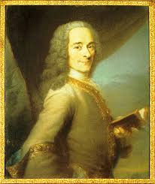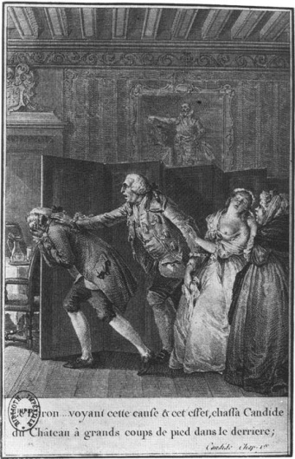

Written and oral works: Regular preparation of an analysis of chapters of Candide and discussion in class. Students working in groups will have to submit an adaptation of some chapters of the novel. In addition, during the semester each student will have to submit the adaptation of two chapters of the novel. Each student will present in class an excerpt of a book or an article on adaptation of novel for the stage. At the end of the semester, for the public performance, each student will have a role either on stage or off stage.
Reading list :
Voltaire, Candide et l’optimisme
Excerpts from :
Dufiet & Petitjean, Approches linguistiques des textes dramatiques
Sylvie Patron, Le narrateur : Introduction à la théorie narrative
Pierre Larthomas, Le langage dramatique : sa nature, ses procédés
Michel Pruner, L’analyse du texte de théâtre
Thierry Gallèpe. Didascalies: Les mots de la mise en scène
Marie-Claude Hubert éd. La Plumes du phénix : Réécriture au théâtre
Linda Hutcheon, A Theory of Adaptation
Articles:
Judith Miller, “From Novel to Theatre: Contemporary Adaptations of narrative to the French Stage.”
John Perry, “Adapting a Novel to the Stage.”

Masson

FRENCH 238 (Spring)
Love Interests: Marriage and Adultery in the 19th Century

This course will examine major nineteenth-century novels and plays, with a specific focus on the relationship between literary genres and the themes of love, marriage, and adultery. How does literature reflect upon other types of discourses on the subject? How do literary texts and caricatures of the period engage questions of class, social order, and transmission of property? And what is the narrative role of desire in representations of marriage and adultery? Readings will include texts by Balzac, Maupassant, Musset, Dumas, Stendhal and Flaubert. We will also discuss caricatures of the period (Daumier, Gavarni). Prerequisite: At least one unit of FREN 206, FREN 207, FREN 208, FREN 209 or above, an SAT II score of 690-800, an equivalent departmental placement score, or an AP score of 5.

In this class, we will investigate how the themes of love, marriage, and adultery have appeared in nineteenth-century French literature. With Stendhal, we will consider love and the ways in which it starts, grows, and develops; as we then proceed to examine how marriage shapes narratives of social mobility, we will discuss the discrepancy between marriage and love in prose fiction. A legal contract, marriage guarantees the conservation and transmission of property; as such, it is at the center of an economy that rarely bodes well with love. While thwarted love is a classic narrative device and appears in many plots, other types of fiction have instead represented love as inconstant and easily annihilated by pride. Musset’s play Les Caprices de Marianne is a case in point, as are the caricatures of the period. We will end the semester on three major novels of adultery, analyzing the use that they make of scandal in and out of the narrative – Stendhal’s Le Rouge et le noir was inspired by a fait divers, while Madame Bovary caused a scandal that resulted in a trial. The adulterous woman is consistently the cause and center of scandal; our semester will thus end on George Sand’s Indiana, a novel written by a woman and who revisits those themes.

Readings:
We will read excerpts from the following texts:
Stendhal, De l’amour.
Marriage , social class, and property
Balzac, Physiologie du mariage (excerpt)
Balzac, “La Femme abandonnée.”
Maupassant, “Le testament,” in Contes de la bécasse
Fragile institutions and inconstant feelings
Musset, Les caprices de Marianne
Caricatures and representations of bourgeois marriage
Alexandre Dumas, Les 3 Mousquetaires, excerpts.
Adultery in the novel (Stendhal, Flaubert)
Stendhal, Le Rouge et le noir (excerpts from the novel and the Gazette des tribunaux relating “l’affaire Berthet”)
Flaubert, Madame Bovary (excerpts from the novel and from the trial)
George Sand, Indiana
Assignments:
Written assignments for this class will include a midterm paper (3-4 pages) and a longer (7-8 page) final paper. There will also be short response papers on assigned readings and an in-class presentation.

de Tholozany

FRENCH 241 (Spring)
Laughter is the Best Medicine

Is laughter timeless? Or is it the product of a specific cultural, national, and historical point of view? Is what made 17th- and 18th-century audiences laugh still funny today? In this course dedicated to study of the evolution of the French comedic genre, students will reflect upon their own sense of the comical and compare it with that of pre-revolutionary audiences. Molière and Marivaux, two of literature’s great playwrights, will anchor our analysis of the formal conventions, linguistic registers, themes, tropes, and character-types of comedy. Contemporary film and comedic routines will sharpen our awareness of the lasting influence these and other early-modern playwrights have had on French humor. Prerequisite: At least one unit of FREN 206, FREN 207, FREN 208, FREN 209 or above, an SAT II score of 690-800, an equivalent departmental placement score, or an AP score of 5.

Laughter is a serious business. This course will focus on the evolution of the comedic genre from the height of the ancien régime to the dawn of the French Revolution. What made 17th and 18th century-audiences laugh, and does that laughter still resonate today? In parallel, we will question whether laughter was comedy’s prime ambition or if playwrights attributed a larger role to themselves and to the genre. How did they strike a balance between a desire to expose society’s absurdities, correct moral vices, and denounce the hypocrisy of certain social circles on the one hand, and the will to entertain audiences on the other?

In our efforts to define the genre and grasp its multiple influences, we will investigate how comedy drew from other forms of theater that were popular in this period, such as the burlesque farces and the pantomime of the fairgrounds or the coups de théâtre of baroque tragicomedies. In so doing, we will begin to understand how notions of “high” and “low” comedy developed, and what place was given to satire, le ridicule, bons mots, and biting laughter, in contrast to the tradition of the Italian commedia dell’arte.

Molière and Marivaux, arguably two of literature’s greatest comedic playwrights, will anchor our exploration of the formal conventions, themes, linguistic registers, tropes, and character-types that moved early modern audiences. We will ask how the influence of their patrons (Molière was Louis XIV’s favorite playwright) and their audiences (Marivaux wrote at the dawn of the Enlightenment) shaped their art. Students will come to recognize the meaning of modern-day references to “Molièresque plots” and the “Marivaudage” between two would-be lovers.
Consideration of Corneille’s comedy as a precursor to Molière and Marivaux’s successes and of Beaumarchais as an heir to their legacy will round out our understanding of French comedic practices.
Throughout our readings, an important component will be to reflect on shifting notions of the comical from the ancien régime to today. Recent stagings of Molière and Marivaux will fuel our discussions of the relevance of these works for twenty-first century spectators. Successful contemporary French comedies (from both theater and film) will complete our study of the comical genre.

Readings
Pierre Corneille, L’illusion comique
Molière, L’Ecole des femmes, Le Misanthrope
Marivaux, Le Jeu de l’amour et du hasard, L'Ile des esclaves
Beaumarchais, Le Mariage de Figaro
Films
L’Esquive
Le Dîner de cons
Le Goût des autres
Georges Dandin
Molière
Théâtre
Yasmina Réza, “Art”
Students will write two 4-5 page papers, give an oral presentation and complete a final exam.

Bilis
FRENCH 308 (Fall)
Advanced Studies in Language

The art of translation and its techniques are studied through analysis of the major linguistic and cultural differences between French and English. Translations from both languages will serve to explore past and present-day practices and theories of translation. Prerequisite: FREN 211 or, for students entering in 2014 or later, FREN 210; and one additional unit, FREN 213 or above.

Comparative study of the major linguistic features of French and English as they apply to the art of translating.

The main goals of the course are:
- to learn `les ficelles du métier de traducteur' — the main strategies needed to translate;
- to get used to using the translator’s toolkit of reference books and to know where to look or whom to ask when the standard references are of no help;
- to learn to think like a translator.

The course stresses the differences between French and English styles of writing, between the two cultures, and how translators engage these differences. Differences of register and dialect, as well as of country, will be discussed.

The main activity of the course is the translation of texts from French into English or from English into French. Texts are taken from a wide variety of registers and genres — from advertising, cartoons, and magazine articles to literary criticism, novels, and poetry. Issues related to translation such as subtitling and dubbing movies will also be discussed.

Texts:
Robert Collins: Dictionnaire français-anglais / anglais-français
Electronic booklet available on the CWIS

Petterson


geographicallyyours.blogspot.com

FRENCH 314 (Spring)
A Cinematic History of Intellectual Ideas in Post-war France: The Politics of Art

This course examines the various ideological turns and patterns in post-World War II France through the study of cinema. Proceeding from the assumption that aesthetics and politics are intertwined, the course will focus on form and content in order to examine the political engagement of filmmakers, overtly militant cinema, propaganda, and the shaping of moral spectatorship, in parallel with specific trends in French intellectual and political history. Our focus
will be on the films of Alain Resnais, Jean-Luc Godard, Agnès Varda, Chantal Akerman, Claude Chabrol, Mathieu Kassovitz, and Abdel Kechiche. Readings will include contemporary political philosophers Jacques Rancière, Alain Badiou, and Étienne Balibar. Prerequisite: FREN 211 or, for students entering in 2014 or later, FREN 210; and one additional unit, FREN 213 or above.

How can one give a satisfactory account of French post-war cinema without at least questioning the relationship between aesthetic movements and processes, on one hand, and political practices, on the other? The radical avant-garde Situationist aesthetic made a strong statement after the war by contradicting the Platonic proscription of the poets and becoming a symptomatic example of the contemporary ebb and flow of aesthetics and politics. Proceeding from the assumption that aesthetic acts are configurations of experience that create new modes of sense perception and induce new forms of political subjectivity, this course will explore the connections between post-war political movements and aesthetic practices in French cinema. Film will include Godard’s La Chinoise and Histoire(s) du cinéma, Chantal Akerman’s Jeane Dielmann, Resnais’s Night and Fog, Agnès Varda’s Les Glaneurs et la glaneuse, Raymond Depardon’s Faits divers, Eric Zoncka’s La Vie rêvée des anges, Olivier Assayas’ Paris s’éveille.

Films will be discussed with concepts provided by contemporary political philosophy including:
Badiou, Alain. Démocratie, dans quel état? 2009.
Badiou, Alain. Petit manuel d’inesthétique, 1998.
Balibar, Etienne. Droit de cité. Culture et politique en démocratie, 2002.
Rancière, Jacques. Le Partage du sensible, 2000.
Rancière, Jacques. Malaise dans l’esthétique, 2004.

Morari


etsy.com

FRENCH 315 (Fall)
Two Women in Literature and Politics:
Olympe de Gouges and George Sand

The lives and writings of Olympe de Gouges (1748-1793) and George Sand (1804-1875) raise a critical question: does history shape writers, or do writers shape history? Olympe wrote the Declaration of the Rights of Women and campaigned for the right of women to divorce, and in her play L’Esclavage des Noirs she argues against slavery. George Sand, influenced by socialist ideas, writes novels and plays that question the social norms and gender roles imposed on women by the conservative society of the 19th century. We will discuss these two writers’ opposition to revolutionary violence and reflect on the ways in which their voices were
ultimately silenced: Olympe decapitated by the guillotine, Sand marginalized as the "Bonne Dame de Nohant," the author merely of rustic novels. Prerequisite: FREN 211 or, for students entering in 2014 or later, FREN 210; and one additional unit, FREN 213 or above.

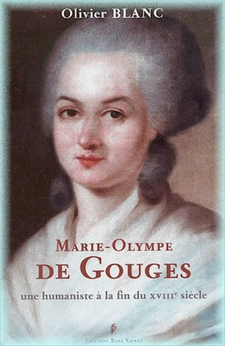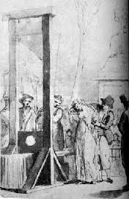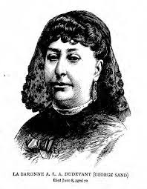

Written and oral work: Regular preparation of an analysis of the texts and discussion in class. One oral presentation, one paper (mid-term) and one final exam.
Reading list :
Olympe de Gouges, Mémoire de Mme de Valmont, excerpts
- Déclaration des Droits de la femme et de la citoyenne
- Écrits Politiques, excerpts
- L’esclavage des noirs
- Réflexions sur les hommes nègres
- lettre Chronique de Paris du 20 décembre 1789, une lettre aux auteurs du journal de Paris, du 27 décembre 1789 et la Réponse au Champion américain ou Colon très aisé à connaître de janvier 1790.
- Le Siècle des grands hommes ou Molière chez Ninon
- La Nécessité du divorce
George Sand, Histoire de ma Vie, excerpts
- Écrits Politiques, excerpts
- Le Père Va-tout-seul
- Lettres à Marcie, excerpts
- La Comtesse de Rudolstadt, excerpts
- Lettre IV des Lettres d’un voyageur

Masson

FRENCH 322 (Spring)
France and Europe: Ambiguities, Obstacles, and Triumphs

After an introduction to various social, cultural, and political aspects of contemporary France and the French, we will turn our attention to issues surrounding France's role in the project to unify Europe. We will investigate the tensions that arise as France commits more deeply to membership in the European Union, and how France is experiencing EU membership differently from its neighbors, in ways that reflect its unique history and culture. Readings will be drawn from a variety of disciplines, including texts by historians, political scientists, sociologists, and economists. Prerequisite: FREN 211 or, for students entering in 2014 or later, FREN 210; and one additional unit, FREN 213 or above. Not open to students who took the same topic as FREN 349.

In this course, we will investigate the tensions that arise as France commits more deeply to membership in the European Union. Readings will be drawn from a variety of disciplines, including texts by historians, political scientists, sociologists and economists. We will begin with an introduction to various social, cultural and political aspects of contemporary France and the French, with a focus on certain “Franco-French” concerns that may not be readily understood from an American perspective.

As anyone who has recently visited a French bookstore can attest, France has become increasingly introspective, wondering what role it can and should play in the twenty-first century. Faced with the pressures of globalization, many French people are wondering whether France can remain an important force in international commerce and a significant voice in international politics without jeopardizing traditional French ways and the “exceptionalism” of French culture.

These growing anxieties will set the stage for our analysis of France’s role in the European Union. This is a particularly exciting time to be studying France’s role in Europe, as the following pressing issues come to the forefront:

- What effect has the incorporation of ten new member-states in summer 2004 and two more in January 2007 had on France’s role in the European Union? In discussions with the United States over the war in Iraq, ideological splits within Europe became increasingly pronounced, primarily between Eastern Europe and the “Old Europe” of the West. How does this affect the character of diplomatic relations between Europe and the rest of the world? Is it possible for the expanded European Union speak with a single voice?

- How will Europe deal with issues of immigration and citizenship as borders become longer and more remote and as the economic divide between Europe and poor countries outside its borders grows?

- With Europe’s focus on commercial exchange, are environmental policies, civil rights issues, social programs and cultural policy being neglected?

- What affect are crises such as the 2014 crisis in Ukraine or the ongoing economic crisis in many European countries having on France’s relationship with the EU?

In the end, we will see that many of France’s anxieties and hopes for the Union are shared by other European nations, but that France is also experiencing membership in the European Union differently from its neighbors, in ways that reflect its unique history and culture. Because much of the course will focus on current issues, many of the readings will come from the internet. The class meetings will be organized in a seminar format, which means that group discussions will be just as important as lectures.

Assignments will include short written assignments and quizzes, one presentation and one final research paper.

Gunther

FRENCH 324 (Fall)
The Belle Epoque and the Emergence of Modern France

The term belle époque (1880-1914) evokes images of Parisian boulevards, bustling cafés, glittering shop windows, and Montmartre cabarets, all symbols of modern consumer culture. No emblem of the era is as iconic as the Eiffel Tower, constructed for the World’s Fair of 1889 as a tribute to French technology and progress. During the years preceding World War I, Paris was the center of the European avant-garde—indeed, the capital of modernity. While cultural ebullience is its hallmark, this period also witnessed the definitive establishment of a republican regime, the expansion of an overseas empire, and the integration of the countryside into national life. Drawing on historical documents and literary texts as well as films, posters, and songs, this interdisciplinary course examines French culture, politics, and society during the era that ushered France into the modern age. Prerequisite: FREN 211 or, for students entering in 2014 or later, FREN 210; and one additional unit, FREN 213 or above.

Not open to students who took the same topic as FREN 349.

We will begin by examining the political situation of the Third Republic, in particular, the scandals that shook the regime, notably the Dreyfus Affair; the conflict of Church and State, and the expansion of an overseas colonial empire. Next, we will study French society of the Belle Epoque, exploring the family, the role of women, and the emergence of a working class and of consumer culture. In the final third of the course, we will study the literary and artistic achievements of the period, concentrating on the Parisian avant-garde, boulevard culture, the 1900 World’s Fair, poster art, and the birth of the cinema.

Readings:
Eugen Weber, France, Fin de Siècle
Roger Shattuck, The Banquet Years
Emile Zola, Au Bonheur des Dames
Jules Ferry, La mission coloniale
Baronne Staffe, Règles de savoir-vivre dans la société moderne (excerpt)
Jacques Ozouf, Nous les maîtres d’école: Autobiographies d’instituteurs de la Belle Epoque (excerpt)
Charles Rearick, Pleasures of Paris (excerpt)
Jules Verne, Paris au XXe siècle
Octave Mirbeau, Le journal d’une femme de chambre (excerpt)

Films:
Paris 1900 (documentary), Germinal, French cancan, Fantômas

Work for this course:
Two papers and an oral presentation.

Datta

FRENCH 333 (Spring)
French Classical Tragedy: Corneille versus Racine:
Rethinking the Parallel

Ever since La Bruyère’s famous comment on Corneille and Racine—“The first depicts men as they should be, the second as they are”—critics have been tireless in pitting the two French tragedians against each other. In this course, we will take a critical look at the archetypal Corneille-Racine parallel in the light of important but marginalized playwrights such as Jean Rotrou, Tristan l’Hermite, and Catherine Bernard, whose works do not fit standard definitions of Classicism and tragedy. This encounter will lead us to question the notion of auteurs classiques and the seventeenth century’s status as the “Grand Siècle.” We will explore the many variations on the Corneille-Racine theme, asking if there is a “grand Corneille” and a “tender Racine,” and considering why in certain historical periods one playwright was considered to encapsulate “French values” and patriotism more than the other. Students will become familiar with an array of seventeenth-century tragedies and reflect on the process and politics of literary canonization.
Prerequisite: FREN 211 or, for students entering in 2014 or later, FREN 210; and one additional unit, FREN 213 or above.

We will analyze the progression from the dominance of tragic-comedy in the early seventeenth century, to tragedy’s heyday at mid-century, and, finally, opera’s supplanting of tragedy at the end of century. We will consider the artistic and political factors responsible for promoting these changes. We will also discuss the specific historical contexts within which the playwrights worked, and how tragedy’s status as the “monarchical genre” influenced their subject matter. We will take into account how the foundation of the Académie française and the Comédie française, as well as the influence of the doctes, the parterre, and the growing importance of female opinion shaped French tragedy.
This course will allow students to engage with critics of French literature who have shaped current thinking on seventeenth-century tragedy (e.g., Barthes, Starobinski, Genette, Forestier) while encouraging them to question the validity of aesthetic periodization and classifications such as “the baroque” or “the classical.” Finally, the course will offer an état des lieux of French classical tragedy today. We will consider, for instance, which plays are still widely taught and performed and for what audiences. We will question the exclusion of certain playwrights at the expense of others and interrogate the status of “minor” and “major” works within the corpus of canonical authors.
Readings:
Corneille, Le Cid, Horace, Suréna, Les Trois Discours sur le poème dramatique
Racine, Andromaque, Bérénice, Phèdre, Préfaces
Rotrou, Le Véritable Saint Genest
Tristan l’Hermite, La Marianne
Catherine Bernard, Brutus
Thomas Corneille, Timocrate
D’Aubignac, La Pratique du théâtre (excerpts)
We will also watch video-recordings of contemporary stagings of these plays, and at least one cinematic adaptation of one of these works.
Assignments: short response papers, one mid-term paper, one final paper, and one oral presentation.

Bilis

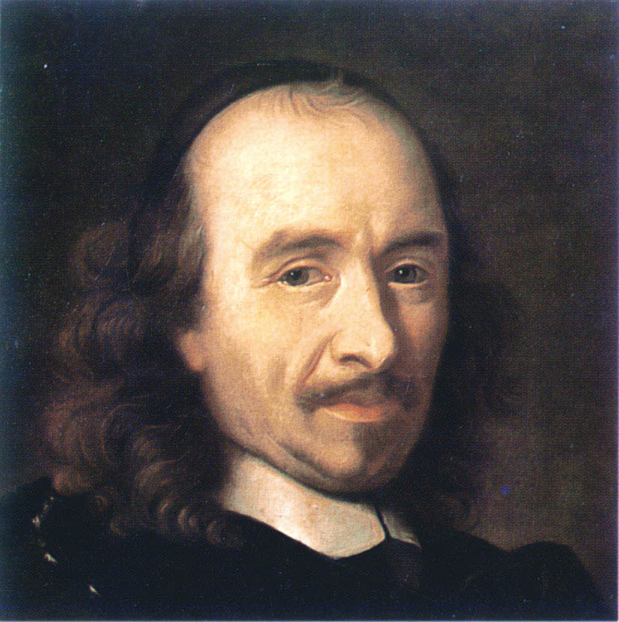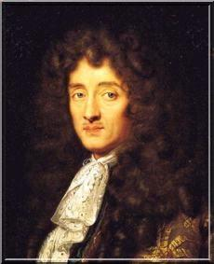
Corneille et Racine
FRENCH 335 (Fall)
ETHICS AND DIFFERENCE

A course on the idea of difference in historical perspective, with particular emphasis on ethical aspects of claiming/identifying difference. Study of difference in texts by the Philosophers of the Enlightenment, travel accounts, anthropological writing, ethnographic film, and recent fiction. The course focuses on methods of close reading and the function of grammatical structures such as objects and variations in tenses, on the position of the narrator, and on nuances in vocabulary. Individual assignments will be based on students’ wider interests. Themes of difference include race, ethnicity, nationality, class, gender, and differential power in individual or group relationships. FREN 211 or, for students entering in 2014 or later, FREN 210; and one additional unit, FREN 213 or above.

We will begin our readings with the progressive, even revolutionary, ideas of the Enlightenment, focusing on how the Philosophers of the Eighteenth-Century thought about difference and why they were interested in it as a concept. Montesquieu, Voltaire, Diderot and the other Philosophers of the era all used “difference” as a key element in their rational critique of the monarchy and the church and in their theoretical search of an equitable society. We will then explore how the notion of difference functioned in French thought from the period of sustained contact with real situations of difference occasioned by voyagers, missionaries, and traders. How did these travelers interpret and understand the different cultures they encountered? What sorts of vocabulary and strategies did they use in language to express their conceptualization of difference? Is it possible to learn something about the conditions of the encounter by reading closely such accounts? How did Louis XIV’s “Code Noir” or Black Code, widely adopted and/or modified by British, Dutch, and Spanish colonial administrations through the colonial period, express the notion of difference to be applied in very real situations in the colonies?
Moving to the context of the colonies themselves, we will study how “difference” was a concept central to administration: control, policing, education, exchange, marriage, burial, travel, immigration, and independence. At this time, we will be particularly interested in ethnography, which approaches the study of social phenomena through observation. How did pioneers in this method that would subsequently be used widely by cultural and social anthropologists go about delineating what they would study and how did they study it? What were the ethical questions with which they grappled in creating such ethnographies based on difference? What was the relationship between this knowledge and colonialism? How did scientific (medical) research weigh in on this relationship? How was “difference” taken up in language by those who were “different”? What was the stake in difference for the African and Asian populations under French colonialism? How was it expressed? What has happened to this notion since independences in the colonies, particularly in the context of immigrants in France? How does this matter to us today? How does this affect how we view the human body? What kinds of traces of this history can we see in how we conceive of difference today? The work of the philosopher Emmanuel Levinas will be central to our discussion of the ethics of difference.

Grades are based on presence, participation, one presentation, one essay/exam, one final assignment.

Required Readings and Films (in bold)
Voltaire. Dictionnaire philosophique (short selections)
Louis-Antoine de Bougainville. Voyage autour du monde (selections)
Diderot, Denis. Supplément au voyage de Bougainville
Bernardin de Saint-Pierre. Voyage à l’île de France
Abbé Ducrois. Réfutation du Voyage à l'île de France
Rousseau, Jean-Jacques. “Discours sur l’origine et les fondements de l’inégalité parmi les hommes”
Code noir (crafted under Louis XIV)
Baudelaire. “A une dame Créole”
Senghor, Léopold Sédar. “Femme nue, femme noire”
Senghor, Léopold Sédar. “Ce que l’homme noir apporte.” In Ce que je crois: négritude, francité, et civilisation de l’universel
Rouch, Jean. Jaguar, 1955
Rouch, Jean. Les maîtres fous, 1955
Todorov, Tzvetan. Conquête de l’Amérique (selections)
Griaule, Marcel. Dieu d’eau: Entretiens avec Ogotemmêli (selections)
Memmi, Albert. Statut de sel
Said, Edward. “What is Orientalism?” In Orientalism
Levinas, Emmanuel. Ethique et Infini: Dialogues avec Philippe Nemo
Pontecorvo Gillo. Bataille d’Alger, 1966
Djebar, Assia. Blanc de l’Algérie
Comaroff, Jean. “The diseased heart of Africa: Medicine, Colonialism, and the Black Body.” In Lindenbaum and Lock, eds., Anthropology of Medicine and Everyday Life

Prabhu

FRENCH 350
Research or Individual Study

350s will ordinarily be permitted in cases where there is no overlap of the content of the proposed study with a course being offered by the French Department in the same semester. A student interested in doing an independent study should first have a well-defined topic, including, for example, the author(s) to be considered, the question or central idea to be studied, and the approach that will be taken. Students should consider which professor whose area of specialization and interests most closely match her proposed study. Meetings and regular assignments will be discussed and arranged with the professor in question. Please refer to the back of this handbook for faculty information or visit http://www.wellesley.edu/french/faculty.

Students should contact the instructor at the time of pre-registration and, in any case, no later than the end of the first week of classes. Prerequisite: FREN 211 or, for students entering in 2014 or later, FREN 210; and one additional unit, FREN 213 or above.

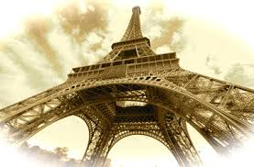
learnfrenchlanguage.org

FREN 359 (Spring)
Calderwood Seminar in Public Writing:
You Say You Want to Change the World: Advocating for Other Cultures (in English)

Your local school board is considering eliminating foreign language instruction at the high school. You think it’s a bad idea. How will you make your voice heard? This seminar will explore writing that challenges language majors to rethink and repurpose their academic knowledge, shaping it to contribute to public debates. Such writing may include op-eds and letters to the editor; book, film and music reviews; blogs; and interviews with notables in the field. Students will write weekly and revise their work in response to comments from the instructor and their peers. The presence of majors in different languages will introduce students to the assumptions, perspectives and approaches of other cultures, with the goal of helping participants become advocates for a
wider, more inclusive cultural literacy. Prerequisite: At least two courses at the advanced 200 level or the 300 level in the major department.

Open to junior and senior majors in the foreign language departments and related programs, and in Classical Studies and Comparative Literature.
Cross-Listed as: CPLT 359.

Participants in this seminar will draw on their mastery of a foreign language and culture to interpret their fields to non-specialists. Their studies have already taught them the skill of projection—of imagining oneself as another and seeing reality from a standpoint outside oneself—that is central to understanding a foreign culture. That skill is also, significantly, one of the keys to writing successfully for a general public. The seminar will be organized around three main issues: the nature and function of language in understanding culture, including issues of translation; the traditions and purposes of criticism and literary theory; and the differing attitudes, values, creativity and histories of national groups.

Lydgate

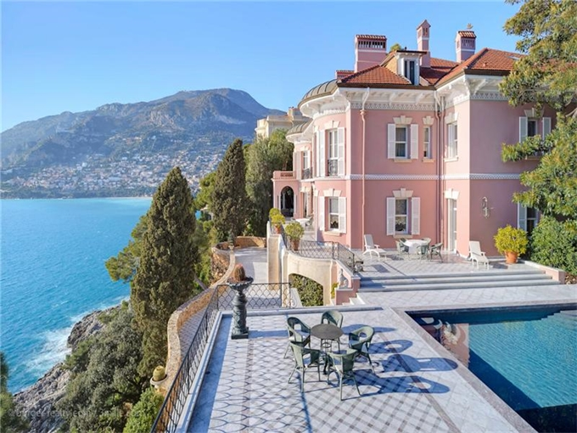

Villa Ephrussi de Rothschild, Saint-Jean-Cap-Ferrat

FRENCH 360: Senior Thesis Research
FRENCH 370: Senior Thesis

Requirements for Becoming an Honors Candidate
1. Grade point average of 3.5 in the major, above the 100-level
(Exceptions: see appended Articles of Government, Book II, Section 2, Honors Programs.)
2. Recommendation of Department's Honors Committee when Project is submitted
3. A 300-level course or its equivalent before the Fall of senior year.
4. French 360 and 370 do not count towards the minimum requirement of two 300-level courses for the major.

Prerequisite for French 360: By permission of the department. See Academic Distinctions.
Prerequisite for French 370: French 360 and permission of the department.

Spring of Junior Year
In the Spring of the Junior Year qualified students who wish to be in the Honors Program must submit a proposal for 360 Senior Thesis Research. Students in the Wellesley-in-Aix program should discuss their plans with the program Director. Any eligible junior who wishes to do so should then consult a faculty member for advice in selecting appropriate research material for summer reading and in developing her topic into a promising proposal, which is to be formally submitted to the department in the fall. The advisor should be contacted in February. In March and April the student should gather a bibliography and by the end of April she should submit it to her advisor along with a preliminary proposal. The advisor should comment on the bibliography and proposal by the beginning of June.

It is suggested that interested students look at the Honors theses of former students in the French Department Germaine Lafeuille Library. The Chair of the department is available for advice about selecting an Honors advisor. Students may also consult the short description of the specializations of each French Department faculty member on the department website http://www.wellesley.edu/french/faculty.

Summer
Read in general area of research and begin writing proposal for submission to the Department. Compile an annotated bibliography.

September
Meet with advisor during the first week of classes to discuss thesis topic, annotated bibliography, and the reading done over the summer. A schedule of conferences and deadlines should be worked out at this time.

October 1
Proposals are to be submitted to the Honors Committee of the department after consultation with the advisor. Goals, scope of study, and critical approach should be clearly and precisely defined. Special attention should be paid to grammar, spelling, and style. A tentative, but detailed, outline of the thesis, suggesting the progression of the argument or analysis must accompany the proposal. A bibliography should also be included. Separate copies of the proposal are to be provided for each member of the Honors Committee.

If the proposal is not approved, the student will be notified by October 8: in this case, the student may withdraw from the Honors Program. She will be credited with one unit of 360
if sufficient work is done during the semester to justify it.

October 29
A more substantial outline should be submitted to the advisor.

December 1
A substantial sample (chapter or section, 20-25 pages) should be submitted to the advisor and the members of the Honors Committee. During finals week, a mini-oral will be scheduled with the student, her advisor and two members of the Honors Committee. At that time, the student, in consultation with her advisor and the committee, should decide whether her 360-370 work thus far, written or otherwise, justifies the continuation of her project into the second semester: it happens sometimes that a topic turns out to be less interesting or fruitful than originally anticipated. In that case, credit will be given for one unit of 360, provided sufficient work has been done. If the submitted sample appears promising, work on the 360 project should continue in consultation with the advisor. In the latter case the instructor may choose to give a T.B.G. grade (To Be Graded) instead of a letter grade for work done in the fall semester.

December
By the end of the final exam period the student will be notified of the decision of the Honors Committee. In order to avoid the possibility of having two 360's on her transcript, a student may find it prudent to register for a course in French which might serve as a substitute for the second semester.

List of Honors Candidates to CCI (Committee on Curriculum & Instruction) of the College
Before the end of the tenth week of classes the Honors Committee reports to the Curriculum Committee of the College (with copy to the Chair of the Department), the names of students registered for 370s who are candidates for honors.

Oral exam
The thesis is due in the Dean's Office at a date specified by the College, usually 2-3 weeks before the last day of classes. The Oral Defense committee comprises the Advisor, the Chair of the Department (or her or his deputy), a representative of the Curriculum Committee of the College, and at least one other department member ordinarily chosen by the Advisor and Honors candidate.

If her thesis and her oral exam are judged of honors quality, the student is awarded honors in the major field. If the thesis is completed but it or the honors exam is not of honors quality, honors are not awarded; 370 remains on the transcript as Senior Thesis with an appropriate grade.

LING 114 (Fall & Spring)
Introduction to Linguistics

Designed to familiarize students with some of the essential concepts of linguistic analysis. Suitable problem sets in English and in other languages will provide opportunities to study the basic systems of language organization – phonology, morphology, syntax, and semantics. Additional topics include introduction to language, organization in the brain, child language acquisition, and language change. Prerequisite: None

In introductory linguistics, we begin with a consideration of the nature of language and then move to an examination of current ideas about the representation of language in the brain. The central part of the course then focuses on the different levels of structural organization in language - the levels of morphology, syntax and phonology—and presents some of the modern techniques of linguistic analysis. Linguistic problem sets will provide the opportunity to develop logic skills and problem-solving techniques. Once students have developed an understanding of the units and principles of language organization at each of these levels, we will begin to explore other topics of interest in linguistics, including semantics (the study of meaning), sociolinguistics (how language use varies with social class membership), historical linguistics (how languages change over time) and language acquisition. There will be problem sets, a midterm and a final. Text: Fromkin, Rodman and Hyams, An Introduction to Language, 9th Edition.

Carpenter

LING 240 (Spring)
The Sounds of Language

What are the possible linguistically relevant sounds of the human vocal tract? How does each language organize a subset of those sounds into a coherent system? Examination of the sounds of language from the perspective of phonetics and of phonology. Each student will choose a foreign language for intensive study of its phonetic, phonologic and prosodic characteristics. Includes extensive use of speech analysis and phonetics software. Prerequisite: LING 114, PSYC 216, or by permission of the instructor.

Carpenter

LING 312 (Fall)
Bilingualism: An Exploration of Language, Mind and Culture

Exploration of the relationship of language to mind and culture through the study of bilingualism. The bilingual individual will be the focus for questions concerning language and mind: The detection of “foreign” accent, the relationship of words to concepts, the organization of the mental lexicon, language specialization of the brain, and the effects of early bilingualism on cognitive functioning. The bilingual nation will be the focus for questions dealing with language and culture: societal conventions governing use of one language over another, effects of extended bilingualism on language development and change, and political and educational impact of a government’s establishing official bilingualism. Prerequisite: Open to juniors and seniors who have taken a related 200-level course in linguistics, psychology, anthropology, philosophy, or by permission of the instructor.

Carpenter

LING 322 (Spring)
The Cognitive Science of Verbal Humor and Verbal Play
We will examine verbal humor and verbal play from the perspectives of several of the key disciplines of cognitive science including psychology, linguistics and philosophy. We will begin with psychological studies of humor, including psychological models of humor and its relationship to personality, health and well-being. We then focus on how the analysis of verbal humor and verbal play depends on the categories and concepts of formal linguistics. We next turn to sociolinguistic approaches to the subject, including an examination of women’s use of verbal humor. Finally, we explore some key philosophical questions: Why does humor exist and what does it reveals to us about the mind? Prerequisite: Open to juniors and seniors who have taken a related 200-level course in linguistics, psychology, anthropology, philosophy, or by permission of the instructor.

Levitt

LING 238 (Spring)
Sociolinguistics

The application of linguistics to the analysis of sociocultural variation in language. We will examine the way information about age, gender, social class, region, and ethnicity is conveyed by variations in the structural and semantic organization of language. We will also examine language attitude and language planning in multilingual societies. Prerequisite: LING 114, PSYC 216, or by permission of the instructor.

Levitt

Writing 125 (Fall)
“Do French Women Really…?”

From their legendary ability to stay thin, to their shrewd mothering skills, sophisticated charm, culinary prowess, and sexual savoir-faire, les Françaises—French women—have long held American commentators in thrall. We will explore the complexity of twenty-first century portrayals of French women as models of a unique vein of femininity. We will explore how writers construct their images of French women from three directions: through close readings, critiques of authorial voice, and the analysis of supporting evidence. We will investigate portrayals of la Française in self-help books, memoirs, feminist manifestos, film, fiction, and historical accounts. Participants will analyze, then imitate the texts we consider, paying close attention to how the choice of a particular genre sheds light on the author’s development of his or her thesis. . Prerequisite: None

Bilis

French Advanced Placement Policies and Language Requirement
A student entering Wellesley must have an Advanced Placement score of 5 or an SAT II score of 690 to satisfy the foreign language requirement. The Wellesley College language requirement is normally met with the completion of either FREN 201-202 or FREN 203. Students who present an AP score of 3 or an SAT II score between 600–640 can satisfy the requirement by taking FREN 205. Students who present an AP score of 4 or an SAT II score between 650–680 can satisfy the requirement by taking one of the following courses: FREN 206, 207 or 209. All incoming students who have studied French previously are required to take the placement test. Any discrepancy between a student’s AP score and her score on the departmental placement test will be resolved by the placement committee. Any student who takes a language course at another institution and would like college credit must have permission in advance and take the French placement test upon her return to verify she has attained the required level.

Requirements for the Major
FREN 101-102, FREN 103 and FREN 201 count toward the degree but not toward the French major. Courses taught in English do not count toward the minimum requirement for the major. Students who begin with FREN 101-102 in college and who plan to study abroad should consult the chair of the department during the second semester of their first year.

Majors are required to complete a minimum of eight units, including the following courses or their equivalents: for students entering before 2014, FREN 211, which develops students’ literary analysis and writing skills in the context of an intensive grammar review, and FREN 308, which focuses on translation and stylistics. Students entering after 2014 may satisfy the 200-level requirement with either FREN 210 or FREN 211, and must also elect FREN 308 or its equivalent.

The goals of a coherent program are: (a) oral and written linguistic competence; (b) acquisition of basic techniques of reading and interpreting texts; and (c) a general understanding of the history of French literature and culture. All majors must take at least one culture course (FREN 207, 225, 229, 230, 237, 322, 323, 324, 332) or spend one semester studying in a Francophone country, and at least one literature course (FREN 209, 210, 213, 214, 217, 221, 224, 238, 241, 302, 303, 306, 307, 313, 315, 317, 330, 331, 333, 335) or an equivalent literature course in French taken abroad). All majors must take two 300-level French courses at Wellesley College, at least one of which must be during their senior year. FREN 350, 360 and 370 do not count towards the minimum requirement of two 300-level courses for the major. No more than two courses taken Credit/No credit at Wellesley College may be applied to the French major.

The French Cultural Studies Major
Wellesley offers an interdepartmental major in French Cultural Studies, which combines courses from the Department of French with those in Africana Studies, Art, History, Music, Political Science or any other department offering courses on France or Francophone countries. French Cultural Studies majors ordinarily work closely with two advisors, one from the French Department and one from the other area of concentration.

The major in French Cultural Studies consists of a minimum of eight units. At least four units in the French department above the 100 level are required, including FREN 207 and FREN 211 or, FREN 210. For all students: In special cases, an upper-level culture course in French approved by the program director may be substituted for FREN 207. At least two units in French at the 300 level are required. FRST 350, FRST 360 and FRST 370 do not normally count towards the minimum requirement of two 300-level courses for the major. In exceptional cases, this requirement may be waived by the FCS director and/or the chair of the French department. No more than two courses taken credit/noncredit at Wellesley College may be applied to the French Cultural Studies major. Students planning to major in French Cultural Studies should consult with advisors to the major. For related courses for credit toward the FCS major, please check http://www.wellesley.edu/french/culturalmajor
La Maison Française
Qualified students are highly encouraged to live at the Maison Française, also known as the French House. The Maison Française is a French-speaking residence and a cultural center for the Wellesley College community. It houses fourteen students and two French assistants from the Université de Provence. It is a place where majors and non-majors who have demonstrated a significant competence in French live and can exchange ideas. During the academic year, the Maison Française organizes seminars, talks and colloquia, which students are encouraged to attend. Details are available on our website at http://www.wellesley.edu/french/maisonfrancaise

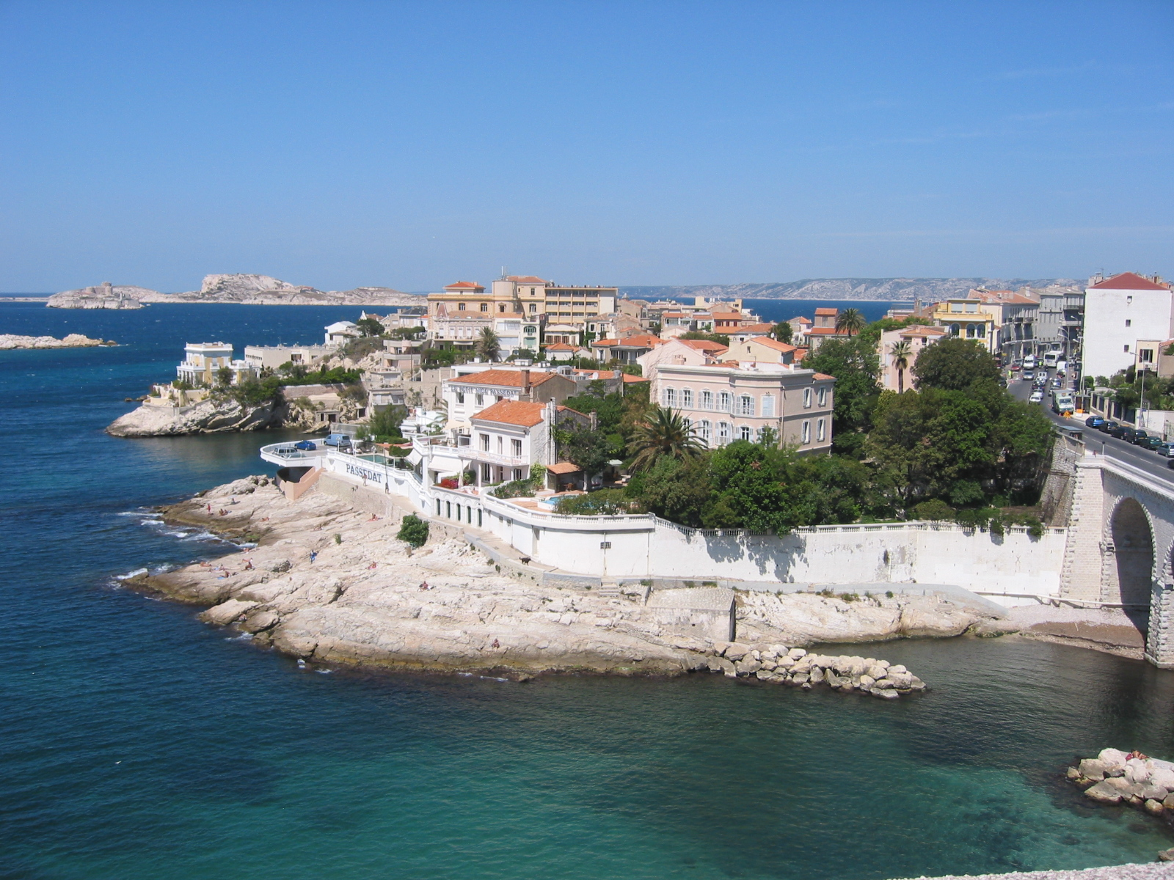

Marseille

Wellesley-in-Aix
The French Department's junior year or semester program in Paris and in Aix-en-Provence, in the South of France, was created during the 1982-83 academic year and has been popular since that time. Students may either spend the entire academic year in Aix or choose a fall or spring semester option. About one quarter of Wellesley's French majors, as well as many non-majors, participate each year. The Wellesley-in-Aix program offers students an exciting and challenging course of study and an authentic experience of French life and culture. The program is tailored to individual interests and needs. Interested students should contact the program's Associate Director, or the Chair of the department. Details are also available on our website:
http://www.wellesley.edu/ois/wellesleyprograms/aix

French Department Faculty and their Specializations

Hélène Bilis

Hélène Bilis specializes in the literature and culture of early modern France, in particular the relationship between seventeenth-century theater and absolutist political theories of sovereignty. Her current book-length project addresses representations of the king-as-judge and scenes of royal decision-making in the works of Rotrou, Corneille, Racine, and Voltaire. Recent publications have focused on feeble and aging kings and the crises of dynastic succession they provoke on the tragic stage. Prof. Bilis is also interested in the historiography of the seventeenth century as France’s “Grand Siècle,” how and why literary genres gain and lose prominence, and early modern rewritings of ancient texts. In the classroom, she uses the insights of visual arts, ceremonial fictions, and juridical and political writings to illuminate literary texts.

Venita Datta

A specialist of nineteenth- and twentieth-century French cultural and intellectual history, Vinni Datta is interested in the relationship of politics and culture, particularly in the formation of national identity. She is the author of Heroes and legends of Fin-de-Siècle France: Gender, Politics and National Identity (2011) and Birth of a National Icon: The Literary Avant-Garde and the Origins of the Intellectual in France (1999). She has recently begun work on a new book project on French images of Americans and the United States in Belle-Epoque France. Professor Datta teaches a variety of courses in cultural history, among them French 332, “Myth and Memory in Modern France,” French 324, “La Belle Epoque,” French 229, “America Through French Eyes: Perspectives and Realities;” and French 207, the introductory course in French Cultural Studies. Professor Datta is a past president of the Western Society for French History (2001) and is currently the co-Editor of the H-France Forum and a member of the editorial board of French Historical Studies.

Pauline de Tholozany

I received a Ph.D. from Brown University in 2011, and am a Mellon Postdoctorate Fellow in French at Wellesley. I am a specialist in nineteenth-century French literature and culture, with a focus on the novel and popular press of the early nineteenth century. I work primarily on representations of civility, customs, and forms of sociability in the literature of the first decades of the century. I am also interested in children’s literature and child-rearing practices of the period. My dissertation looked at perceptions and representations of clumsiness from the late XVIIIth century to the 1840s. I am currently working on a book manuscript in which I question the concept of maladresse as it emerged in nineteenth-century France and evolved from signifying social disgrace to becoming a sign of sincerity, naturalness, and eventually originality. I look at the history of clumsiness from several critical perspectives, borrowing concepts from anthropology, sociology, philosophy, history, and psychoanalysis. My book touches upon a variety of subjects, and includes chapters on social customs, literary representations of clumsiness, child-rearing practices, and caricatural representations of maladresse. I am also interested in representations of flâneurs and flânerie in nineteenth-century Paris, and more specifically in the marginal figures that appear in newspapers and physiologies of the period such as the child flâneur, the clumsy or overly distracted flâneur, and female embodiments of flânerie.

Sylvaine Egron-Sparrow

Sylvaine Egron-Sparrow specializes in French civilization and conversation courses. Her areas of interest include contemporary novels, analysis of films by immigrant filmmakers, and novels by African writers. She has been Director, Associate Director and Campus Director of the Wellesley-in-Aix program, and Director the French House.

Marie-Cecile Ganne-Schiermeier

A native of southwest France, Marie-Cécile Ganne-Schiermeier holds a Ph.D. in French literature and an MA in English literature from Boston University, as well as a Licence de lettres modernes from La Sorbonne. She has taught in several institutions, including UMass Amherst, Boston University, Fordham University and Drew University. She is committed to seeking out new and enhanced pedagogical approaches, including the use of technology in the classroom, and is dedicated to teaching and to her students. Her academic focus includes anonymously-authored early modern French texts and her research concentrates on authorship, textual strategies and the fashioning of subjectivity. Currently, she is interested in Asian Francophone literature and the rise of chocolate as a culinary and social commodity in early modern France.

Scott Gunther

Scott Gunther is a specialist of contemporary French culture and society. His interests include the mass media, gender and sexuality, France’s role in the European Union, Franco-American relations, Franco-German relations and comparative (French/American) law. He teaches from a broad, interdisciplinary perspective, relying on the contributions of disciplines as diverse as law, gender and sexuality studies, anthropology, history, sociology and cultural studies. He has published articles on gay politics in France and on French popular media. His book, The Elastic Closet: A History of Homosexuality in France, 1942-present (Palgrave, January 2009) examines gay politics in contemporary France with a focus on the complex relationship between French republican values and the possibilities they offer for social change. In 2014-15 he is the Campus Director of Wellesley-in-Aix.

Andrea Levitt

Andrea Levitt teaches a variety of linguistics courses - sociolinguistics, historical linguistics, bilingualism, and the spoken and written word. Professor Levitt has published numerous articles on speech perception and production in children and adults. She is also interested in the acquisition of speech sounds and native-like prosody by second-language learners. Both the National Institutes of Health (NIH) and NATO have provided support for her work. Professor Levitt is a research scientist at Yale University's Haskins Laboratories, a center for the study of speech and reading. She frequently involves Wellesley students as assistants in research ongoing projects. Andrea Levitt was one of three recipients of the Samuel and Anna Pinanski Teaching Prize for 1998-1999, and in 1999, she was named Margaret Clapp '30 Distinguished Alumna Professor of Linguistics and French. She served as chair of the French department from 1995-1998 and 2007-2011 and as associate dean of the college from 1999-2004.

Barry Lydgate

Barry Lydgate teaches courses on post-Liberation Paris (FREN 237, “Saint-Germain-des-Prés”) and on Renaissance literature and culture (FREN 301, "Books and Voices in Renaissance France" and 302, "Discourses of Desire in the Renaissance.") He has written on Rabelais, Montaigne, the genesis of the novel and literary self-portraiture in the sixteenth century. He is also interested in comparative and cross-century courses—his “Books of the Self” (FREN 217) examines confessional writings from St. Augustine to Annie Ernaux—and in language teaching. With a colleague at Yale, he is co-author of French in Action, a multimedia course in French language and culture supported by grants from the Corporation for Public Broadcasting, the Florence Gould Foundation and the French government. The Third Edition of the course has just been published. He is chair of the college committee that supports Wellesley students for Rhodes, Marshall, Mitchell and Churchill scholarships and Watson Fellowships, and is chair of the French department in 2014-2015.

Catherine Masson

Catherine Masson is a specialist of theater. Her approach to theater is not only literary and theoretical, but also practical—she has performed with professional actors, and designed decor and costumes. In her classes, students are introduced to techniques of acting and directing. She is also concerned with the influence of performance on spectators and has studied surrealists, 20th century playwrights, and contemporary writers. She has written on the role of the stage director as critic, analyst and rewriter. She created a montage on Jacques Prévert, Pour faire le portrait de Prévert, which has been performed in the US and in various European countries (1996, 2001). Since 2004 her play, George Sand - Gustave Flaubert, Echanges Epistolaires has been performed under her direction in France, Switzerland, Monaco, and the US; it was published in 2006. She directed a production of Huis clos by Jean-Paul Sartre that has been presented in Europe and the US. She is currently doing research on George Sand, Marguerite de Navarre and Olympe de Gouges as playwrights. Her book, L'Autobiographie et ses aspects théâtraux chez Michel Leiris, was published in 1995. She has done research on women playwrights at the Comédie-Française and has given presentations on the theater of Marguerite de Navarre, Olympe de Gouges and George Sand. She has written articles on twentieth-century theater, and more recently on George Sand's theater and on her adaptations of novels for the stage and of Shakespeare. She has written an article on the reception of George Sand’s work in the US from 1837 to 1876. She co-edited eight plays by Marguerite de Navarre for the first volume of an anthology, Théâtre de femmes de l’Ancien Régime (2006). She also co-edited the volume George Sand, une écriture experimentale (2006). Her edition of the play Cosima by George Sand was published in France by Le Jardin d’Essai in 2013. She is currently preparing a book, George Sand Dramaturge: Adaptation et Réécriture.

Codruta Morari

My research focuses on forms of spectatorship in post-war European cinema, with an emphasis on French film, seeking to reveal the dynamics of the viewers embodied minds as the locus of modern subjectivity. I have published articles on film perception, cinephilia and urban spectatorship. My work examines the relationship between the cinematic apparaturs and the cognitive, affective and ideological basis of film perception. I am currently working on two books based on my doctoral thesis defended in 2008 at the University of Sorbonne Nouvelle. "The Topographical Mind: Essay on the Metaphor-Effect in Cinema" is an essay on the rhetoric of film perception. "The Praxis of Visuality: Maps and Urban Paths in the Project of Mapping History" aims to weave together post-war French cinema and the formation of the modern self. I look forward to rich and lively discussions in my courses on French cinema and the politics of French art.

James Petterson

James Petterson is a specialist of nineteenth- and twentieth-century literature and poetry, with a focus on their philosophical and ideological contexts. In 2000 he published Postwar Figures of L'Ephémère: Yves Bonnefoy, Louis-René des Forêts, Jacques Dupin, André du Bouchet (Lewisburg: Bucknell University Press). His second book, Poetry Proscribed: Twentieth-Century (Re)Visions of the Trials of Poetry in France, was published in fall 2008, and was published in French by the Presses Universitaires du Septentrion (April 2013). Professor Petterson is currently working on a book project provisionally titled Poetry’s Incomplete Indifference on poetry, philosophy and political commitment in twentieth- and twenty-first-century France. Petterson is also the translator of works and essays by Gérard Noiriel, Jacques Dupin, Jean Baudrillard, and Yves Bonnefoy. Along with courses on poetry, Professor Petterson offers seminars on “Literature and Inhumanity: Novel, Poetry, and Film in Interwar France,” “Le Roman Contemporain et le Plaisir du Texte,” and “Commitment and the Contemporary French Poet.” He also offers an advanced course on the practice and theory of translation, a survey of French literature and culture from the Enlightenment to the present, and Intermediate French. Professor Petterson serves on a number of college committees including the Committee on Lectures and Cultural Events, and has served as Representative to the Modern Language Association Delegate Assembly.

Anjali Prabhu

I specialize in Francophone studies and theoretical issues in literature, cinema, culture, and postcolonial studies. I am currently completing Contemporary Cinema of Africa and the Disapora (Blackwell Press). My first book is entitled, Hybridity: Limits, Transformations, Prospects (SUNY 2007). My articles have undergone peer-review and appeared in journals such as Research in African Literatures, French Forum, Cinema Journal, Studies in Twentieth-Century Literature, International Journal of Francophone Studies, Journal of French and Francophone Philosophy, Levinas Studies, and Diacritics. In upper-level classes I offer, you are likely to follow debates and read some articles taken from journals and collections such as these. I’ve also contributed to edited collections in postcolonial/ Francophone studies. Some of this work includes many authors/filmmakers whom you are likely to encounter in my classes as well: for example, Mariama Bâ and Sembene Ousmane from Senegal, Assia Djebar and Albert Memmi from Algeria, Driss Chraïbi from Morocco, Moufida Tlatli from Tunisia, Frantz Fanon and Edouard Glissant from Martinique, Jean-Marie Teno from Cameroon, Abdourahman Waberi from Djibouti, Ananda Devi and Marie-Thérèse Humbert from a small island called Mauritius, off the coast of Africa. I recently published a substantial essay on Glissant, Fanon, and Memmi in the Cambridge History of Postcolonial Literatures (Cambridge UP, 2011). Other courses in Francophone studies, I offer are: FREN 218, 331, 330, and 334. I also routinely teach FREN 210, 211, and 201-202. I look forward to meeting you in some of these courses and for independent study. I often guide students for their work or study in Francophone countries. I am currently an elected member in three capacities within the Modern Language Association: (a) Postcolonial Division Executive Committee (b) Northeast representative to the Delegate Assembly and (c) Program Committee. I serve on the Editorial Boards of Research in African Literatures and Journal of French and Francophone Philosophy.

Marie-Paule Tranvouez

Marie-Paule Tranvouez, a specialist of the nineteenth-century French novel, wrote her doctoral dissertation on Balzac using a narratological and semiotic approach. Her teaching interests include pedagogy, the French Novel, cultural studies and the autobiography as a genre. She is a co-author of the sixth edition of Ensemble: Culture et Société, a cultural textbook introducing students to contemporary French documents and media. With her co-author, Jean-Marie Schultz, she published the second edition of Réseau: Communication, Intégration, Intersections, an innovative intermediate French textbook based on the notion of linguistic and cultural intersections. She was the Secretary of the Association for French Cultural Studies and has co-organized several colloquia on cultural studies at Wellesley College. In 2014-2015 she is Director of the French House.

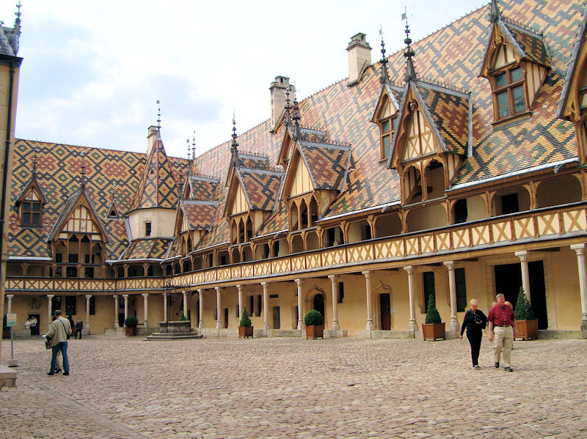

Les Hospices de Beaune- Hôtel-Dieu

French Department Awards Spring 2015

Carlo François Prize for Excellence in French

1. Candidates éligibles:
Sont éligibles:
a. étudiantes dont la langue maternelle n'est pas le français;
b. étudiantes de parent(s) dont la langue maternelle n'est pas le français.
c. étudiantes du niveau 200, à partir de 205, n'ayant jamais suivi de cours 300

2. Conditions:
Après avoir été nommées par leur(s) professeur(s), les candidates ayant accepté de participer au concours, rédigeront un texte en français lors d’une séance d’une heure et demie dans la bibliothèque Germaine Lafeuille. Date et heure au choix selon le “honor code”: le mercredi 10 avril (entre 12h et 14h) ou le jeudi 11 avril (entre 10h et 14h). Les candidates souhaitant participer à ce concours devront contacter préalablement Sarah Allahverdi (poste 2403) pour prendre rendez-vous. Les candidates se présenteront à Sarah Allahverdi (Green Hall 228A) qui leur fournira les questions et du papier. Un choix de sujets sera proposé et l’usage de dictionnaires sera permis.
Le texte soumis ne doit porter aucun nom d’auteur, l’anonymat permettant au jury d’évaluer objectivement la qualité du français.
Le but de ce prix est de reconnaître la maîtrise de la langue française et la qualité de l’expression écrite. Un seul prix sera décerné.
3. Procédure:
Chaque candidate devra remettre son manuscrit en mains propres à Sarah Allahverdi (Green Hall 228A) qui lui assignera un numéro d'ordre.
4. Dates:
Les manuscrits doivent être déposés au département immédiatement après la séance de rédaction le 8 ou le 9 avril, 2015.

Germaine Lafeuille Prize

1. Candidates éligibles:
Spécialistes de français.

2. Conditions:
Les candidates devront soumettre un essai imprimé (analyse ou critique littéraire), en français, portant sur une oeuvre ou un auteur de langue française. Cet essai peut fort bien être un "paper" écrit dans le cadre d'un cours de littérature. Il peut aussi être un chapitre extrait d'un mémoire de "350" ou de "360/370". Il peut également être un essai rédigé tout spécialement pour ce prix. Longueur approximative des manuscrits: 8 à 10 pages imprimées à double intervalle.

Ou bien, les candidates pourront soumettre une composition originale en français (poèmes, nouvelle, pièce de théâtre, etc.) Longueur approximative des manuscrits: 8 à 10 pages imprimées à double intervalle. Les manuscrits de poésie pourront être plus courts.

Les manuscrits imprimés ne doivent porter aucun nom d'auteur, l'anonymat permettant au jury d'évaluer objectivement le contenu et la forme des manuscrits soumis.

Deux prix seront décernés.

3. Procédure:
Chaque candidate devra remettre son manuscrit en mains propres à Sarah Allahverdi (Green Hall 228A), qui lui assignera un numéro d'ordre.
4. Dates:
Les manuscrits doivent être déposés au département avant le 9 avril 2015 à 16h00.

Michel Grimaud Award for Excellence in the Translation of French

l. Candidates éligibles:
Spécialistes de français.
2. Conditions:
Les candidates devront soumettre une traduction française (thème ou version) d’un texte court, traduction faite lors d’une séance d’une heure et demie dans la bibliothèque Germaine Lafeuille. Date et heure au choix selon le “honor code”: le mercredi 10 avril 2013 (entre 12h et 14h) ou le jeudi 11 avril 2013 (entre 10h et 14h). Les candidates souhaitant participer à ce concours devront contacter préalablement Sarah Allahverdi (poste 2403) pour prendre rendez-vous. Au moment du rendez-vous, elles se présenteront à Sarah Allahverdi (Green Hall 228A) qui leur fournira les textes et du papier. Un choix de textes sera proposé et l’usage de dictionnaires sera permis.
Un seul prix sera décerné.
3. Procédure:
Chaque candidate devra remettre son manuscrit en mains propres à Sarah Allahverdi (Green Hall 228A), qui lui assignera un numéro d'ordre.
4. Dates:
Les manuscrits doivent être déposés au département immédiatement après la séance de rédaction le 10 ou le 9 avril 2015.

French House Award in Cultural Studies

l. Candidates éligibles:
Spécialistes de français.
2. Conditions:
Les candidates devront soumettre un essai en français, portant sur un aspect de la culture française (histoire, art, cinéma, sociologie, science politique). Cet essai peut être un devoir écrit dans le cadre d’un cours de culture. Il peut aussi être un chapitre extrait d’un mémoire de “350” ou de “360 /370”. Il peut également être un essai rédigé tout spécialement pour ce prix. Longueur approximative des manuscrits: 12 à 15 pages imprimées à double intervalle.
Les manuscrits imprimés ne doivent porter aucun nom d’auteur, l’anonymat permettant au jury d’évaluer objectivement le contenu et la forme des manuscrits soumis.
Un seul prix sera décerné.
3. Procédure:
Chaque candidate devra remettre son manuscrit en mains propres à Sarah Allahverdi (Green Hall 228A) qui lui assignera un numéro d'ordre.
4. Dates:
Les manuscrits doivent être déposés au département avant le 9 avril 2015 à 16h00.

The Dorothy Dennis Prize

1. Candidates éligibles:
Juniors de Wellesley College, de préference spécialistes de français, passant l'année scolaire entière en France dans le cadre du programme de Wellesley. Les candidates doivent apporter la preuve d'un fort intérêt pour l'histoire et la civilisation française ainsi que d'un réel souci de perfectionnement dans la maîtrise de la langue française.

2. Conditions:
Le but du prix est de permettre à la lauréate d'enrichir sa découverte de la France grâce à une expérience culturelle marquante: par exemple, une visite d'une journée dans une région du pays qu'il ne lui serait pas possible autrement d'explorer, l'expérience d’un spectacle, ou d'une exposition en français. Au cours du premier semestre les candidates devront soumettre un projet précis. Le prix est accordé de façon à être utilisé durant le second semestre. Les demandes doivent être déposées avant le 1er décembre 2012 à 16h00.

Nathalie Buchet Fellowship
for Preliminary Thesis Work in the French Department

The Nathalie Buchet Fellowship supports an excellent student with strong initiative and the ability to work both independently and under close supervision. The ideal candidate will have displayed in her classes: a strong command of the French language; the ability to read critically, analyze closely, identify and obtain secondary texts, and understand basic theoretical or technical language as appropriate to her chosen area; as well as consistent capacity to respect deadlines and deliver under pressure. The award, in the amount of $1,000, is to support research, travel, procuring of books, films or other material in the summer between the student’s junior and senior year. It is intended for a student who will work actively on her thesis preparation in the summer and whose advisor is willing to participate in it. Receipt of this award does not affect eligibility for other thesis awards.

1. Deadline
April 30th of student’s junior year.

2. Eligibility
Declared French/French cultural studies majors nominated by prospective advisors (French department faculty) at the end of their junior year are eligible for the award. Strong candidates, those who have taken a variety of classes in the French department and who have already discussed in detail with their advisor the thesis that they intend to write in their senior year, are eligible to be nominated for the Nathalie Buchet Fellowship by their professor. Before nominating the student, the advisor will seek support from at least two other members of the department who have also had this student in their classes or in registered independent work for credit. Completing an independent study (FREN 350) does not satisfy the terms of the award.

3. Application
The student should submit a short proposal (about 2 pages) to her professor based on their conversations. It is understood that this proposal will be representative of the student’s own work under the guidance of her advisor.

- Calendar
Advisors will circulate the proposal (April 30th deadline) to members of the prize committee on behalf of the student along with the written recommendations of at least two other members of the French department and the student's Wellesley transcript. The prize committee for the department will select the winner. The chair of the French Department will announce the award to the student and advisor, who is responsible for contacting the student and going over the student’s summer research plans. The student is then expected to contact the department chair by May 30th to make arrangements for payment of the award. The student should report to her advisor as arranged between them and carry out promptly any changes to the plans that were agreed upon. The advisor is expected to respond to the student and maintain communication at reasonable intervals over the summer. The student, along with her advisor, will be invited to discuss her summer research with the members of the prize committee in September.

5. Report and Expenses
The entire amount received by the student should be spent by early September of the fall term of her senior year. By the end of the first week of classes in the fall of her senior year, the student must submit to her advisor a written report outlining the work that she completed. Any amount that is undocumented and/or unspent by this time reverts to the department. The student must submit original receipts documenting all expenditures supported by the award to the department administrative assistant.

The Michèle Respaut
French House Fellows Program

Overview of the program
The Michèle Respaut French House Fellows program provides an opportunity for students to learn about French/Francophone politics and culture through internships in government offices, political and public interest groups, media organizations, private groups, and research and cultural institutions. Two Fellows from the Wellesley-in-Aix program who have identified and secured an internship will be selected to work in France or another francophone country for up to eight weeks during the summer. Fellows receive a stipend to help defray living expenses and an additional stipend for housing. Upon their return, after consultation with the Fellowship director they will present a talk to the college community about their internship at the Tanner Conference.

Application procedure
Wellesley students on the Wellesley-in-Aix program are eligible to apply to the Michèle Respaut French House Fellows program. Students who spend a full year have priority.
The application consists of:
- An up-to-date résumé
- A completed application form including an essay in French describing your project (available at the Wellesley office in Aix-en-Provence).
- Two references (one from a faculty member in the French Department, the other from faculty, work supervisor, etc.)
- Grade report (including the French fall grade report if available)
- A “Convention de stage” from the participating internship entity. Please check with the Wellesley-in-Aix director.
Students who are accepted by the program must submit a letter from a parent or a guardian acknowledging their participation.

Deadline for completed application is April 15. Selection will be announced by April 25.
Selection will be made by the Michèle Respaut French House Fellows selection committee based upon the following criteria:
- Evidence of preparation for specific placement through course work, employment, previous internships, travel, or other experience;
- Initiative, maturity, adaptability, and responsibility, as indicated by a candidate's application materials and recommendations;
- Quality of oral and written expression in French as presented in the essay;
- Potential for intellectual growth through the project.
Once accepted by the program, students must agree to abide by the list of responsibilities they sign under the provisions of the Wellesley College Honor Code.

Arranging Placement
Michèle Respaut French House Fellows, with the assistance of the Wellesley-in-Aix Director, will be responsible for identifying and applying for appropriate positions. The Fellowship funds will be disbursed upon confirmation from the institution where the student plans to intern.

Financial and Housing Arrangements
The base stipend (taxable) for summer 2014 will be $5000. For further information, please contact the department administrative assistant for the name of the Fellowship Director for 2014-15.

The Michèle Respaut French House Fellowship program is
supported by the French House Fund.

