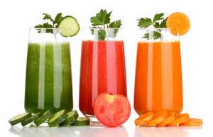

Two-Part Message for you about Healthy You

Part I
Blending For Your Health!

Please join us for a fun Healthy You program on Thursday August 27th in the Houghton Chapel Multifaith Room from 12:30-1:30.

Blending and Juicing....what's the best choice? Both blending and juicing your fruits and vegetables are hot topics right now. Are you wondering what combinations of fruits and vegetables work best? What should you avoid? How often should you have one of these drinks? What about fruit...can it cause you to gain weight? We will cover all of these topics and more. Plus, there will be a few yummy concoctions to taste and recipes for you to try at home.

Rsvp to Sandra Murga at x3289 – space is limited. Hope to see you there!
Part II
Please find attached a Healthy You survey related to the Active You Walking Challenge that completed this past June. Please complete the survey – it will only take you 5 minutes – the deadline is August 24th.

Your feedback will be important as we design the next walking challenge program.

https://www.surveymonkey.com/s/MK78Z3P

Thank you and have a healthy remainder to the summer!

