ACTIVATING YOUR NEW BANK OF AMERICA PROCUREMENT/TRAVEL & ENTERTAINMENT CARDS
Please follow the steps below after you receive your new Bank of America Procurement and/or Travel & Entertainment card:
- Activate Your Card
  - Call the toll-free number 888-233-8855
  - Provide them with your 16-digit credit card number
  - You will need your Verification ID which is your Banner ID with the #9 replacing the alpha character
    - For example if your Banner ID is B12345678, your Verification ID is 912345678
  - Provide them with your office phone number which is associated with this account
    - Note: If you do not have an office number and provided a mobile phone number on your application form instead, please provide that number
- Selecting your PIN number
  - You will be prompted to choose a new 4 digit PIN over the phone
  - You may also access this selected PIN number online at any time through BofAML.com/globalcardaccess
  - Note: If your PIN fails at your first attempted point-of-transaction, you may need to run the charge a second time. Sometimes upon activating the card and choosing a PIN over the phone there is a lag in communication with the bank.

If you forget your PIN and would like to access it online please follow the steps below:
- Log into BofAML.com/globalcardaccess
- Click on “Register New User” button
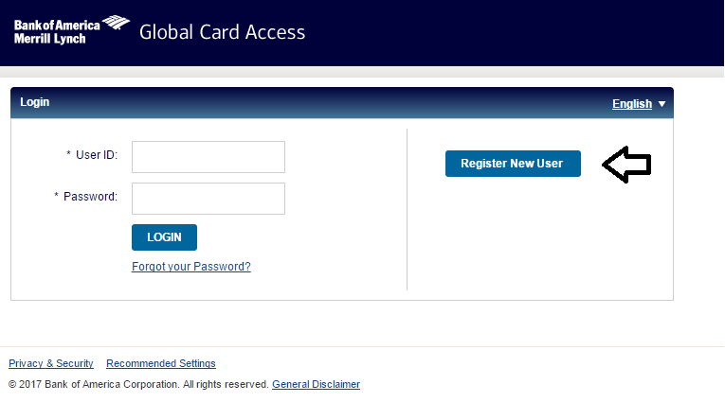

- Enter your 16-digit credit card number and select “I am a Cardholder”. Click “Submit” to continue.
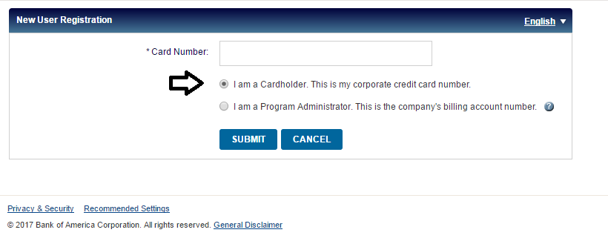
- Enter the Name on Card exactly as it appears on the front of your card, the Expiration Date located on the front of the card, the 3-digit Security Code on the back of your card, and your Verification ID (Banner ID with the #9 replacing the alpha character). Click “Submit” to continue.
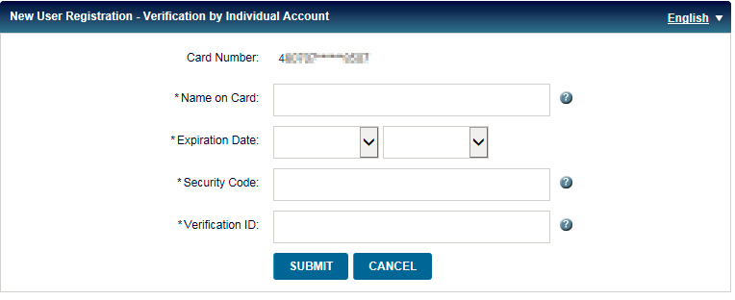

- Create your User ID, Password, and answer 3 security questions. Click “Submit” to continue.
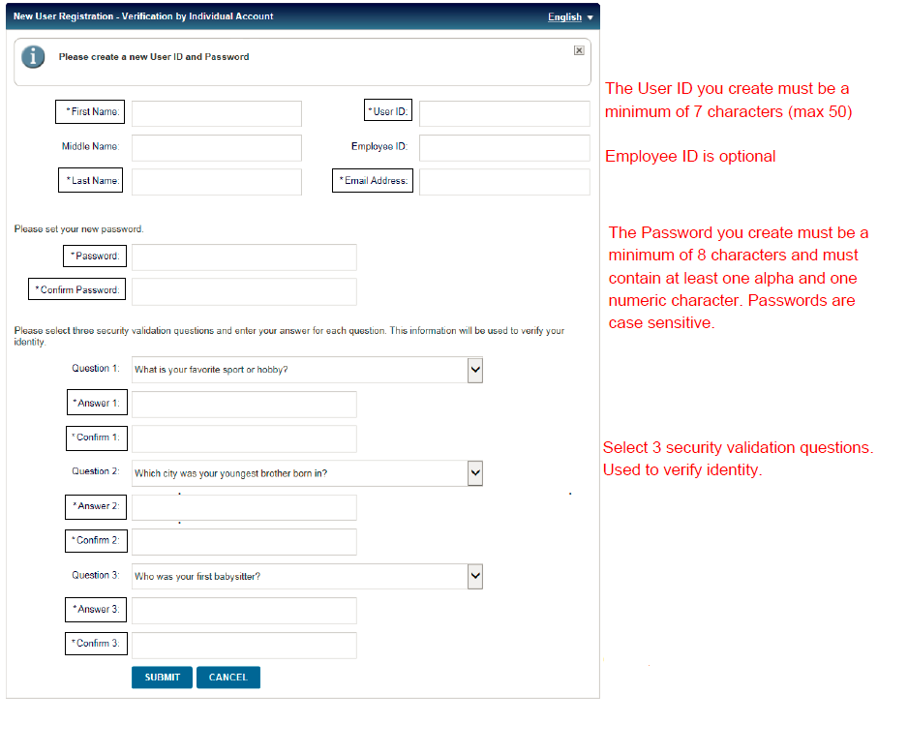

- Click on “Accept” to acknowledge the Terms & Conditions
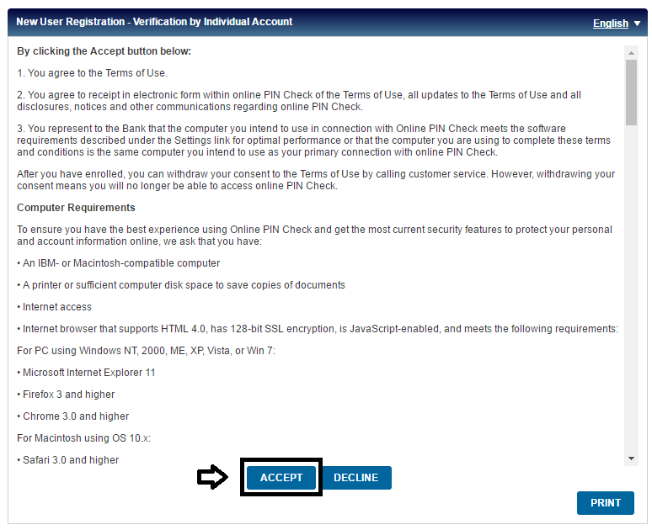
- Your registration is now complete and you should be re-directed to the home screen. Enter the User ID and Password that you just created and click “Login”.
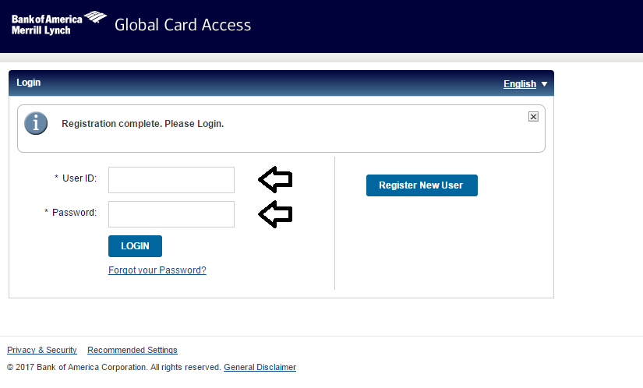

- Answer the security question when prompted. Click “Submit” to continue.
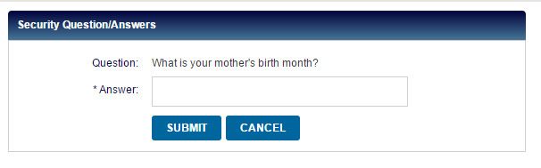
- Click on “Check Your PIN” under “PIN Check”
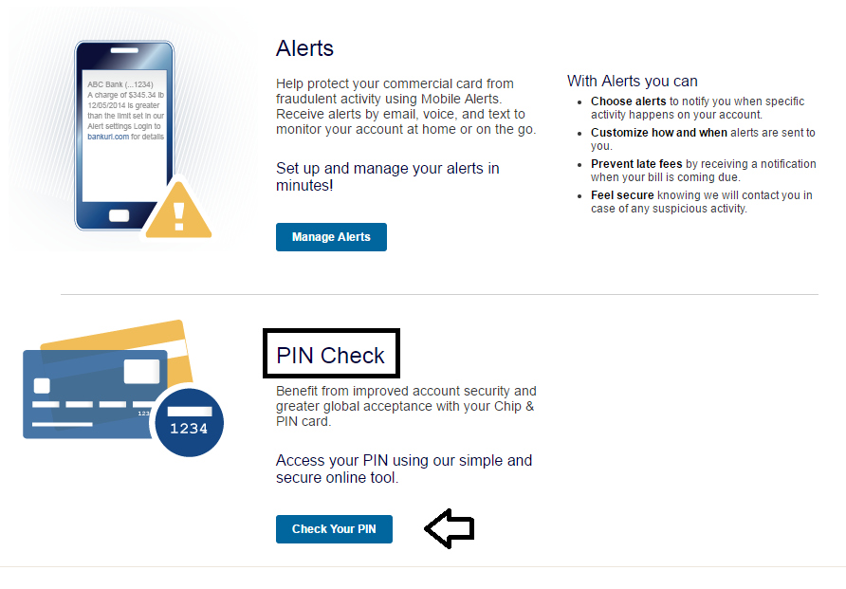

- Enter the 3-digit Security Code found on the back of your card. Click “Submit” to continue.
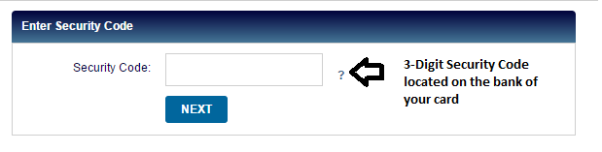
- Click on “Show my PIN”. The PIN number for your card will flash one digit at a time. You can re-enter the security code to view the PIN again.
