VERIFYING TRAVEL & ENTERTAINMENT CARD TRANSACTIONS IN WORKDAY
Please follow the steps below for verifying card transactions on your new BoA T&E card:
- Log into Workday
- On your home page, if you already have this worklet saved, click on “Expenses”
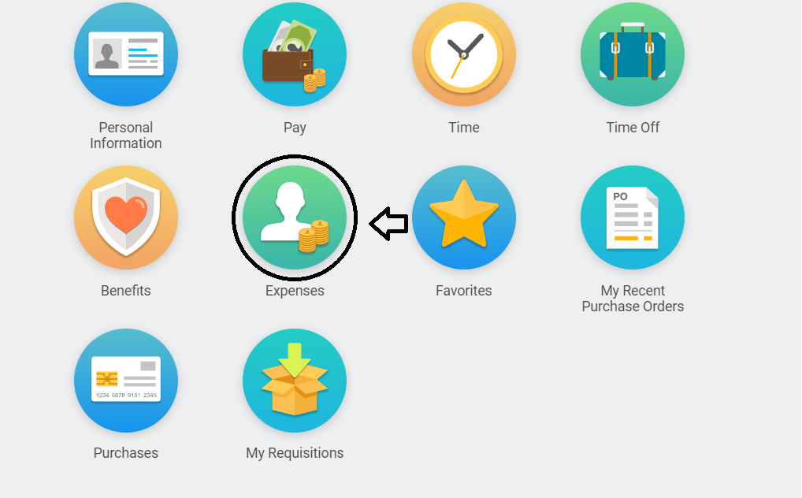
- Under “Actions” in the left-hand column, select “Create Expense Report”
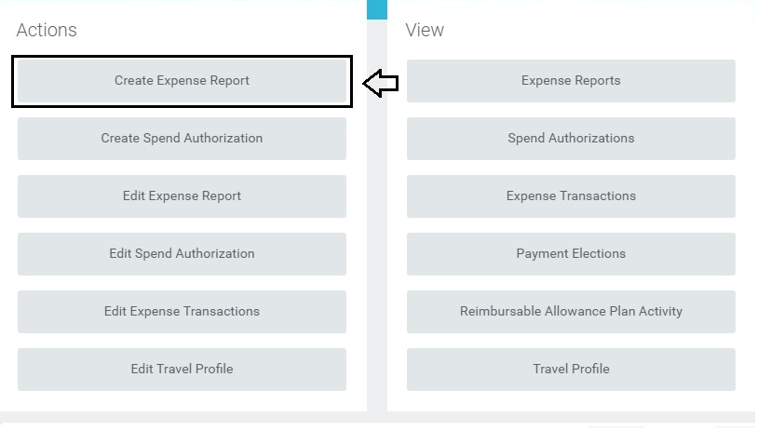
- On your home page, if you do not have any worklets saved, type “Create Expense Report” into the search bar to access the correct screen
- Creation Options will default to “Create New Expense Report”, Company will default to “Wellesley College”, and the Expense Report Date will default to today’s date
- Your default “Cost Center” (this was previously the “Org” in Banner) and your default Fund are automatically populated. Enter the correct “Division” and “Program” numbers.
  - Helpful tip: If you use the available drop-down list, there is only one division and one program that can be selected. This is the correct default one you should select.
  - Note: If you are reallocating to a different Cost Center than your default, please select the new Cost Center first and the rest of the fields will auto-populate.
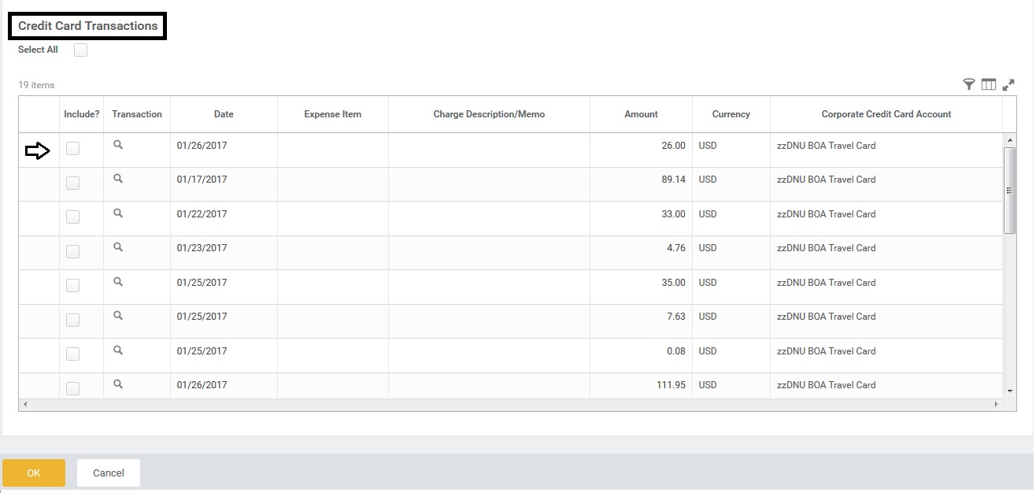
- All of the posted T&E Card transactions will be listed below under “Credit Card Transactions”. Select the transaction(s) you’d like to add to your Travel Expense Report by clicking on the box(es) under the “Include?” column. You may also choose to reallocate all charges at the same time by clicking the “Select All” box. Click OK to continue.
- Under “Expense Report Information” select the correct “Business Purpose” from the available drop-down list.
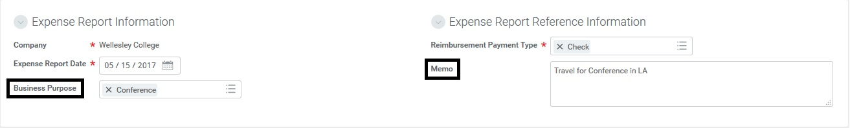
- Under “Expense Report Reference Information” enter the appropriate business description that corresponds to your trip in the “Memo” field.

- Under “Expense Report Line”, select the “Expense Item” from the available drop-down list for your credit card transaction (this is the equivalent to “Spend Category” which is what the “Account” used to be in Banner)
- Under “Item Details”, if the “Expense Item” you selected requires additional information, you will be prompted to provide it.
  - For example, if you select “Airfare-Domestic”, it will require you to also select the Airline, Arrival date, Departure Date, and Class of Service.
- Select the correct Fund, Cost Center, Division, and Program for the transaction
- Attach your receipts by clicking on “Attachments” and selecting or dropping a file from your computer
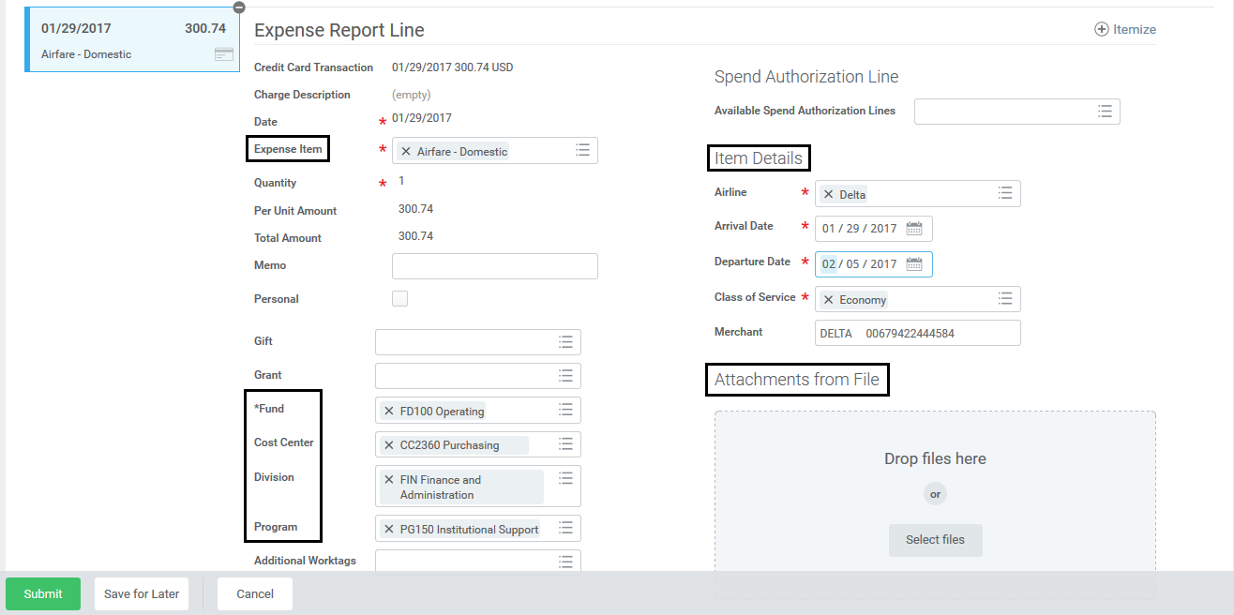
  - Note: Receipts for expense reports can be uploaded per transaction or they can be loaded in bulk at a header level

- Once your report is compete, click “Submit”
- The “Next Step” is for the expense report to be routed to your Supervisor for review

