WORKDAY INFO AND ‘TIPS’
FOR VERIFYING PROCARD AND TRAVELCARD CHARGES.
BULLET POINTS
(Keep reading for the finer details.)

- CHARGE TRANSACTIONS *NEVER* DISAPPEAR IN WORKDAY, THEY JUST MOVE!

- YOU’RE THE CARDHOLDER SO IF YOUR CARD IS LOST/STOLEN, IF YOU SUSPECT A FRAUDULENT CHARGE, OR IF YOUR CARD IS DECLINED, CONTACT THE BANK IMMEDIATELY. (Contact us next.)

- THE ‘PROCESS HISTORY’ TAB IS YOUR FRIEND!

- IF YOU RECEIVE A MONTHLY AUTO-REMINDER LISTING ‘NEW’, ‘DRAFT’, OR ‘IN PROGRESS’ VERIFICATIONS THAT ARE *30+ DAYS PAST THE CHARGE DATE*, YOU MUST VERIFY THESE OR POLITELY CHASE YOUR APPROVERS TO ACT.

- SAVE RECEIPTS ELECTRONICALLY, SAVE THEM IN ONE FOLDER, & RENAME THEM WHEN YOU SAVE THEM. And ONLY ATTACH PDF’S, JPG’S/JPEG’S, OR DOC/DOCX files. (iPhone users take heed and see below!)

- BOTH PROCARDS AND TRAVEL CARDS CARRY RESTRICTIONS. (They share some restrictions; Procards carry more.)

- USE OUR STEP-BY-STEP INSTRUCTIONS (they’re really good and about to get better.) AND SAVE THEM FOR REFERENCE WHEN YOU’RE FILLING OUT YOUR VERIFICATIONS AND EXPENSE REPORTS.

- WHEN CREATING AN EXPENSE REPORT (ER), THE ‘MEMO’ FIELD ON THE 1st PAGE IS THE MEMO FIELD THAT COUNTS. (NOT THE MEMO FIELD ON THE SECOND PAGE.)

- BE PREPARED – WITH YOUR COSTING INFORMATION AND YOUR RECEIPT(S) HANDY, A VERIFICATION TAKES LESS THAN A MINUTE. (Seriously. I used to time them.)

- PROCARD CHARGES ARE LOCATED IN YOUR ‘PURCHASES’ WORKLET; TRAVEL CARD CHARGES ARE LOCATED IN YOUR ‘EXPENSES’ WORKLET.

- THIS PAGE CONTAINS SOME GREAT INFORMATION AND MANY USEFUL LINKS: https://www.wellesley.edu/workday/finance

Charge transactions never disappear, they just move (or you need to scroll down and look for them)!
- If you don’t see a ‘New’/unverified Procard charge that you’re expecting to see in your ‘Purchases’ worklet there are a several possible reasons:
  - the vendor may not have charged your card because the item hasn’t shipped yet; *or*
  - you may have viewed the charge or started the verification, but not submitted it - when this occurs, the status changes from ‘New’ (untouched) status to ‘Draft’ (touched or viewed, but not submitted) status, and it moves to a different location. There are excellent step-by-step instructions on finding, opening, editing, and submitting ‘Draft’ Procard verifications. You can link to these on our website.
- If you don’t see your ‘New’/unverified Travel Card charges in the ‘Expenses’ worklet [they’re located at the bottom of the 1st page of the Expense Report form], they may simply be out of sight.
  - Try scrolling down to see them below your cost center information.
  - If you still can’t find them, they have probably moved into ‘Draft’ status. You can search for them a number of ways. There are excellent step-by-step instructions on finding, opening, editing, and submitting ‘Draft’ Expense Reports. You can link to these on our website.

Your credit card is issued to you by Bank of America (BOA) so they want to hear from you, the Cardholder, not the Purchasing Office.
- If your card is lost or stolen or if you see fraudulent charges in Workday, call the Bank immediately at 888-449-2273 (this number is also provided in the “Procard and Travel Card Policies and Procedures” doc, accessible on our website.) *Next*, email us to let us know you’ve reported the problem.
- If your card is declined online or in person, call the number on the back of the card and ask why. Bank of America’s folks can tell you why it was declined and 90% of the time, put the charge through for you while you’re talking to them.
- If you receive a ‘Fraud Alert’ email from the bank that asks you to call them, call the number on the back of your card. Let us know if, after you speak with them, Bank of America cancels your card and issues you a new one.
- If you have a dispute with the vendor, attempt to resolve it with the vendor. If that’s unsuccessful, you have the option to call number on the back of your card and report the disputed charge to BOA. They will investigate and relative to their findings, refund the purchase price to your card, if the vendor still refuses.
- Please note that the original charge in Workday – the charge you’re disputing - must be verified within 30 days from the charge date regardless of the status of a dispute. (If you subsequently receive a credit from BOA, you’ll verify the charge credit at that time.)

The ‘Process History’ tab is your friend when you want to find out why your ‘In Progress’ verifications haven’t been approved yet.
- Type the verification number (it begins with PC-) or the expense report number (it begins with ER-) into the search box on your Workday homepage and click ‘enter’.
- Click on the search result (the full number that’s linked to the verification/expense report form.)
- Click on the ‘Process History’ tab. You’ll see the history of the verification - where it’s been sent and who has touched it starting with the day and time you submitted it.
- 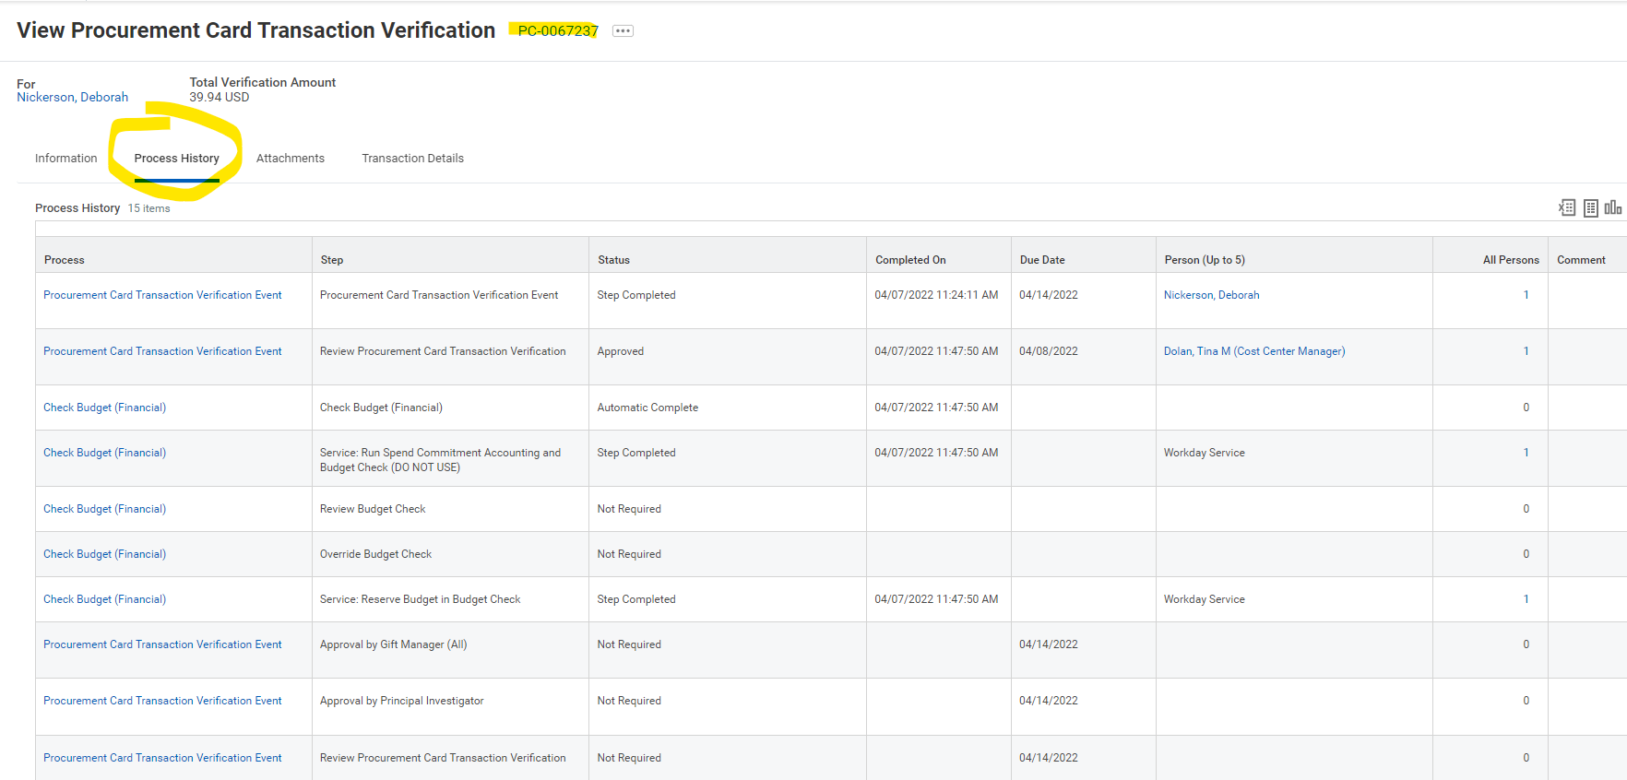
Using this tab can be a game changer. If you’re getting our auto emails and they repeatedly list ‘In Progress’ verifications or Expense Reports of yours, this indicates they have not been approved. By viewing the information in the PC’s or ER’s Process History tab, you can see the name of the person whose action is needed to move it forward and contact them to ask them to take action on it as soon as possible.

Monthly auto-reminders/notifications.
The monthly auto-notifications sent out on our behalf by LTS address all cardholders with unverified charge transactions in Workday whether the the verifications/ER’s are ‘late’ or not.
- All the information you need to find and complete your late transactions is contained in that notice.
- If the charges detailed in the notice are less than 30 days from the date of the charge, it is simply a reminder that you have unverified charges waiting for you and is not a notice that your verifications are ‘late’.
- If unverified charges are listed that are 30+. 60+ or 90+ days beyond the charge date, you need to complete and submit the ‘New’ and ‘Draft’ verifications as well as contact approvers who are not taking action on your ‘In Progress’ verifications and expense reports and ask that they take action on them right away. Exception: purchases made in advance of a trip or event on a Travel Card do not need to be verified 30 days from the charge date – in fact, all trip- or event-related charges should be verified via a single Expense Report after the trip or event has taken place.

Receipts – gather or retrieve them, save them together, and rename them.
When people tell me they spent and hour creating a few expense reports or verifying a handful of Procard charges, 99% of the time they spent 55 of those minutes searching for their receipts and figuring out what cost center or grant number to use. The following recommendations can result in your spending less than a minute per charge.
- Keep all your receipts or paid invoices in one folder.
- Name them using a single, simple naming convention such as “vendor name_purchase date_dollar amount”. For example, “Amazon_9-24-22_39.99”.
- Know what costing information you’re allocating your charges to and have it handy.
- iPhone users: If you plan to submit an image of a receipt and you use an iPhone, first change the phone’s default image setting to insure the resulting image is a JPG/JPEG file, not Apple’s default image file (HEIC). Approver’s down the line using PC’s won’t be able to view the HEIC’s and will send your verification or expense report back.

Both of our cards carry restrictions!
- You can’t use either type of card at cash machines.
- You can’t use either type of card with online payment services like PayPal or Venmo.
- There are more restrictions that cover both cards; See our Procard and Travel Card Policies and Procedures document accessible on the Finance webpage.
- We want Travel Cards to be convenient when you’re on the road, so you can use them to make necessary work-related purchases while you’re traveling. For example, if you need a notebook while you’re at a conference, you can use your Travel card instead of pulling out your Procard. If, however, you are traveling to a destination city in order to buy equipment or artwork for the college, for example, you would bring and use your Procard.
- Transportation, accommodations, and most conference registration charges will be declined if you attempt to charge them to your Procard. They will only be put through on a Travel Card.
- Neither card should be used for purchases of $10,000, or more. Purchases Orders are required for purchases of this size. (If you require an exception, please contact Joe Gibree to discuss your request.)

Travel Cards - exceptions to a ‘rule’ and several things of note.
- Although we require that you submit verifications within 30 days of a charge, there’s an exception. When purchases are made on a Travel Card for a trip or conference, etc., that’s taking place 30 days or later from related charges, you should wait until the trip or event has taken place to submit your expense report. This will allow final charges for all expenses related to a particular business trip or event to be included in a single Expense Report.
- If you put charges on your card that you won’t be able to verify until after the typical 30-day required period, please let me know when you will be traveling and when you expect to be able to submit your Expense Report; you will still receive the automated monthly notices.
- The Memo field on the 1st page of an ER is required; the other Memo field, located on the 2nd page, is not required.
- The Memo field on the 1st page should, using as few words as possible, include three things: the reason for the trip/event, the trip/event dates, and the destination city. Examples: “Baker Conference, 6/2/22-6/6/22, Los Angeles” or “CHEM 101 class dinner w/students, 6/2/22, Wellesley”.

When you need help, don’t hesitate to contact us and provide us with as many details as possible when you do. For example, when someone emails and says “I don’t understand why I’m getting an error message when trying to submit my PC verification” it would be helpful if they would also tell us what the error message says (or include a screenshot of it) and include the PC’s number.

Thanks!
The Purchasing Office Team

