Wellesley College
Spring Semester 2013

Sergio Parussa

ITAS 309
Italian Jewish Literature
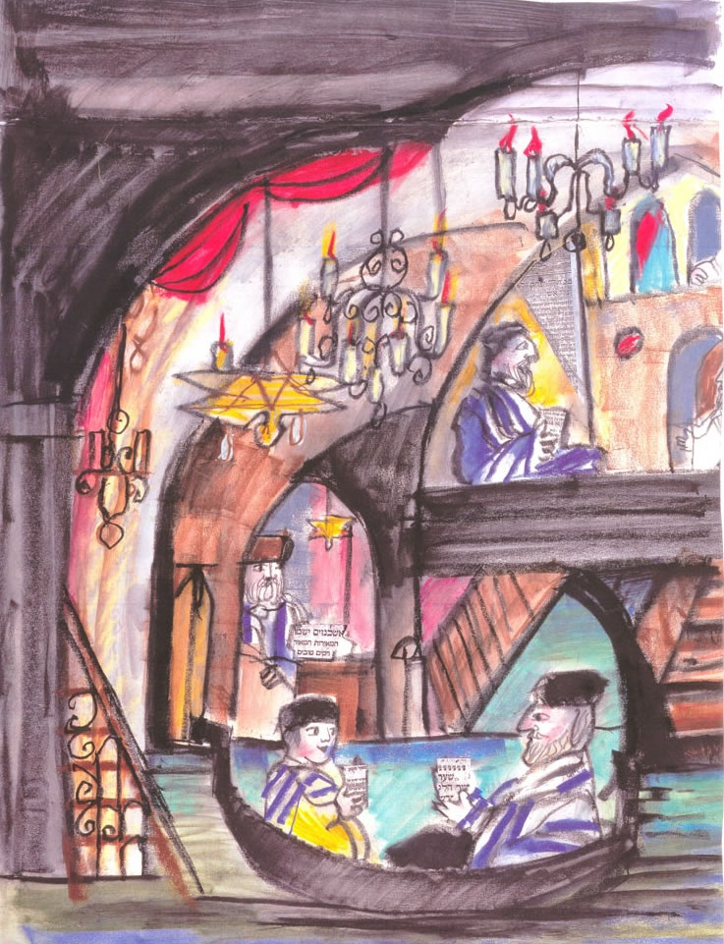
Course Location: T 1:30pm – 4:00pm in Jewett Art Center 452
Office hours: T 9:30am - 10:30am & F 10:00am - 11:00am
and by appointment in Founders 224 B
Phone #: ext. 2879
Email: sparussa@wellesley.edu

This course offers an overview of Italian Jewish culture and literature from the Middle Ages to the present. Students will read prose and poetry, essays and articles, as well as watch films that address issues such as religious and cultural identity, the right to difference, anti-Semitism and the Shoah. The course will also give students an overview of the formation and transformation of the Jewish community in Italian society. In addition to well-known Jewish Italian writers like Primo Levi and Giorgio Bassani, students will read pertinent works by non-Jewish writers like Rosetta Loy.
Texts:
Bassani, Giorgio. Il giardino dei Finzi-Contini. Torino: Einaudi, 1962.
Ginzburg, Natalia. Lessico famigliare. Torino: Einaudi, 1963.
Levi, Primo. Se questo è un uomo. Torino: De Silva, 1947.
Levi, Primo. Il sistema periodico. Torino: Einaudi, 1975.
Loy, Rosetta. La parola ebreo. Torino: Einaudi, 1997.
Millu, Liana. Il fumo di Birkenau. Firenze: Giuntina, 1947.
Parussa, Sergio. Writing as Freedom, Writing as Testimony. Syracuse, NY: SUP, 2008.

The films for the course are available at the reserve desk of the library or on Sakai.

A package of extra texts and articles related to the course subject will be available on Sakai or will be distributed in class during the semester.

Course Requirements:
Attendance and participation.
Attendance is mandatory. Each additional absence after three will affect your final grade.
Even if students miss a class they will be expected to read the material assigned for that week.

Students are expected to write a one-page paper in Italian every week in response to the readings assigned for that week.

The midterm exam will be an in-class written examination in response to a set of general questions on the course's subject.

The final paper may be a longer version of one of the in-class presentation or something completely new. The final paper is due by the end of the exam period.

This is a graded course. Receiving credit in the course means that all work -- especially the mid-term exam, the final paper, and the in-class oral presentations -- be of above the C- level.

For the final grade, preparation, attendance, and participation will count 20%; the mid-term exam 20%; the in-class oral presentation 20%; and the final paper 40%.
This course complies with the Wellesley college policy (http://www.wellesley.edu/Registrar/gradingpolicy_faq.html). While that policy asks faculty to hold each 100- and 200-level course with 10 or more students to an average of no higher than 3.33, it does not require faculty to grade on a "curve." There is no arbitrary limit on the number of As, Bs, Cs etc., and every student will be assigned the grade she earns and deserves according to the grading standards of the college.
Calendario

Settimane Letture

1. Introduzione al corso.
Mar 29 Gennaio What is Jewish Literature?

2. Le origini.
Mar 5 Febbraio Elegia giudeo-italiana.
Writing as Freedom, Writing as Testimony, pp. 1-10.

3. Risorgimento ed Emancipazione.
Mar 12 Febbraio Primo Levi, Il sistema periodico, ‘Argon’ (1975).
Umberto Saba, Ebrei (1956).
Writing as Freedom, Writing as Testimony, pp. 10-40.

4. Fascismo e Antifascismo.
Mar 26 Febbraio Natalia Ginzburg, Lessico famigliare (1963).
Writing as Freedom, Writing as Testimony, pp. 62-93.

5. Antisemitismo.
Mar 5 Marzo Giorgio Bassani, Gli occhiali d’oro (1958).
P. Levi, Il sistema periodico, ‘Zinco,’ ‘Ferro’ (1975).
Writing as Freedom, Writing as Testimony, pp. 94-115.

6
Mar 12 Marzo Esame di Mid-Term in classe.

Spring Break (Sabato 16 Marzo – Domenica 24 Marzo)

7. La memoria.
Mar 26 Marzo Giorgio Bassani, Il giardino dei Finzi-Contini (1962).
Vittorio De Sica, Il giardino dei Finzi-Contini (1970).
Writing as Freedom, Writing as Testimony, pp. 116-131.

8. Shoah I.
Mar 2 Aprile Primo Levi, Se questo è un uomo (1947).
Giorgio Bassani, Una notte del ’43 (1956).
Florestano Vancini, La lunga notte del ’43 (1970).
Presentazioni in classe.

9 Shoah II.
Mar 9 Aprile Liana Millu, Il fumo di Birkenau (1947).
Primo Levi, Ad ora incerta (1984).
Presentazioni in classe.

10. La Shoah e il cinema.
Mar 16 Aprile Gillo Pontecorvo, Kapò (1959).
Liliana Cavani, Il portiere di notte (1974).
Primo Levi, I sommersi e i salvati, pp. (1986).
Presentazioni in classe.

11. Ebrei e Cristiani.
Mar 23 Aprile Rosetta Loy, La parola ebreo (1997).
Presentazioni in classe.

12. Ebrei e Cristiani.
Mar 30 Aprile Noi ricordiamo: una riflessione sulla Shoah (1998).
Presentazioni in classe.

13.
Mar 7 Maggio Presentazioni in classe.

Reading period: 9 - 12 May
Final papers due by 4:00pm on May 17

