How to report your Stripe.com Codes to AlumniMagnet
The MyWellesley Community software, AlumniMagnet (AM), allows clubs, classes and shared identity groups (SIGs) to have their membership and store purchases go directly to their own bank accounts. To do this, the treasurer of each group has to sign up for an account on Stripe.com and send the codes to rmarshal@wellesley.edu so she can forward them to AM for installation. You will need an email address that you can pass on to the next treasurer. We suggest going to gmail.com and creating a generic account for your group, like WCChicago@gmail.com)
1. Gather Your Information
Before starting your Stripe setup, you’ll need to setup a bank account for your group that you can pass off to someone when you are no longer the treasurer. (If you need further instructions, please contact the Alumnae Association at 781-283-2331). Once you have your account you’ll need:
      - Your ABA routing number
      - Your account number
      - Your EIN number

- Create Your Account
Go to http://www.stripe.com. On the lower left part of the page you will see a green button that says Create Account.

A box that says Create your Stripe account at the top will pop up.
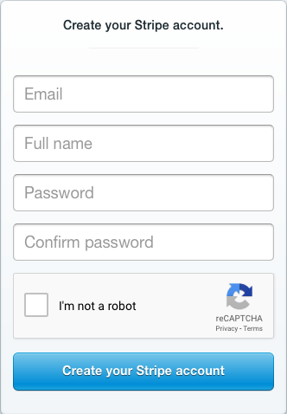

Add your email address (Please see the first paragraph about setting up your email address), Full name, Password and confirm your password. Make sure your password is something that contains upper case and lower case letters as well as numbers. It’s very important that you remember your password and that you use a password that you are willing to give to the next treasurer. Please be sure to share the password the president of your club, class or SIG in case you forget it. Click on the box that says “I’m not a robot” and follow the instructions to choose the correct images. Then click on Create your Stripe account.
This will take you straight to your dashboard.
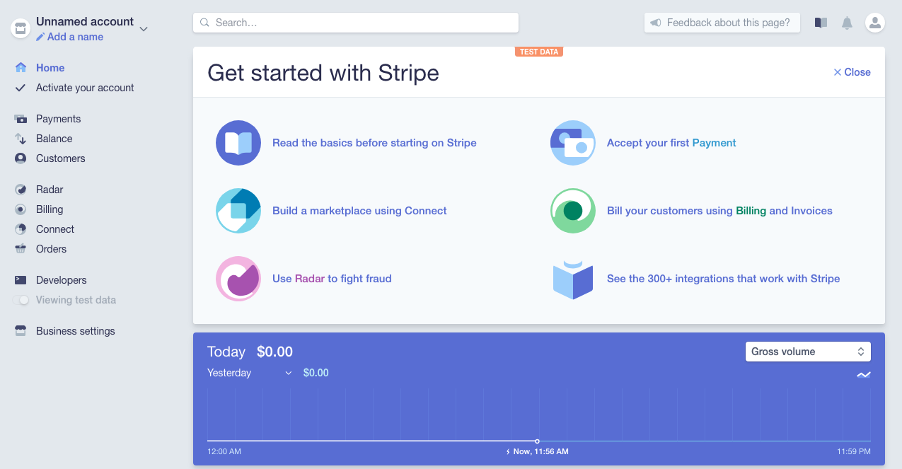

From your Dashboard, you will want to click on Activate Account on the left hand side.
This will bring you to a page where you are going to put in your information. The first dropdown is where you set your country. If you are not in the United States, please talk to the Alumnae Association before proceeding.
Please enter your Business address in the spaces provided. This is the address that appears on your club, class or SIG checks. Then proceed to Type of Business and choose Nonprofit organization from the dropdown. You will need to fill in the all of the fields on this page and then click Submit Application at the bottom.

Next go to Business Settings on the left hand side toward the bottom and in the second section called Credit Card Statement Details (see below) enter how you would like the name of your club, class, or SIG to appear on the credit card statement when someone makes an order and the phone number. For the phone number, please put the phone number of the Director of Alumnae Engagement Programs, 781-283-2334. That is the number someone will call if they don’t understand a charge. The Alumnae Association will answer the question or forward the question to you or whomever the current treasurer is for your group.
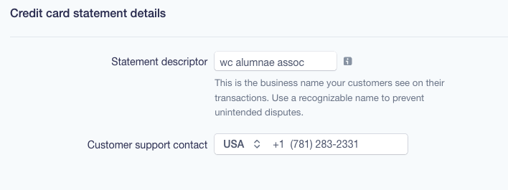
- Give your API Keys to the WCAA
Now that you’ve activated your account, you need to give the WCAA the live keys and test keys. Click on Developers on the left hand column and then choose API Keys.

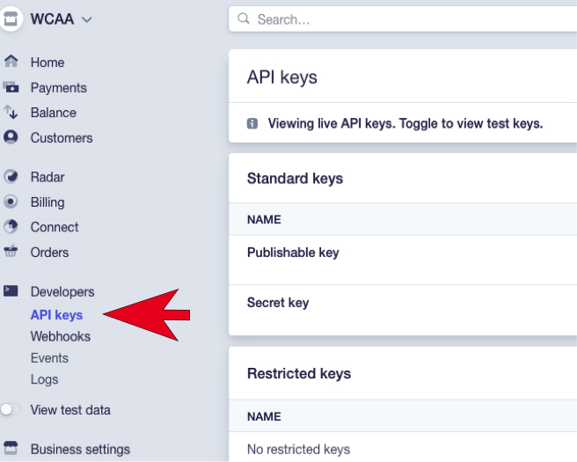

That will bring up your keys. Please copy (Don’t screen shot the page. You need to copy the text in the box) the keys (Live Secret Key and Live Publishable Key) and send them to rmarshal@wellesley.edu. They will be installed within a couple of days.

- Activating your account
You may find that your account is in test mode. If this happens you will need to make it live. Just change it from Test to Live.

