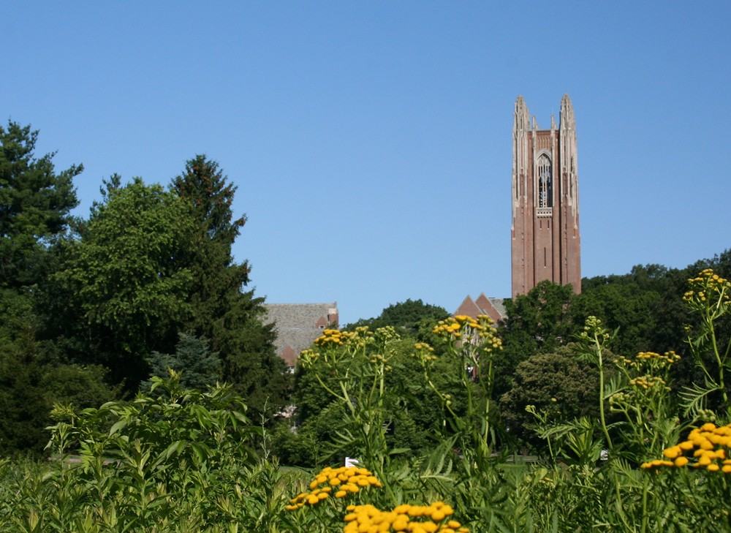



Wellesley College Alumnae Association

106 Central Street

Green Hall, Rm 246

Wellesley, MA 02481

Insert Text Here