Table of Contents

Welcome to the Department of English and Creative Writing 2

New Courses 4

Course Descriptions 5

Major and Minor Requirements 37

Honors 39

Directions for Sophomores Planning to Major in English or English and Creative Writing 40

People:
English Department Administration 41

Faculty Bios 42

March 23, 2018

Welcome to the Department of English and Creative Writing!

Read, Write, Create.

These three words reflect the core activities of our discipline. They also inform the change, as of Spring 2018, in the department name to include Creative Writing, because they express our conviction that the discipline of literary study brings together critical and creative modes of writing and thought. Fundamentally, the discipline stresses the intensive study of writers and their works in literary, cultural, and historical contexts. It is keyed to the appreciation and analysis of literary language, through which writers compose and organize their poems, stories, novels, plays, and essays. The discipline equally stresses writing critically and creatively in response to reading literature.

We thus offer a wide range of courses: introductory courses in literary and writing skills; more advanced courses in influential writers, historical periods, and themes in English, American, and world literatures in English; and numerous courses in creative writing, including screenwriting and creative nonfiction.

Our course offerings strike a balance between great authors of past centuries and emerging fields of study. We teach courses on writers such as Shakespeare, Milton, Jane Austen, and James Joyce, and on Asian American literature, writers from the Indian subcontinent, and film. We stress analysis and argument in paper-writing, critical thinking, and literary research, and we foster and develop a deep, complex, passionate response to literature.

This booklet is designed to help you with the selection of courses in the English department and, if you choose, with the construction of a major or minor in English. To that end, it contains longer and more informative descriptions of each course than will fit into the Wellesley College Course Catalog. It also contains a detailed list of major and minor requirements, a page of “Directions for Sophomores Planning an English or English and Creative Writing Major,” a schedule of course times, and brief statements in which each member of the faculty describes his or her special area of teaching and research.

Please don’t hesitate to call on the Chair (Yu Jin Ko) or on any member of the department for further discussion of these matters or to ask any other questions you may have about the department or the major.

A few more, introductory facts about the structure of the English curriculum:

1) At the 100 level, we offer a variety of courses that serve as a gateway to the study of literature and writing.

- 103: Beyond Borders: Writers of Color Across the Globe, 106: Harry Potter’s 19th Century, 112: Introduction to Shakespeare, 115: Great Works of Poetry, and 117: Musical Theater are
open to all students. These courses are designed especially for non-majors, though prospective majors are also welcome to take them. They offer an introduction to the college-level discussion of important literary works and topics.
- 120: Critical Interpretation is a multi-section course, with a maximum of twenty students per section. It too is open to all students, but is required of all English and English and Creative Writing majors. Its chief goal is to teach students the skills, and the pleasures, of critical reading and writing, through the close and leisurely study of poems, drama, and fiction, and frequent written assignments. ENG 120/WRIT 105 satisfies both the First-Year Writing requirement and the Critical Interpretation requirement of the English major; includes a third session each week.
- 150: First-Year Seminar is a limited-enrollment, changing topic course for first-year students that links the close reading of literature with developments in intellectual history.

2) Our 200-level courses represent a collective survey of English, American, and world literature in English history from the Middle Ages through the late 20th century (and early 21st), each covering a part of that vast territory. Most of these courses are open to all students, without prerequisite. Many courses at the 200-level are perfectly appropriate ways to begin the college level study of literature. In order to make a more educated guess about whether a particular course is right for you, you should talk to the instructor

3) Our 300-level courses are diverse, and many change topics every year. This booklet is especially important as a guide to them. They include courses on particular topics in the major periods of English literature, but also courses on themes and topics that link together works from more than one period and more than one place. We offer, for example, ENG 320 Literary Cross Currents, ENG 324 Advanced Studies in Shakespeare, and ENG 345 Advanced Studies in Nineteenth-Century Literature. ENG 382 (Literary Theory) belongs to neither group; it is an introduction to literary theory, remaining pretty much the same from year to year, and is especially recommended to students thinking of going to graduate school. The 300-level courses are open to all students who have taken two literature courses in the department, at least one of which must be 200 level, or by permission of the instructor.

4) Last but not least, we offer a number of creative writing courses. At the 200 level, we offer courses in poetry, fiction, screenwriting, and creative non-fiction (English 206). At the 300 level, we offer advanced courses in poetry and fiction.

We invite you stay abreast of department news by joining our two Google groups, English Dept. Announcements and Creative Writing Opportunities and Announcements. We hope you'll come to the department’s lectures, events, and parties, and to our ongoing colloquium series, at which faculty present recent research or lead discussions on interesting topics in literature and film.

Connect with us on Facebook (Wellesley College English Department) and Twitter (@WellesleyENG), too, to keep abreast of department news.
New Courses

We call your attention to the following new courses and newly cross-listed courses:

- ENG 246 Victorians, Decadents, and the Beginnings of Modern Poetry
- ENG 258/ Gotham: New York City in Literature, Art, and Film
AMST 258
- ENG 280 The Poetry of Frank Bidart
- ENG 294 Writing AIDS, 1981-Present
- ENG 316 Calderwood Seminar: Dead Poetry Society
- ENG 341 Sisters, Brothers, and Lovers: Sibling Relationships in Romantic
Literature
- ENG 348 Jane Austen and Anthony Trollope
- ENG 357 The World of Emily Dickinson
- ENG 383/ Women in Love: American Literature, Art, Photography, Film
AMST 383

Note: Courses marked with a double dagger (‡) satisfy both the pre-1800 and pre-1900 requirements. Courses marked with a single dagger (†) satisfy the pre-1900 requirement. Courses marked with a looped square (⌘) satisfy the Diversity of Literatures in English requirement (see description of the Diversity of Literatures in English on pp. 37 and 38.)

Please consult the course browser for course prerequisites and distributions.

Faculty for 2018-2019:

Bidart | Gonzalez | Lynch (Fall) | Rosenwald | Wall-Randell
Brogan | Hickey | Meyer (Spring) | Sabin (Fall) | Whitaker
Cain | Ko (Chair) | Noggle | Shetley
Cezair-Thompson | Holmes | Peltason (Spring) | Smee (Fall)
Chiasson | Lee | Rodensky | Sides

Course Descriptions

ENG 103/CPLT 113 (1) BEYOND BORDERS: WRITERS OF COLOR
ACROSS THE GLOBE
(⌘)
Mr. Ko

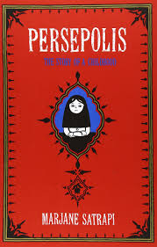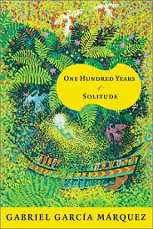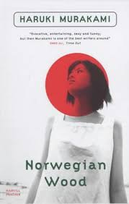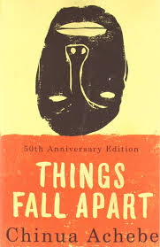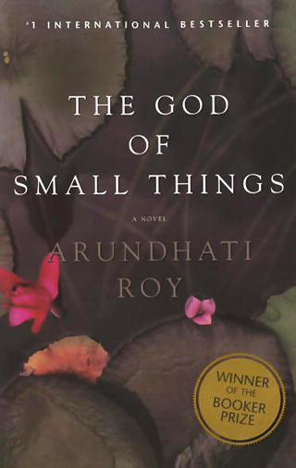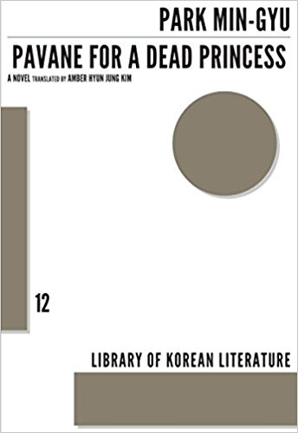

This course takes a whirlwind tour of the world through the imaginative literature of writers of color across the globe. Although each work will provide a distinct and exhilarating experience, a number of overlapping threads will connect the works in various ways: generational change and conflict amidst cross-cultural encounters; evolving ideas of love and identity; the persistence of suffering, among others. The syllabus will likely include the following works: Chinua Achebe's Things Fall Apart; Gabriel Garcia Marquez's One Hundred Years of Solitude; Haruki Murakami's Japanese love song to youth and the Beatles, Norwegian Wood; Marjane Satrapi's graphic novel of an Iranian childhood, Persepolis; the Indian writer Arundhati Roy's God of Small Things, and Min-Gyu Park's contemporary novel about Korea, Pavane for a Dead Princess. Fulfills the Diversity of Literatures in English requirement.

Students may register for either ENG 103 or CPLT 113 and credit will be granted accordingly.
ENG 112 (2) INTRODUCTION TO SHAKESPEARE
Mr. Peltason

Shakespeare wrote for a popular audience and was immensely successful. Shakespeare is also universally regarded as the greatest playwright in English. In this introduction to his works, we will try to understand both Shakespeare’s popularity and greatness. To help us reach this understanding, we will focus especially on the theatrical nature of Shakespeare’s writing. The syllabus will likely be as follows: Romeo and Juliet, A Midsummer Night’s Dream, Twelfth Night, Othello, King Lear, and The Winter’s Tale.
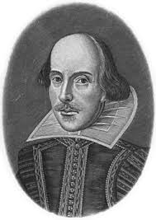

Prerequisite: None. Especially designed for the non-major and thus not writing-intensive. It does not fulfill the Shakespeare requirement for English majors.

ENG 115 (1) GREAT WORKS OF POETRY
Mr. Bidart

We live in a culture that has lost any collective agreement or wisdom about what a poem is, or why we read poetry. Yet many of the greatest things ever written are poems. How can we read poems so that we experience them as brilliantly made things, as powerful, seductive works of art? This course will look at great poems from the whole history of poetry in English (and at some poems in translation). Why read poetry? This course attempts to tackle that question head-on, with an emphasis on the pleasure and insight great art brings.

Mandatory credit/noncredit.

ENG 116/AMST 116 (2) ASIAN AMERICAN FICTION
(⌘)
Ms. Lee

At various times over the past century and a half, the American nation has welcomed, expelled, tolerated, interned, ignored, and celebrated immigrants from Asia and their descendants. This course examines the fictions produced in response to these experiences. Irony, humor, history, tragedy and mystery all find a place in Asian American literature. We will see the emergence of a self-conscious Asian American identity, as well as more recent transnational structures of
feeling. We will read novels and short stories by writers including Jhumpa Lahiri, Ha Jin, Le Thi Diem Thuy, Maxine Hong Kingston, Chang-rae Lee, and Julie Otsuka. Fulfills the Diversity of Literatures in English requirement.

ENG 120 (1) (2) CRITICAL INTERPRETATION
Mr. Chiasson, Mr. Noggle, Mr. Cain

English 120 introduces students to a level of interpretative sophistication and techniques of analysis essential not just in literary study but in all courses that demand advanced engagement with language. In active discussions, sections perform detailed readings of poetry drawn from a range of historical periods, with the aim of developing an understanding of the richness and complexity of poetic language and of connections between form and content, text and cultural
and historical context. The reading varies from section to section, but all sections involve learning to read closely and to write persuasively and elegantly. Required of English majors and minors.

ENG 120/WRIT 105 (1) (2) CRITICAL INTERPRETATION
Ms. Wall-Randell, Mr. Rosenwald, Ms. Brogan

English 120 introduces students to a level of interpretative sophistication and techniques of analysis essential not just in literary study but in all courses that demand advanced engagement with language. In active discussions, sections perform detailed readings of poetry drawn from a range of historical periods, with the aim of developing an understanding of the richness and complexity of poetic language and of connections between form and content, text and cultural and historical context. The reading varies from section to section, but all sections involve learning to read closely and to write persuasively and elegantly. Required of English majors and minors.

This course satisfies both the First-Year Writing requirement and the Critical Interpretation requirement of the English major. Includes a third session each week.

Open only to first-year students.

ENG 150Y (1) FIRST YEAR SEMINAR: CREATING MEMORY
Ms. Hickey



What do we remember and why? How are memories created, coded, and stored? To what extent can we choose or shape our memories? What part does memory play in constituting a self, creating a “story” of oneself? Does memory constitute identity? How has technology altered what and how we remember? How does memory—individual or collective—behave in response to shocking or traumatic events?

As we ponder such questions, we’ll cultivate an awareness of the insights afforded by philosophy, psychology, and cognitive science. Our primary focus, though, will be on works of literature by a range of authors, including Shakespeare, William Wordsworth, Emily Brontë, Christina Rossetti, Marcel Proust, Sir Arthur Conan Doyle, Virginia Woolf, Jorge Luis Borges, Vladimir Nabokov, Seamus Heaney, Toni Morrison, and Li-Young Lee.

As a student in this seminar, you’ll be invited to write in several genres (creative, critical, reflective, documentary); to learn from guest lectures by Wellesley science, humanities, and social science faculty; to explore creative arts such as music, theater, drawing, photography, painting, sculpture, book arts, film, or television; to visit Wellesley College Library’s Special Collections and Book Arts Lab; and to experiment with different ways of collecting, curating, and presenting memories.

Open only to first-year students.
ENG 180/CPLT 180 (2) WHAT IS WORLD LITERATURE?
(⌘)
Ms. Sides

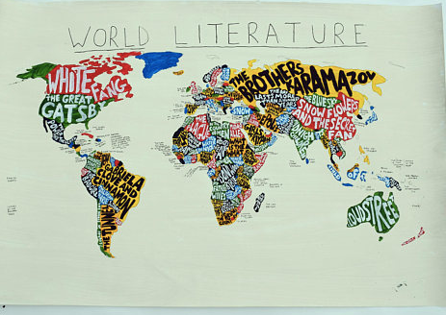

“World Literature” views a literary work as the product of local culture, then of regional or national culture, and finally of global culture. Critics of world literature argue that a text’s richness may be lost in translation, that too often a privileged Western literary tradition forces “other” literatures into a relationship of belatedness and inferiority, and that world literature leads to the globalization of culture—and as the global language becomes predominantly English, the world of literature will be known through that single language alone. This course offers an opportunity to not only read rich and exciting literary texts from ancient eras to the contemporary moment but also after reading key critical essays that defend and critique “World Literature” to reflect on the cultural politics that directly or indirectly determines who reads what. Range of texts from contemporary Arabic short fiction, science fiction from China and Africa, global gothic fiction, and poetic forms across time and cultures--sonnets and haikus. Fulfills the Diversity of Literatures in English requirement.

Students may register for either ENG 180 or CPLT 180 and credit will be granted accordingly.

ENG 202 (2) Poetry
Mr. Chiasson

The student who enjoys poetry but has always been shy of writing should feel free to take this course. I assume that you may or may not have written before, but have wanted to write and felt a serious audience would be helpful.

Class periods will be devoted to reading the poems written by members of the class, as well as published poems that seem relevant or illuminating in relation to student work.

Enrollment limited to 15. Mandatory credit/noncredit. Students who have taken this course once may register for it one additional time.

ENG 203 (1) (2) SHORT NARRATIVE
Ms. Holmes, Ms. Cezair-Thompson

This workshop is designed for students who are interested in discovering the mystery and mechanics of prose fiction. Members will write and revise short stories in the range of 5-7 pages and discuss them in class. Assignments will include the close reading of short fiction by established writers, oral storytelling, character sketches and storyboarding. However, the focus of the workshop will be the work generated by its members.

Enrollment limited to 15. Mandatory credit/noncredit. Students who have taken this course once may register for it one additional time.

ENG 203 (1) SHORT NARRATIVE
Ms. Sides

This course requires the full immersion of each writer into immediately producing her own stories. From even the most hazy first draft, we will work on finding the pulse of each story and then bringing that story into sharp focus. During the semester, each student will write two short stories (10-16 pages) and one short-short story (1-5 pages). One stipulation: I want all work to be produced during the semester; please don't come armed with stories you have already written. Everyone will have a chance to present their stories in the class workshop and to work in small
writing groups. To remind us of the amazing variety of the short story form, we will look closely, in a writerly way, at stories by favorite authors, old and new.

Enrollment limited to 15. Mandatory credit/noncredit. Students who have taken this course once may register for it one additional time.

ENG 204/CAMS 234 (1) THE ART OF SCREENWRITING
Ms. Cezair-Thompson

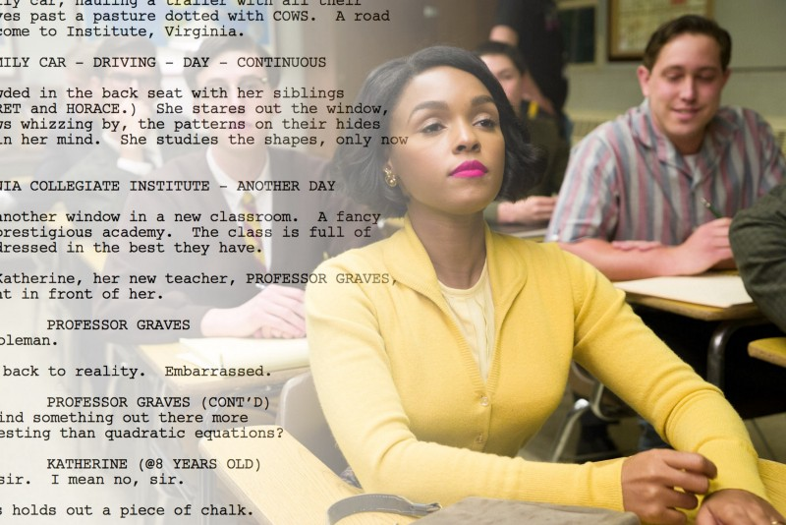
A creative writing course for those interested in learning how to write films of various genres, including but not limited to drama, suspense, horror, sci-fi, and romantic comedy. This course focuses primarily on feature-length films as well as screen adaptations of literary works. However, students who are particularly interested in writing the Short Film will have the opportunity to develop this skill. You will also be introduced to some of the business aspects of screenwriting, e.g. pitching film ideas to producers and collaborating on pre-script
development. Students will watch several films, read screenplays, participate in workshops, and complete two screenwriting projects.

Students may register for either ENG 204 or CAMS 234 and credit will be granted accordingly. Students who have taken this course once may register for it one additional time.
Prerequisite: None. Recommended for students interested in film, drama, creative writing.

Enrollment limited to 15. Mandatory credit/noncredit.

ENG 205 (2) Writing for Children
Ms. Meyer
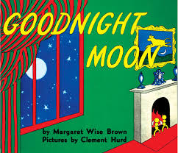
What makes for excellence in writing for children? When Margaret Wise Brown repeats the word “moon” in two subsequent pages—“Goodnight moon. Goodnight cow jumping over the moon”—is this effective or clunky? What makes rhyme and repetition funny and compelling in one picture book (such as Rosemary Wells’s Noisy Nora) but vapid in another? How does E.B. White establish Fern’s character in the opening chapter of Charlotte’s Web? What makes Cynthia Kadohata’s Kira-Kira a novel for children rather than adults—or is it one? In this course, students will study many examples of children’s literature from the point of view of writers and will write their own short children’s fiction (picture book texts, middle-reader or young adult short stories) and share them in workshops. Enrollment limited to 15 students. Mandatory credit/noncredit.

ENG 206 (1) Nonfiction Writing
Ms. Holmes
Topic for 2018-19: Memoir

A workshop course on the study and practice of memoir, with the goal of making the autobiographical stories that matter to us, matter to our readers. We’ll focus on the essentials of memoir: generating and evaluating material, and developing voice, character, sensory details, structure, plot, conflict and tension, and scenes and dialogue. You’ll write two autobiographical stories, and then revise one. We’ll workshop each story as a class, and learn how to critique others’ work in order to better draft and revise our own work.

Enrollment limited to 15. Mandatory credit/noncredit.

ENG 206 (2) Nonfiction Writing
Ms. Sides
Topic for 2018-19: Writing the Travel Essay



Taken a trip lately—junior year abroad, summer vacation, spring break? Look back fondly or in horror at a family road trip? Turn your experience into a travel essay. We will be studying both the genre of the literary travel essay and the more journalistic travel articles appearing in newspaper and magazine travel sections and writing our own travel narratives. The course focuses on the essentials of travel writing: evocation of place, a sophisticated appreciation of cultural differences, a considered use of the first person (travel narratives are closely related to the genre of memoir), and basic strong writing/research skills.

Texts: Best American Travel Writing
Lonely Planet Guide to Travel Writing

Enrollment limited to 15. Mandatory credit/noncredit.

ENG 208/CAMS 208 (2) WRITING FOR TELEVISION
Ms. Holmes

A workshop course on writing the television script, including original pilots and episodes of existing shows. We’ll study both one-hour dramas and half-hour comedies, and practice the basics of script format, visual description, episode structure, and character and story development. Students will complete a final portfolio of 30-50 minutes (pages) of teleplay.

Enrollment limited to 15. Mandatory credit/noncredit.

Students may register for either ENG 208 or CAMS 208 and credit will be granted accordingly.

ENG 210 (2) THE HISTORY OF THE ENGLISH LANGUAGE:
“The perfection, the beauty, the grandeur & sublimity”
(‡)
Mr. Whitaker

In 1774, an anonymous author wrote of “the perfection, the beauty, the grandeur & sublimity” to which Americans would direct the English language. The author may or may not have been future president John Adams, but we know that Adams did advance a similar idea some years later. The notions that Americans could and would perfect the English language and that the process was already well underway were very much in the air. Sentiments like these have persisted, and they have resulted in a powerful sense that our English is the English. On the contrary, in this course we will explore the complex conclusion that American English is not “perfect” and that it is but one English among many. We will discover that even within America a great variety of Englishes coexist. We will consider, among other varieties, African American Vernacular English and Appalachian English along with their influences on so-called Standard American English. We will achieve a new appreciation of modern English by becoming familiar with the methods of historical linguistics as well as by considering the historical changes that have contributed to English’s modern variations. We will study Old English, later medieval
English, the early modern English of Shakespeare’s day, and the varying Englishes of the modern British isles as well as those of modern America. We will read linguistic and literary histories along with literary passages from multiple times and places. We will ask, how does the history of the language affect our views of the world and our selves? And how are we continually shaping English’s future?

ENG 213 (1) CHAUCER: COMMUNITY, DISSENT, AND DIFFERENCE
IN THE LATE MIDDLE AGES
(‡)
Mr. Whitaker

What happens to the medieval Christian community when the unity of the Church breaks down? How does a narrative position its author and its characters within contemporary political controversy? Which characters are inside the traditional bounds of community? Which are outside? And how should we interpret the differences between them? In this course, we will
examine these and other questions about medieval English literature and culture through the lens of Chaucer’s Canterbury Tales and other writings. The course will focus on Middle English language and poetics as well as medieval structures of community—political, cultural, economic, and religious. For example, we will thoughtfully consider the engagement of Chaucer’s work with the fourteenth century’s Wycliffite heresy, a radical movement that challenged the English Catholic Church’s ability to properly administer sacraments such as baptism, Eucharist, and marriage.

ENG 216 (2) A SURVEY OF ENGLISH LITERATURE
(‡)
Mr. Noggle

Medieval, Renaissance, Eighteenth Century, Romantic, Victorian: these identify the major historical areas that organize English literary study. This course will survey foundational texts—prose, drama, poems—to which readers have turned over the centuries to understand the meanings of English literature. For all students who want a synoptic view of literary history, it offers prospective and beginning English majors (including first-years) a chance to explore possibilities for future study; helps students concluding their majors place what they’ve already learned in a continuous historical context; and provides non-majors with an overview of what
English literature is all about. We will start with Beowulf, read some narrative medieval poets including Chaucer, sample major Renaissance works such as Milton’s Paradise Lost, study eighteenth-century satire and Romantic poetry, and conclude with great works of the Victorian age.

ENG 223 (1) SHAKESPEARE I -- THE ELIZABETHAN PERIOD
Ms. Wall-Randell

The formative period of Shakespeare's genius: comedies such as A Midsummer Night's Dream and The Merchant of Venice; histories such as Richard II and Henry IV (Part I); and tragedies such as Julius Caesar and Hamlet. We will undertake detailed study of Shakespeare's poetic language and will examine the dramatic form of the plays and the performance practices of Shakespeare's time. We will also explore important themes, ranging from gender relations and identities to national self-consciousness. The viewing and analysis of contemporary performances and films will be integrated into the work of the course.

ENG 224 (2) SHAKESPEARE II -- THE JACOBEAN PERIOD
Mr. Ko

The great tragedies and the redemptive romances from the second half of Shakespeare's career, which include Troilus and Cressida, Measure for Measure, Othello, King Lear, Coriolanus, Antony and Cleopatra, Cymbeline, The Winter's Tale, and The Tempest. While encompassing thematic concerns ranging from gender relations to the meaning of heroism, particular focus will fall on tragic form and its transformation in the romances. Extensive attention will be paid to theatrical practices, Shakespearean and contemporary, aided by the viewing of stage performances and film adaptations.

ENG 227 (1) MILTON
(‡)
Mr. Noggle

At the heart of this course will be a study of Milton's great epic poem, Paradise Lost, and some of its encyclopedic concerns: the place of humankind in the universe, the idea of obedience, the subjectivity of women, even the issue of literary adaptation itself. But Milton was a keen student of the whole spectrum of Renaissance forms, mastering and redefining them in virtuoso turns: religious psalms, lyric poetry ("L'Allegro," "Il Penseroso"), elegy ("Lycidas"), courtly entertainment (Comus), tragedy (Samson Agonistes), polemic (Areopagitica). Since Milton's career was so intertwined with the extraordinary times he lived in—the English Civil War and the restoration of the monarchy—we'll consider his historical and cultural context, and read some of his radical and startlingly "modern" political writings.

We'll also consider Milton's "afterlives," as an inspiration to the Puritan colonizers of America and to its nationalist revolutionaries, as an influence on the poets of the Romantic period.

Requirements: Two short papers, a midterm, a longer final paper, and a memorization/recitation exercise.

ENG 234 (2) RESTORATION AND EIGHTEENTH CENTURY
BRITISH LITERATURE
(‡)
Mr. Noggle

This course will explore the richness of Restoration and eighteenth-century British literature by focusing on three related areas: its use of humor, sometimes genteel and subtle, sometimes cruel, obscene, and outrageous, to define and police the limits of society; the new opportunities it afforded women to participate in public culture as readers and writers; and its renderings of encounters between Britons and the wider world brought about by the nation’s engagement in slavery and other types of commerce, overseas exploration, and empire. The authors we will read include Alexander Pope, Jonathan Swift, Aphra Behn, John Wilmot, earl of Rochester, Samuel Johnson, Mary Wortley Montagu, and Olaudah Equiano.

ENG 241 (1) Romantic Poetry
(†)
Ms. Hickey

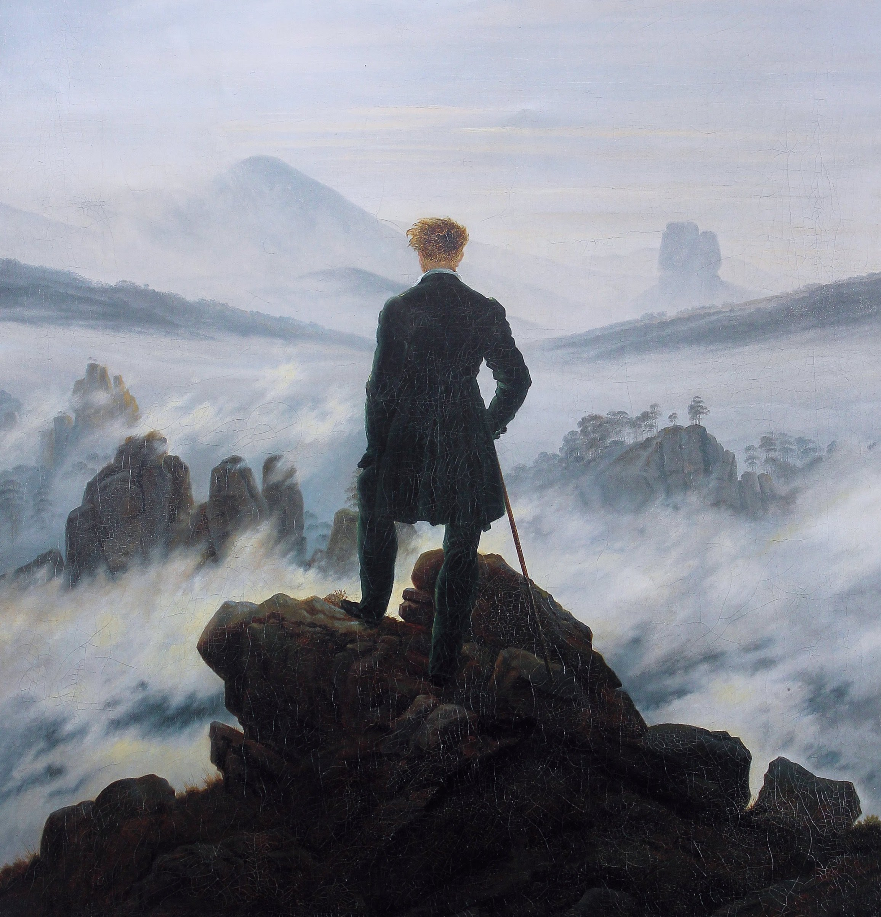
“It is impossible to read the compositions of the most celebrated writers of the present day without being startled with the electric life which burns within their words.”

P.B. Shelley, A Defence of Poetry

Emphasis on the great poems of six fascinating and influential poets--Blake, Wordsworth, Coleridge, Shelley, Byron, and Keats—alongside writings by Dorothy Wordsworth and others. We’ll explore and interrogate major themes of Romanticism: imagination, memory, creation, childhood, nature, the individual, sympathy, social critique, encounters with otherness, the lure of the unknown, the sublime, inspiration as "the spontaneous overflow of powerful feelings," dejection and writer's block, bipolar poetry, influence (from opium to "the viewless wings of Poesy"), rebellion, revolution, transgression, exile, the Byronic hero, the femme fatale, love, desire, beauty, truth, fancy, illusion, complexity, ambiguity, mystery, mortality, immortality.

Open to majors and non-majors, first-years through seniors. No previous coursework in poetry necessary.

ENG 246 (2) VICTORIANS, DECADENTS, AND THE BEGINNINGS
OF MODERN POETRY
†
Ms. Hickey
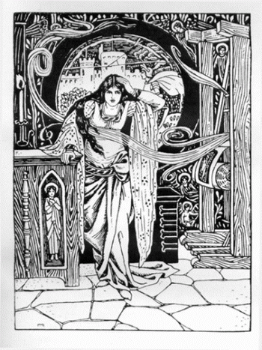
Questioning the labels "Victorian" and "Modern," this class spans eight decades of literary tradition and innovation: Tennyson, the Brownings, Emily Bronte, the Rossettis and the Pre-Raphaelite Brotherhood, Arnold, Hopkins, Wilde, Hardy, fin-de-siècle Aesthetes and Decadents, World War I poet Wilfred Owen, Yeats, and Eliot. We'll trace thematic and stylistic connections, analyzing diverse representations of love, longing, loss, the power and limits of words, Medievalism, marriage and its discontents, gender dynamics, the Woman Question, women's authorship, beauty, art, artifice, aesthetic and sensual pleasures, pain, suffering, sacrifice, the pity of war, repression, depravity, "madness," spiritual crisis, and fears for civilization. A Book Arts workshop and readings from Pater, Ruskin, Mill, Arnold, and William Morris will further illuminate the role of artists, artisans, and consumers of art.
Out flew the web and floated wide.
The mirror crack'd from side to side.

Tennyson, The Lady of Shalott

Open to majors and non-majors, first-years through seniors. No previous coursework in poetry necessary.

ENG 247/CPLT 247/ME/R 247 (2) ARTHURIAN LEGENDS
(‡)
Ms. Wall-Randell

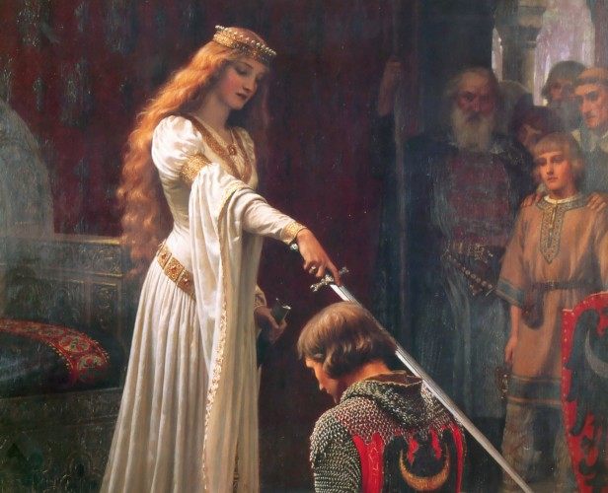

A survey of legends connected with King Arthur, and their literary context in medieval and Renaissance romance, from the sixth century through the sixteenth, with some attention to new interpretations of the Arthurian tradition and of the romance mode in the nineteenth and twentieth centuries. Texts may include: Geoffrey of Monmouth’s History of the Kings of Britain, Lawman’s Brut, Chrétien de Troyes’ romances, tales about Tristan and Isolde from Béroul and Marie de France, Sir Gawain and the Green Knight, Chaucer’s “Wife of Bath’s Tale,” Malory’s Morte D’Arthur, Tennyson’s Idylls of the King, and/or twentieth-century cinematic adaptations. We’ll consider the ways in which romance develops as a counterpoint to epic; examine the lessons romance teaches about social ethics, truth and lies, privacy and the self, and close reading; and explore the history of women, past and present, as readers and writers of romance.

Requirements: Two papers, a midterm, and a final exam. Students may register for either ENG 247 or CPLT 247 or ME/R 247 and credit will be granted accordingly.
ENG 251 (1) Modern Poetry
Ms. Brogan

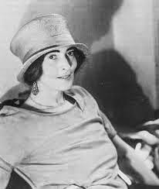
H.D. (Hilda Doolittle)

“Make it new,” Ezra Pound’s famous injunction to his contemporaries, captures the exciting, volatile, experimental energies of the modernist period, one of the most important revolutions in the history of English literature. Modernist writers in the early decades of the twentieth century radically rethought what a poem is, what a novel is, what literary language itself is. We are still the heirs of the great poetic innovators who emerged during that time: William Butler Yeats, T. S. Eliot, Ezra Pound, H.D. (Hilda Doolittle), Marianne Moore, Wallace Stevens, William Carlos Williams, and Langston Hughes. In this course we will consider what connects their work, as well as the profound divisions among them. We’ll think about how their poetry responds to world war, new technologies, urbanization, shifts in gender roles, and breakthroughs in the visual arts. Toward the end of the semester, we’ll take a look at the generation following great modernists (Robert Lowell, Elizabeth Bishop, Sylvia Plath), poets writing in the 1940s-1970s, to see how they revise the modernist legacy. No previous coursework in poetry necessary.

ENG 253 (2) CONTEMPORARY AMERICAN POETRY
Mr. Bidart

A survey of the great poems and poets of the last 75 years, a period of immense invention and brilliant creation. Our poets articulate the inside story of what being an American person feels like in an age of mounting visual spectacle, and in an environment where identities are suddenly, often thrillingly, sometimes distressingly, in question. Without repudiating the great heritage of Modernism, how have the poets that followed added to it? Poets include: Robert Lowell, Elizabeth Bishop, Allen Ginsberg, Sylvia Plath, the poets of “The New York School”
(John Ashbery, Frank O’Hara), Adrienne Rich, Louise Glück, Robert Pinsky, Anne Carson, Yusef Komunyakaa, Rita Dove, Dan Chiasson, and others.

Mandatory credit/noncredit.

ENG 258/AMST 258 (1) GOTHAM: NEW YORK CITY
IN LITERATURE, ART, AND FILM
Ms. Brogan

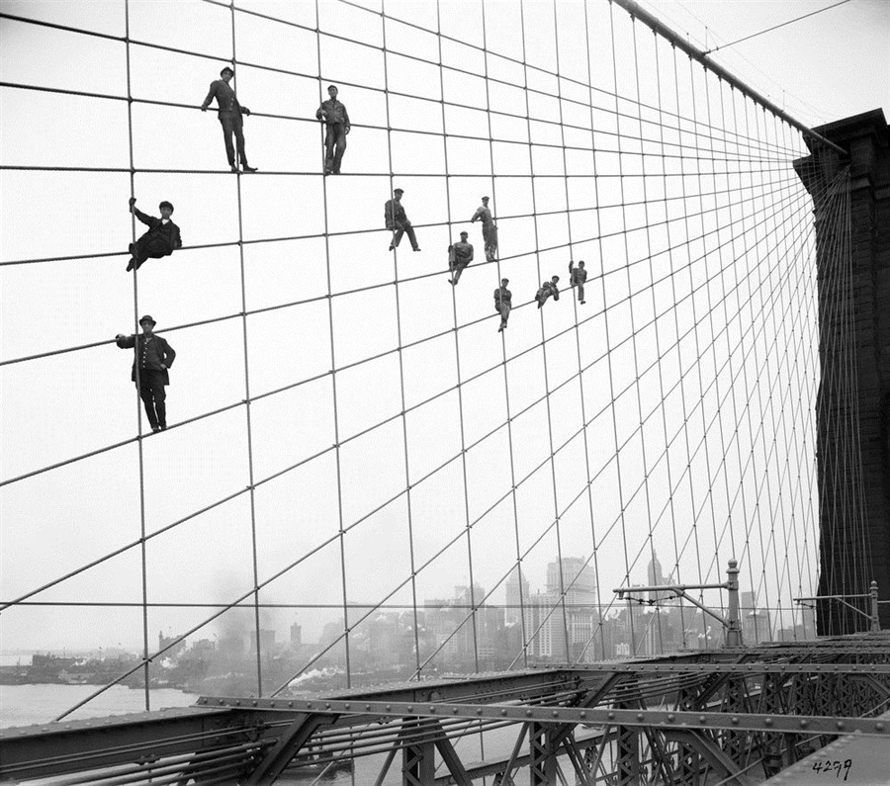
Photograph of painters on the Brooklyn Bridge: Eugene de Salignac, 1914

This course examines that icon of modernity, New York City, as it appears in literature, art, and film. We'll cross neighborhoods and centuries to consider how Americans have variously envisioned this cultural and financial capital. We'll also consider how each imagining of the city returns us to crucial questions of perspective, identity, and ownership. How does the city become legible to its inhabitants, and how do readings of the city vary according to one's physical, cultural, and social position in it? Authors may include: Walt Whitman, Herman Melville, Edith Wharton, Anzia Yezierska, Ralph Ellison, Paule Marshall, Chang-rae Lee, Teju Cole, and Colson Whitehead. Artists include, among others, John Sloan, Helen Levitt and Berenice Abbott; filmmakers Vincente Minnelli, Martin Scorsese, and Spike Lee.

Students may register for either ENG 258 or AMST 258 and credit will be granted accordingly.

ENG 262/AMST 262 (2) American Literature to 1865
(†)
Mr. Cain

This is the greatest, most thrilling and inspiring period in American literary history, and the central theme represented and explored in it is freedom, and its relationship to power. Power and freedom—the charged and complex dynamics of these intersecting terms, ideas, and conflicted realities: we will see and examine this theme in literature, religion, social reform, sexual and racial liberation, and more. We will start with selections by Emerson, Thoreau, Melville, Hawthorne, and Dickinson. These brilliant writers and thinkers will establish the groundwork for the main part of the course—an intensive study of Frederick Douglass, Harriet Beecher Stowe, and Walt Whitman—three extraordinary figures who led fascinating (really, incredible) lives and wrote astonishing books. We will enrich our work by studying films dealing with the period—for example, Edward Zwick’s Glory (1989), about one of the first regiments of African-American troops, and Steven Spielberg’s Lincoln (2012). The literature that we will read and respond to was written 150 years or so ago, but the issues that these writers engage are totally relevant to who we are and where we are today. In important ways this is really a course in contemporary American literature.

Students may register for either ENG 262 or AMST 262 and credit will be granted accordingly.

ENG 263/PEAC 263 (2) AMERICAN LITERATURE AND SOCIAL JUSTICE
Mr. Rosenwald

A study of American fictions, plays, songs, essays, memoirs, and films dealing with questions of justice in the relations between races, ethnic groups, genders, and classes. General discussion of the relations between justice and literature, specific discussion of what particular works suggest about particular social questions.

Possible authors and works: Rebecca Harding Davis, Life in the Iron Mills; Edward Bellamy, Looking Backward; Upton Sinclair, The Jungle; Marc Blitzstein, The Cradle Will Rock; John Steinbeck, Grapes of Wrath; poems about the Sacco and Vanzetti case; Lorraine Hansberry’s Raisin in the Sun;poems by Langston Hughes, Edna St. Vincent Millay, Muriel Rukeyser, Robert Lowell, Adrienne Rich; memoirs by Jane Addams, Dorothy Day, James Baldwin, Martin Luther King, Barbara Deming, Ta-Nehisi Coates; accounts of the Japanese internment camps plays by the Teatro Campesino and Anna Deveare Smith; songs by Joe Hill, Billie Holiday, Woody Guthrie, Pete Seeger, Nina Simone, Janelle Monáe.

Opportunity for both critical and creative work.

Students may register for either ENG 263 or PEAC 263 and credit will be granted accordingly.

ENG 266/AMST 266 (1) Topics in American Literature from the Civil War to the 1930s
Mr. Cain
Topic for 2018-19: From Page to Screen: American Novels and Films

This course will focus on important Americans novels from the late nineteenth century to the mid-twentieth century, and the attempts (sometimes successful, sometimes not, but always interesting) to turn them into movies, translating them from the page to the screen. Authors to be studied will include Henry James, Willa Cather, F. Scott Fitzgerald, Carson McCullers, and Edith Wharton. For comparison and contrast, we will move beyond the chronology of the course to consider books by two more recent authors, Malcolm X and Patricia Highsmith. Perhaps the main question we will ask is this: Is it possible to turn a great book, especially a great novel, into a great or even a good movie?

Students may register for either ENG 266 or AMST 266 and credit will be granted accordingly.

ENG 268/AMST 268 (2) AMERICAN LITERATURE NOW:
THE TWENTY-FIRST CENTURY
Mr. Shetley

This course will explore the richness and diversity of American (and some Canadian) writing since 2000, focusing primarily on writers who have emerged in the new century. We’ll read novels and short stories by both established authors, such as Jennifer Egan and Junot Diaz, and rising talents like Ben Lerner and Roxane Gay. We’ll also look at the work of some experimental writers, such as Lydia Davis and Percival Everett, and some examples of the genre fiction against which literary writing has defined itself, like Stephenie Meyer’s Twilight, to think about the ways that intellectual and cultural prestige are established in contemporary America. Given that MFA programs have become a defining feature of the literary landscape in the US, we’ll examine some of the controversies around the spread of these programs through excerpts from recent treatments like Mark McGurl’s The Program Era and Chad Harbach’s MFA vs. NYC. And we’ll dip into the occasionally bitter rivalries and feuds that have shaped understandings of the contemporary literary scene: Jonathan Franzen vs. Oprah, Jonathan Franzen vs. Jennifer Weiner, Francine Prose vs. Sadia Shepard. Studying these conflicts will help illuminate the terrain of literary and cultural values within which contemporary American literature is written, read, and discussed.

Students may register for either ENG 268 or AMST 268 and credit will be granted accordingly.
ENG 272 (1) THE NINETEENTH-Century Novel
†
Ms. Rodensky

Victorian novels continue to command a large and growing readership even in the 21st century, and for good reason. Victorian novelists create rich and engaging worlds that they invite us to enter, and we are eager to accept their invitations, notwithstanding the fact that the journeys they
take us on -- with Oliver Twist in the workhouse or alongside Margaret Hale as she confronts a labor riot -- aren't exactly pleasant. Indeed, the novels we will read together confront some of the most anxiety-provoking issues of the nineteenth century, including issues involving the expression and repression of sexuality (particularly female sexuality), the expansion of voting and other individual rights, class mobility, problems of agency, free will, and responsibility, and the decline of religious belief. We will also attend to the novel as an agent of social and moral reform during this period of its greatest power and influence.

Readings may include the following novels: Dickens, Oliver Twist; Charlotte Brontë, Jane Eyre; Gaskell, North and South; Eliot, Middlemarch and “The Lifted Veil”; and Hardy, Tess of the D’Urbervilles.

ENG 273 (2) THE MODERN BRITISH NOVEL
Ms. Rodensky

"What does it mean then, what can it all mean? Lily Briscoe asked herself, wondering whether, since she had been left alone, it behooved her to go to the kitchen to fetch another cup of coffee or wait here. What does it mean? -- a catchword that was, caught up from some book,
fitting her thought loosely . . .". So begins the third and final section of Virginia Woolf's To the Lighthouse. We take Lily Briscoe's question seriously: What does it all mean? But maybe to 'mean' doesn't mean anything any more, and is merely a 'catchword, caught up from some book' (like To the Lighthouse)? These provocative questions, among others, thrillingly animate the
novels that we categorize as 'modern.' As we take up each of the six novels assigned for the course, we will consider what makes the novel 'modern': how and where do the novelists challenge our expectations as novel-readers, particularly with respect to the development of plot, character, and even the use of language itself? Breaking away from their Victorian precursors, modern novelists sought to radically reimagine the reading experience and its place in the larger culture. Their experiments push us to examine our own assumptions about the formation of identity and the possibilities for human connection. The stakes are high as we meet the challenges these novelists create for us.

Novels may include: E.M. Forster, Howards End; D.H. Lawrence, St Mawr; James Joyce,
A Portrait of the Artist as a Young Man; Joseph Conrad, The Secret Agent; Virginia Woolf,
To the Lighthouse; and Jean Rhys, After Leaving Mr. Mackenzie.

ENG 275/CPLT 275 (1)
TRANSLATION AND THE MULTILINGUAL WORLD
Mr. Rosenwald

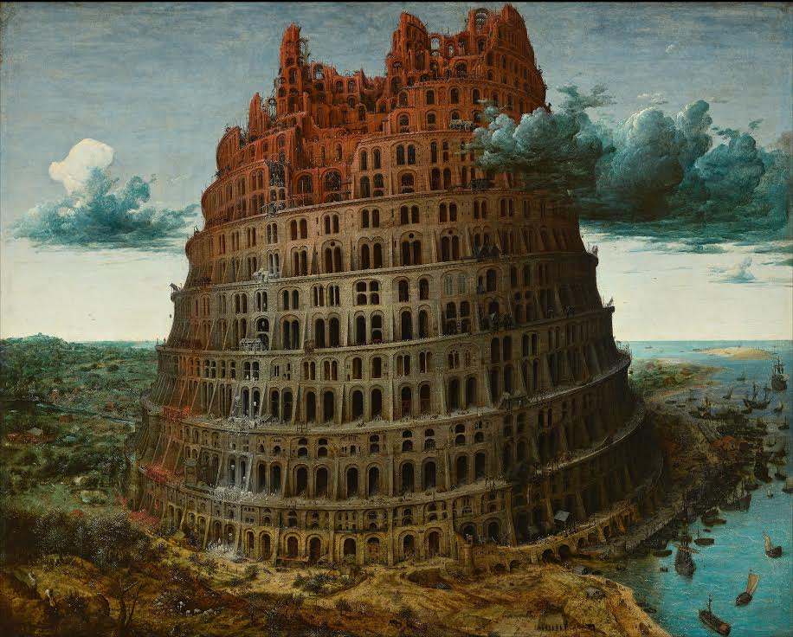

A study of translation in theory and in practice, in its literal and metaphorical senses alike, and of the multilingual world in which translation takes place. Topics: translation of literary texts, translation of sacred texts, the history and politics of translation, the lives of translators, translation and gender, machine translation, adaptation as translation. Students taking the course at the 300 level will do a substantial independent project: a translation, a scholarly inquiry, or a combination of the two.

Competence in a language or languages other than English is useful but not necessary. Open to students who have taken WRIT 118/ENG 118.

Students may register for either ENG 275 or CPLT 275 and credit will be granted accordingly.

ENG 277/SAS 277 (1) MODERN INDIAN LITERATURE
Ms. Sabin
(⌘)
Topic for 2018-19: South Asian Women Writers and Filmmakers

South Asian women have been recognized as literary writers (and film performers) throughout the modern period, but only more recently have they attained opportunities to direct and write for the screen. This course will explore a selection of outstanding modern and contemporary short stories, novels, non-fiction writing and films by women artists from India, Pakistan and the South Asian diaspora. Most of our selections will come from English language originals, but we
will approach some through translation (and sub-titles), which will help us consider the limited place of English in a part of the world where it is only one (and a contested one) among many important other languages.

The material spans several generations from the late colonial period to the present: from the radical Progressive Writers movement (featuring both Hindu and Muslim Indian women writers in the 1930s and early 40s) to the trauma of Partition (still dominating writers through the 1980s), and then to shifting attitudes as more women move out of traditional domestic roles into work in the world. The global prominence of South Asian writing and film by women who have emigrated or at least found publication opportunities (and prizes) in the West raises interesting further questions about the relationship of artists to audiences. Other topics likely to emerge include: the variety of modern challenges to the constraints and comforts of tradition; the tension between primary commitment to artistic values or to art as a medium for social reform; the role of religious, class, and caste divisions that complicate any form of gender solidarity.

Some of the writings (especially those in translation) will clearly be directed to an indigenous audience; others to a more global or even primarily Western audience. One open question for discussion will be whether or not a distinctive non-Western female tradition of theme and/or expressive style emerges from this variety.

This is an exciting subject because in addition to its fascinating history, it is also rapidly happening NOW. The writers and filmmakers to be included will likely be selected from the following list—still open to change depending on new suggestions that come to my attention before Fall 2018:

Important Urdu, Hindi, and Bengali writers with strong progressive social goals (to be read by us in translation): Rasheed Jahan, Ismail Chugtai, Amrita Pritam, Mahasweta Devi.

Writers from India and Pakistan, writing in English, but with diverse "homes": Santha Rama Rau, Bapsi Sidhwa, Anita Desai, Urvashi Butalia ,Arundhati Roy, Kiran Desai, Kamila Shamsie, Bina Shah, Jhumpa Lahiri.

Filmmakers: Aparna Sen, Mira Nair, Deepa Mehta, Sabiha Sumar, Paromita Vohra.

Fulfills the Diversity of Literatures in English requirement.

Students may register for either ENG 277 or SAS 277 and credit will be granted accordingly.

ENG 280 (2) FRANK BIDART
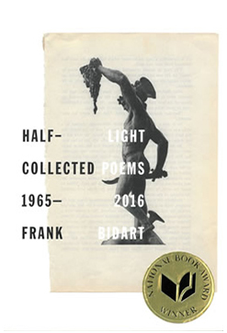
Mr. Chiasson

A course on the poetry of one of the key figures in American Literature of the past fifty years. Topics include: Bidart as a confessional and post-confessional writer, incorporating the innovations of his mentors, Robert Lowell and Elizabeth Bishop; Bidart as experimental poet, extending the high-Modernist line pioneered by Ezra Pound and William Carlos Williams; Bidart as a practitioner of the dramatic monologue as channelled from Shakespeare to Robert Frost; as a regional poet of California and New England; as a poet of queer identity; and, crucially, as a poet of unsurpassed formal and rhetorical inventiveness. We will read Bidart's collected volume, Half-Light: Collected Poems 1965-2016, in its entirety.

ENG 291 (2) What is Racial Difference?
(⌘)
Mr. Whitaker
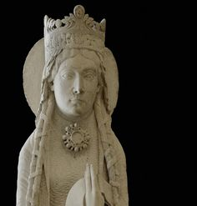
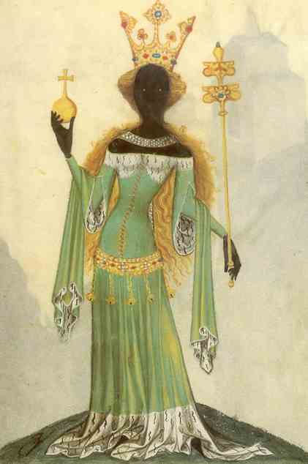
Through literary and interdisciplinary methods, this course examines the nature of race. While current debates about race often assume it to be an exclusively modern problem, this course uses classical, medieval, early modern, and modern materials to investigate the long history of race and the means by which thinkers have categorized groups of people and investigated the differences between them through the ages. The course examines the development of race through discourses of linguistic, physical, geographic, and religious difference--from the Tower of Babel to Aristotle, from the Crusades to nineteenth-century racial taxonomies, from Chaucer to Toni Morrison. Considering the roles physical appearance has played in each of these arenas, we will thoughtfully consider the question:
What Is Racial Difference?

This course has been developed with the support of the Enduring Questions program of the National Endowment for the Humanities. Fulfills the Diversity of Literatures in English requirement.

ENG 294 (2) WRITING AIDS, 1981-PRESENT
Mr. Gonzalez

AIDS changed how we live our lives, and this course looks at writings tracing the complex, sweeping ramifications of the biggest sexual-health crisis in world history. This course looks at diverse depictions and genres of H.I.V./AIDS writing, including Pulitzer Prize-winning plays like Angels In America and bestselling popular-science "contagion narratives" like And the Band Played On; independent films like Greg Araki's The Living End and Oscar-winning features and documentaries like Philadelphia, Precious, and How to Survive a Plague. We will read about past controversies and ongoing developments in AIDS history and historiography. These include unyielding stigma and bio-political indifference, met with activism, service, and advocacy; transforming biomedical research to increase access to better treatments, revolutionizing AIDS from death sentence to chronic condition; proliferating "moral panics" about public sex,
"barebacking," and "PrEP" (pre-exposure prevention), invoking problematic constructs like "Patient Zero," "being on the Down Low," "party and play" subculture, and the "Truvada whore"; and constructing a global bio-political apparatus ("AIDS Inc.") to control and protect populations. We will look at journal articles, scholarly and popular-science books (excerpts), as well as literary and cinematic texts. Also some archival materials from ACT UP Boston, the activist group.
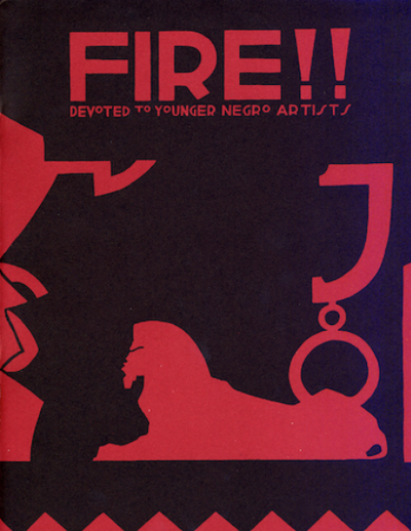
ENG 295/AFR 295 (2) Harlem Renaissance
(⌘)
Mr. Gonzalez

This is an introduction to the Harlem Renaissance, a movement of African American literature and culture of the early twentieth century, which encompassed all major art forms, including poetry, fiction, and drama, as well as music, the visual arts, cabaret, and political commentary. This movement corresponds with the publication of The New Negro anthology (1925). Literary authors we will study may include Langston Hughes, Jean Toomer, Nella Larsen, Zora Neale Hurston, Wallace Thurman, and Richard Bruce Nugent. We will also enter into contemporary debates about “the color line” in this period of American history, reading some earlier work by W.E.B. Du Bois, Booker T. Washington, or James Weldon Johnson, in the context of early Jim Crow, the Great Migration, the Jazz Age, and transatlantic Modernism. Fulfills the Diversity of Literatures in English requirement. Students may register for either ENG 295 or AFR 295 and credit will be granted accordingly.

ENG 296/AMST 296 (2) IMMIGRATION AND DIASPORA IN 21 st CENTURY AMERICAN LITERATURE
(⌘)
Ms. Brogan

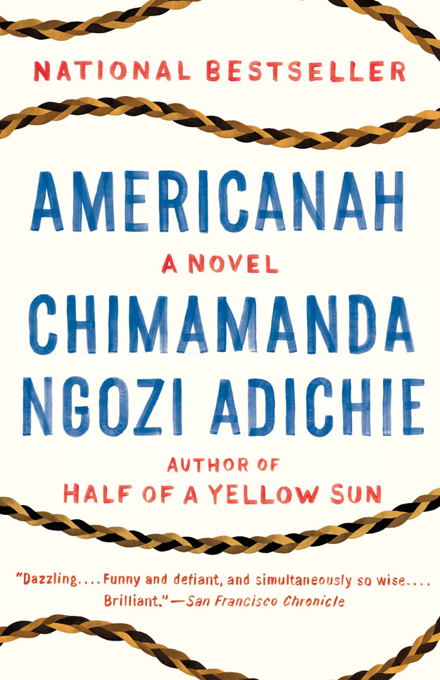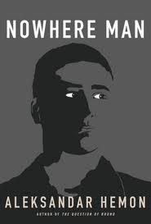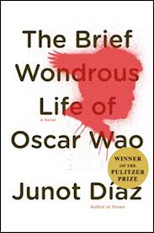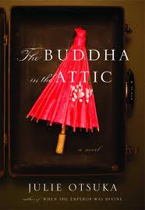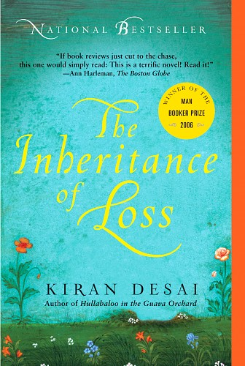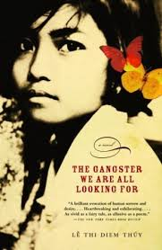

This course explores the exciting new literature produced by writers transplanted to the United States (or who are children of immigrants). We’ll consider how the perspectives of recent immigrants redefine what is American by sustaining linkages across national borders, and we’ll examine issues of hybrid identity and multiple allegiances, collective memory, traumatic history, nation, home and homeland, and globalization. Our course materials include novels, essays, memoirs, and visual art. We’ll be looking at writers in the United States with cultural connections to China, Egypt, Nigeria, Dominican Republic, India, Viet Nam, Bosnia, Ethiopia, and Japan. Some authors to be included: André Aciman, Chimamanda Adichie, Junot Díaz, Kiran Desai, Aleksandar Hemon, Mohsin Hamid, Lê Thi Diem Thúy, Dinaw Mengestu, and Julie Otsuka. Photographers and artists to be studied include Surendra Lawoti, Priya Kambli, and Asma Ahmed Shikoh. Opportunity for creative and interdisciplinary work. Fulfills the Diversity of Literatures in English requirement.

Students may register for either ENG 296 or AMST 296 and credit will be granted accordingly.

ENG 297/AMST 281 (1) RAINBOW REPUBLIC: AMERICAN QUEER CULTURE
FROM WALT WHITMAN TO LADY GAGA
Mr. Fisher (American Studies)

Transgender rights, gay marriage, and Hollywood and sports figures’ media advocacy are only the latest manifestations of the rich queer history of the United States. This course will explore American LGBTQ history and culture from the late nineteenth century to the present, with an emphasis on consequential developments in society, politics, and consciousness since Stonewall in 1969. The course will introduce some elements of gender and queer theory; it will address historical and present-day constructions of sexuality through selected historical readings but primarily through the vibrant cultural forms produced by queer artists and communities. The course will survey significant queer literature, art, film, and popular culture, with an emphasis on the inventive new forms of recent decades. It will also emphasize the rich diversity of queer culture especially through the intersectionality of sexuality with race, ethnicity, class, and gender. Students may register for either ENG 296 or AMST 296 and credit will be granted accordingly.

ENG 299/AMST 299 (1) AMERICAN NIGHTMARES: THE HORROR FILM
IN AMERICA
Mr. Shetley

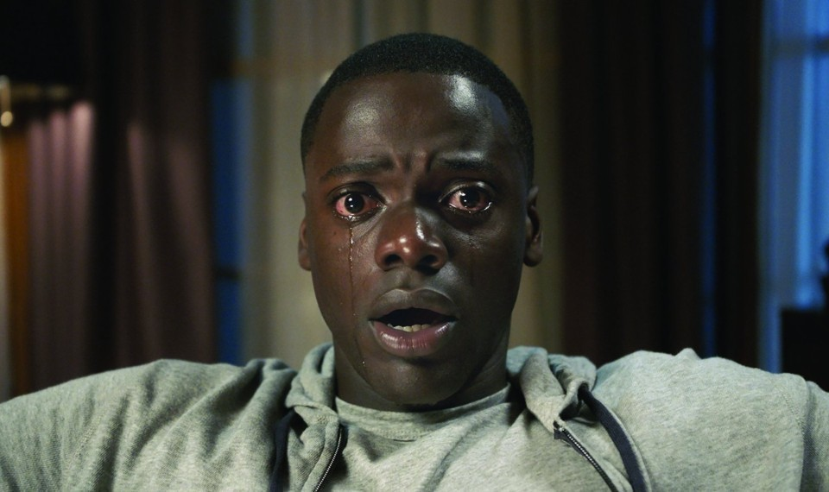

An exploration of the horror film in America, from the early sound era to the present. We’ll pay particular attention to the ways that imaginary monsters embody real terrors, and the impact of social and technological change on the stories through which we provoke and assuage our fears. We’ll study classics of the genre, such as Frankenstein, Cat People, Night of the Living Dead, and The Exorcist, as well as contemporary films like Get Out, and read some of the most important work in the rich tradition of critical and theoretical writing on horror, as well as some of the literary texts on which important works of cinematic horror are based. Throughout, we’ll consider some of the following questions: why do audiences take pleasure in terror? what are the implications of changes in the horror film’s favored forms of monstrosity? how do gender and race figure in our understandings of the monstrous, and the normality threatened by the monstrous? what cinematic strategies seem particularly well adapted to evoking the characteristic emotions of horror?

Students may register for either ENG 299 or AMST 299 and credit will be granted accordingly.

ENG 301 (2) Advanced Writing/Fiction
Ms. Cezair-Thompson

A workshop in the techniques of fiction writing together with practice in critical evaluation of student work. Students who have taken this course once may register for it one additional time. Mandatory credit/noncredit.

ENG 302 (2) ADVANCED WRITING/POETRY
Mr. Bidart

Intensive practice in the writing of poetry. Classes will be devoted to discussion of the students’ poems. The emphasis will be on the possibilities for revision, and on developing some objectivity about one’s own work. Students who have taken this course once may register for it one additional time. Mandatory credit/noncredit.

ENG 316 (1) CALDERWOOD SEMINAR: DEAD POETRY SOCIETY
Ms. Lynch
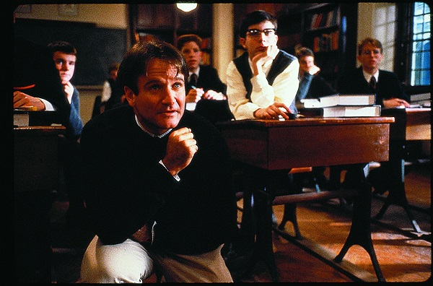
This Calderwood seminar will show that there is no such thing as dead poetry. In a series of weekly writing and editing exercises ranging from movie reviews to op-eds, we will explore the many ways that the great poetry of centuries past speaks directly to modern experience. We will be taught both by the poets themselves (whose eloquence will rub off on us) and each other, as each student will pick a “beat” (for example, women poets of the Renaissance) that she will become expert at explaining to a lay audience. By the end of the semester, not only will you be able to persuade a newspaper reader that blank verse matters as much as Twitter; you will also learn how to articulate the value of your English major to a prospective employer--and how to transmit your excitement about the latest discoveries in your field to friends and parents.

ENG 325 (2) ADVANCED STUDIES IN SIXTEENTH-
AND SEVENTEENTH-CENTURY LITERATURE
‡
Ms. Wall-Randell
Topic for 2018-19: Non-binary Gender on the Renaissance Stage

In early modern England, in theory and largely in practice, gender roles were highly codified, and men's and women's places in society, in nature, and before God were seen as profoundly distinct. Yet at the same time, on the stage, in the plays of Lyly, Shakespeare, Jonson, Middleton, and others, gender was being portrayed as wildly mutable, unstable, and uncategorizable. Female characters dress as men in the plots of the plays, while male actors dressed as women to enact those roles (women were forbidden from public performance). Was the theater, with its cross-dressing and gender-fluid plots, serving as a contained zone of misrule, an exceptional space that “proved the rule” of strict gender distinctions in the rest of the society? Or does it provide a secret window into a pervasive, far more complex and unsettled way of thinking about gender than Renaissance England has heretofore been given credit for?

ENG 341 (2) SISTERS, BROTHERS, AND LOVERS: SIBLING RELATIONSHIPS IN ROMANTIC LITERATURE
(†)
Ms. Hickey
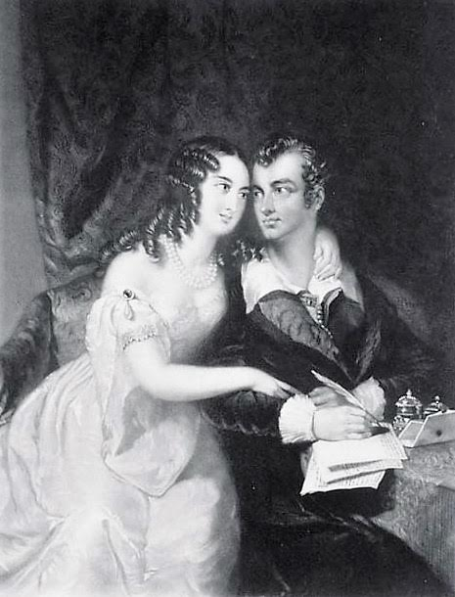

From Life's commencement to its slow decline
We are entwined --- let Death come slow or fast,
The tie which bound the first endures the last!
Byron, “Epistle to Augusta”

How do siblings, sibling relationships, and conceptions of brotherhood and sisterhood figure in Romantic-period authorship and texts? What is particularly Romantic about sisters and brothers? We'll consider such questions from several different angles, looking, for example, at the following: representations of siblings in literary texts; sister-brother writers (but also the importance of non-writing siblings); the relation of genius to genes; the complications of step-siblings, half-siblings, and siblings-in-law; the overlap or conflict of sibling relationships with friendship, marriage, romantic love, and self-love; and brotherhood as metaphor (revolutionary, abolitionist, Christian). Texts: poems, and some prose, by William and Dorothy Wordsworth (poems and journals), Coleridge (poems, letters, etc.), Charles and Mary Lamb (poems, personal essays, letters), De Quincey (Confessions of an English Opium-Eater), Keats (poems, letters), Byron (poems), P.B. Shelley (poems), Mary Shelley(Frankenstein), and Jane Austen (Sense and Sensibility).

ENG 347 (2) NINETEENTH-CENTURY NOVELS OF ROMANTIC MISTAKE
(†)
Ms. Meyer

“Reader, I married him,” Jane Eyre tells us as her novel draws to a close. Many nineteenth-century novels focus on the period of a woman’s life in which she reaches maturity and makes
romantic decisions, the period of what George Eliot calls “maidens choosing.” Many of these novels end with the apparently happy marriage of the female protagonist. So despite any suggestions within the body of the novel that women’s traditional role is not a satisfying one, the heroine often seems contentedly ensconced in that role by the novel’s end. But what happens after the wedding? In particular, what happens when the heroine chooses wrong—disastrously wrong? And what forces have propelled her toward a mistaken choice? In this course we will consider novels that look at a heroine’s life after a marriage that she comes to regret (Anne Brontë’s The Tenant of Wildfell Hall, George Eliot’s Middlemarch and [or?] Daniel Deronda, Henry James’s The Portrait of a Lady) and, to lighten the mood, some novels in which the heroines make bad romantic choices that do not end in marriage (Jane Austen’s Sense and
Sensibility, Charlotte Brontë’s Villette). What do these novels of romantic mistake have to say about the choices available to women, about female sexuality, about women’s education, about women’s lives?

ENG 348 (2) SEMINAR: JANE AUSTEN AND ANTHONY TROLLOPE
Mr. Peltason

Three novels by each of these great and pleasure-giving writers, with an emphasis on their ambitious reinventions of the genre of romantic comedy. In Pride and Prejudice, Emma, and Persuasion, Jane Austen (1775-1817) makes the marriage plot the vehicle of a larger vision of achieved social order—of social order achieved in the face of all manner of stupidities and obstructions. In The Warden and Barchester Towers, written near the beginning of Anthony Trollope’s (1815-1882) long career, the marriage plot is joined to what looks like a solidly conservative social vision. But looks are deceiving, and The Last Chronicle of Barset shows what Trollope is ready to psychology and society in all its strangeness.

ENG 351 (1) The Robert Garis Seminar
Mr. Smee
Topic for 2018-19: Non-fiction Prose

An advanced, intensive writing workshop, open to six students, named for a late Wellesley professor who valued good writing. This is a class in writing non-fiction prose, the kind that
might someday land you in The New Yorker or The Atlantic. Our genre is often called "literary journalism," and here the special skills—technical precision, ability for physical description, and
psychological insight—necessary for writing fiction are applied to real-life events and
personalities. We will read and emulate authors like Joan Didion, Hilton Als, Ian Frazier, John McPhee, and Joseph Mitchell, and you will produce a 5,000-word piece of your own.

We will meet once in the spring and students are expected to work on their project over the summer. Many students will be inclined to write about themselves—memoir is ever popular—but memoirs will only be permitted if they elucidate some topic other than the self. Thus, you might write about growing up on a commune, but then you must also plan to make your piece about communes: how they form, their history, what academic experts have to say about them, their politics, etc. You may write about your high school gymnastics career, but only if you plan also to research and include discussion of high school gymnastics across the country, its history, its critics, etc. It will be hard to write about, say, your parents' divorce or a high school romance in a way that sheds light on any larger questions, and so you will likely avoid such topics, preferring to spend the summer reporting on a topic of personal interest but in which you are not personally implicated.

You will be expected to do some research for your paper over the summer, and there will also be required summer reading. The payoff will come in the fall, when you will, it is hoped, produce your most polished, and likely longest, piece of writing yet.

English 351 carries .5 units of credit and meets over the course of six weeks. Enrollment limited to 6. Permission of instructor required. Mandatory credit/noncredit.

ENG 355 (1) ADVANCED STUDIES IN TWENTIETH CENTURY LITERATURE
Mr. Gonzalez
Topic for 2018-19: Misfit Modernism
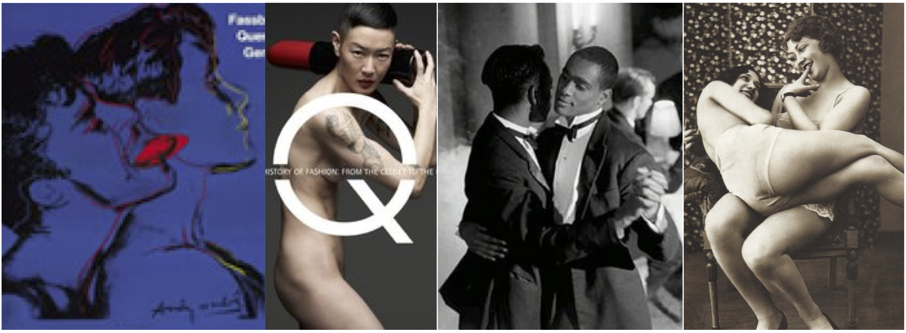
We will read texts by “modernist misfits,” authors who pushed the boundaries of fiction in the first half of the twentieth century. Some of these works were banned in their time, which only added to their allure. Today, these fictions still have the capacity to shock – we will recognize our own secret longings and dark desires in the murky mirrors these authors wrought. Modernist misfits may include canonical yet still controversial writers alike: James Joyce, Virginia Woolf,
James Weldon Johnson, Christopher Isherwood, and Zora Neale Hurston. We might also read excerpts by JK Huysmans, Oscar Wilde, and Jean Genet. Key themes include obsessional love, double lives, bohemianism and cosmopolitanism, and, of course, sex, drugs, and rock ‘n roll.

Assignments:
- A close-reading paper, 4-7 pp, due early in the semester
- A 7-10 pp research paper, due at the end of the term with a
- Bibliography and Outline due earlier in the semester;
- Five journal response (1p) to the readings (basically, every other week); and
- A 10-minute oral report (with a multi-media component, a handout, or both) on a discrete cultural artifact or social phenomenon from the modernist era (topic to be discussed with me early in the term); examples include a presentation on Billie Holiday; the Paris exhibition “Manet and the Post-Impressionists” (1920); or a modernist “little magazine,” such as The Egoist, BLAST, or The Dial.

ENG 357 (1) THE WORLD OF EMILY DICKINSON
Mr. Chiasson
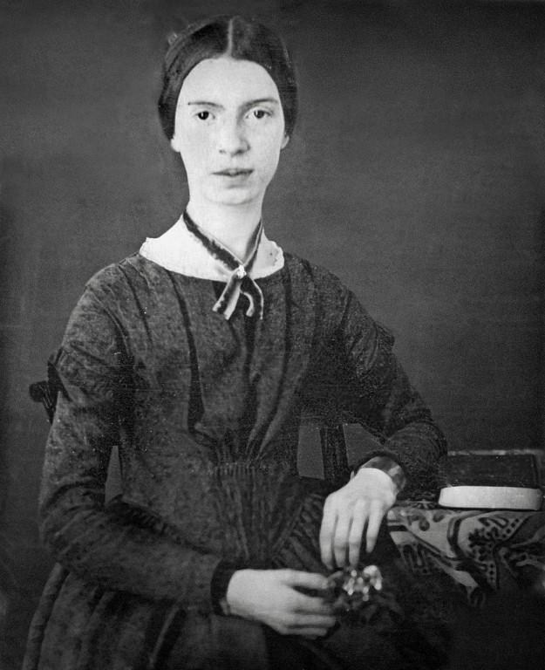
The poems and letters of Emily Dickinson, arguably the most important American poet of the nineteenth century, provide a window into one of the most thrilling and idiosyncratic minds in literature. Dickinson lived her entire adult life in her family's elegant home on the main street of Amherst, Massachusetts, writing in her spacious bedroom through the night. The house and its views, as well as its gardens and paths, are all vivid presences in her work. Dickinson hand-wrote all of her poems on paper she scavenged around the house; scholars are still debating how to read and interpret her hand-done poems. To study Dickinson is to be confronted with questions that seem sometimes more forensic than literary critical. We will explore Dickinson's online archives and visit, several times, her house and gardens in Amherst. This course should appeal not only to lovers of poetry but to lovers of old houses, scrapbooks, ghost stories, and the material history of the New England region.

ENG 375/CPLT 375 (1)
TRANSLATION AND THE MULTILINGUAL WORLD
Mr. Rosenwald

A study of translation in theory and in practice, in its literal and metaphorical senses alike, and of the multilingual world in which translation takes place. Topics: translation of literary texts,
translation of sacred texts, the history and politics of translation, the lives of translators, translation and gender, machine translation, adaptation as translation. Students taking the course at the 300 level will do a substantial independent project: a translation, a scholarly inquiry, or a combination of the two.

Competence in a language or languages other than English is useful but not necessary. Open to students who have taken WRIT 118/ENG 118.

Students may register for either ENG 375 or CPLT 375 and credit will be granted accordingly.

ENGLISH 382 (1) Literary Theory
Ms. Lee

A survey of major developments in literary theory and criticism. Discussion will focus on important perspectives—including structuralism, post-structuralism, Marxism, and feminism—and crucial individual theorists—including Bakhtin, Empson, Barthes, Derrida, Foucault, Jameson, Sedgwick, and Zizek.

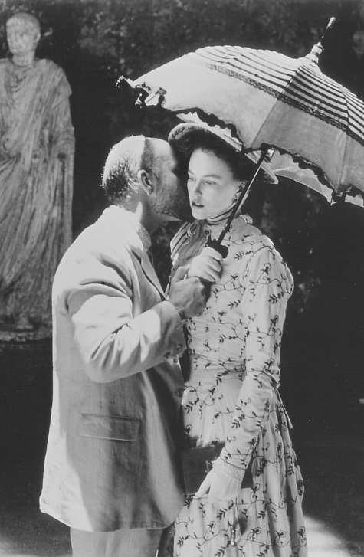
ENG 383/AMST 383 (1) WOMEN IN LOVE: AMERICAN LITERATURE, ART,
PHOTOGRAPHY, FILM
Mr. Cain

Study in depth of two important, challenging American novels: The Portrait of a Lady by Henry James and Sister Carrie by Theodore Dreiser. Detailed consideration of biographical, historical, and social contexts. Also: film adaptations; works of art by John Singer Sargent, Thomas Eakins, and Georgia O'Keefe; and photographs by Alfred Stieglitz.

Students may register for either ENG 383 or AMST 383 and credit will be granted accordingly.

ENG 387 (1) AUTHORS
Ms. Rodensky
Topic for 2018-19: Virginia Woolf - From Victorian to Modern
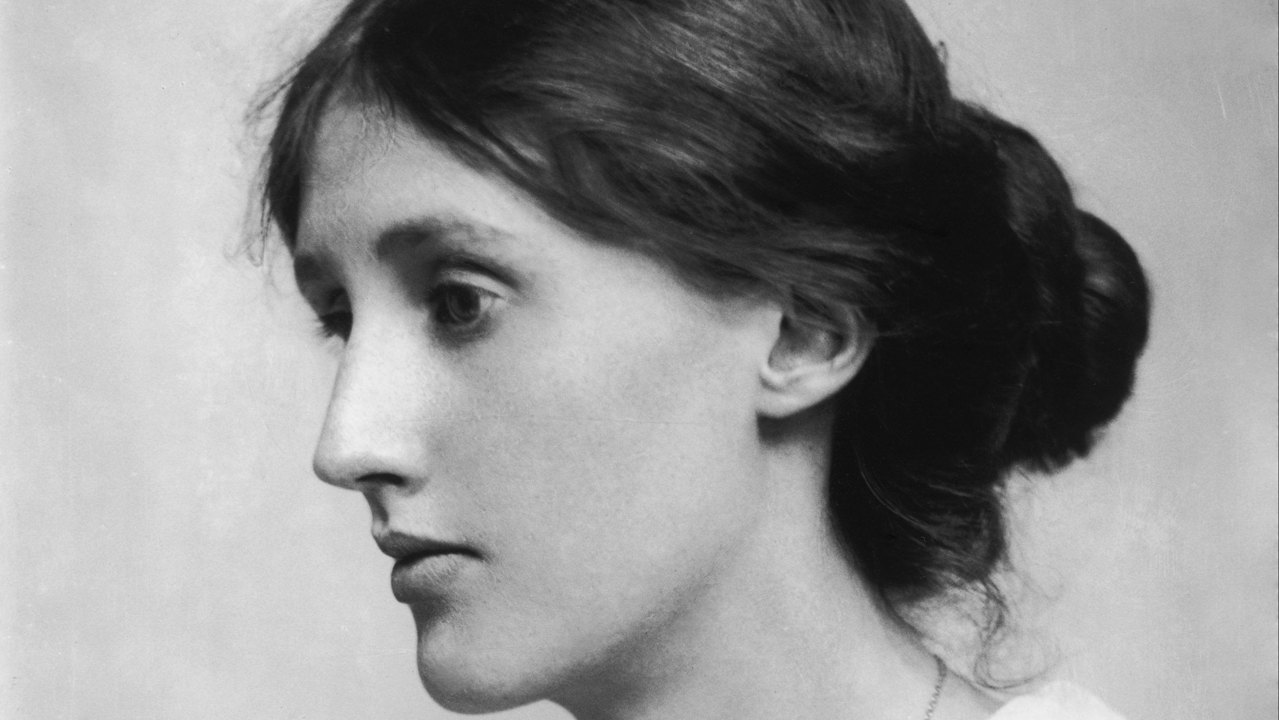
In this course, we will begin by examining Virginia Woolf’s development as a writer (her early essays, reviews, short stories and novels, particularly The Voyage Out) and then turn our attention to her two greatest works -- Mrs. Dalloway and To the Lighthouse. We will consider how Woolf reinvents herself as a modernist. We will also read excerpts from her diaries and other autobiographical works.

ENG 388 (1) TRAUMA, CONFLICT, AND NARRATIVE:
TALES OF AFRICA AND THE AFRICAN DIASPORA
(⌘)
Ms. Cezair-Thompson

This course explores the role of narratives in response to mass trauma, focusing on regions of Africa and African Diaspora societies. Drawing on the emerging fields of trauma narrative and conflict resolution, we will examine the effectiveness of oral, written and cinematic narratives in overcoming legacies of suffering and building peace. Topics include: violence in colonial and postcolonial Central Africa, the Biafran war, South Africa during and after Apartheid and Rwanda’s 1994 genocide. We will also explore the trans-Atlantic slave trade and its impact on African-American and Caribbean societies. Types of narrative include novels,
memoirs, films, plays, and data from truth and reconciliation commissions. Students will be exposed to trauma narrative not only as text but as a social and political instrument for post-conflict reconstruction. Fulfills the Diversity of Literatures in English requirement.

Requirements for the English Major
The English major consists of a minimum of 10 units, at least eight of which must be in areas other than creative writing. At least seven units must be above 100 level, and of these at least two units must be earned in 300-level literature, film, or literary theory courses. At least eight of the units for the major must be taken in the department, including the two required units in 300-level courses dealing with literature, film, or literary theory; with the approval of a student’s major advisor, two courses taught within language and literature departments and related interdisciplinary programs and departments at Wellesley and other approved schools may be offered for major credit; these may include literature courses taught in translation or in the original language. (Transfer students may apply to the chair to earn major credit for more than two literature-based courses taken outside the College.) Students planning to study for a full academic year in a program abroad in the United Kingdom should seek the counsel of their advisors or the department chair to avoid running up against the college’s rule that 18 courses must be taken outside any one department; universities in the United Kingdom commonly require all courses to be taken within their English departments.
The First-Year Writing requirement does not count toward the major. Courses designated WRIT 105/ENG 120 satisfy both the ENG 120 requirement and the First-Year Writing requirement, and count as a unit toward the fulfillment of the major. Independent work (ENG 350, ENG 360, or ENG 370) does not count toward the minimum requirement of two 300-level courses for the major or toward the 10 courses required for the major. 300-level courses in creative writing also do not count toward the minimum requirement of two 300-level courses for the major.
All students majoring in English must take ENG 120 (Critical Interpretation) or WRIT 105/ENG 120, at least one course in Shakespeare (200 level), and two courses focused on literature written before 1900, of which at least one must focus on literature before 1800. For students entering the College in 2017 and beyond, we also require at least one course that focuses on postcolonial, minority, or ethnic writing. This Diversity of Literatures in English requirement can be fulfilled with a course from another department, but that course will count as one of two courses that majors can take elsewhere. Courses within the department that fulfill this requirement will be designated each year in the Department of English and Creative Writing Course Booklet.
Courses taken in other departments at Wellesley College may not be used to satisfy any of the above distribution requirements for the major. With the chair’s permission, courses taken abroad during junior year or on Twelve College Exchange may satisfy certain distribution requirements. ENG 112, ENG 223, ENG 224, and ENG 247/MER 247 do not satisfy the pre-1800 distribution requirement. Transfer students or Davis Scholars who have had work equivalent to ENG 120 at another institution may apply to the chair for exemption from the critical interpretation requirement.
Requirements for the English and Creative Writing Major
The English and Creative Writing Major is a concentration within the English Major designed for students with a strong commitment to developing their own creative work. Students will graduate with a degree in English and Creative Writing. Students will take a series of workshops in one or more creative genres (fiction, poetry, children’s literature, playwriting, screenwriting,
writing for television, and creative nonfiction) and select, in consultation with their advisor, courses in literary study that provide the background in and knowledge of literary tradition necessary to make a contribution to that tradition.
The concentration consists of a minimum of 12 units. In addition to eight courses in the critical study of literature, majors take a minimum of four units of creative writing work. Further, students must fulfill all the requirements of the English major, including ENG 120, a course on Shakespeare, the period distribution requirements, and two 300-level literature courses. (Creative writing courses may be repeated once for additional credit.) For students entering the College in 2017 and beyond, we also require at least one course that focuses on postcolonial, minority, or ethnic writing. This Diversity of Literatures in English requirement can be fulfilled with a course from another department, but that course will count as one of two courses that majors can take elsewhere. Courses within the department that fulfill this requirement will be designated each year in the Department of English and Creative Writing Course Booklet. (Transfer students may apply to the chair to earn major credit for more than two literature-based courses taken outside the College.)
A student who is extremely motivated and capable of independent work and who has the permission of a faculty advisor may take an independent study (ENG 350); however, it is recommended that students take full advantage of the workshop experience provided by the creative writing courses. A student qualifying for honors in English and whose proposal has been approved by the Creative Writing Committee may pursue a creative writing thesis; the thesis option, although it includes two course units (ENG 360 and ENG 370), can only count as one of the four creative writing courses required by the concentration. Creative writing faculty generally direct creative theses; however, other English department faculty may direct creative theses.
Students interested in the creative writing concentration are urged to begin planning their programs early in their careers at Wellesley. It is expected that they will have taken at least one writing workshop by the time of election of the major (spring semester sophomore year or fall semester sophomore year, for students studying internationally), and have been in touch with a member of the creative writing faculty to plan the major. Creative writing concentration majors must choose a member of the creative writing faculty as their advisor. Students who are interested in the creative writing concentration but who do not feel confident that they have had sufficient experience in writing to choose the concentration at the time of the election of the major should elect the English major; they may add the creative writing concentration later.

Requirements for the Minor in English

A minor in English consists of five (5) units: (A) 120 or 120/WRIT 105 and (B) at least one unit on literature written before 1900 and (C) at least one 300-level unit, excluding 350 and (D) at least four units, including the 300-level course, taken in the Department; a maximum of two creative writing units may be included. A course on Shakespeare can count toward the minor, but it does not fulfill the pre-1900 requirement.

Honors
The department offers a single path toward honors. The honors candidate does two units of independent research culminating in a critical thesis or a project in creative writing. Applicants for honors should have a minimum 3.5 GPA in the major (in courses above 100 level) and must apply to the chair for admission to the program. Except in special circumstances, it is expected that students applying for honors will have completed five courses in the major, at least four of which must be taken in the English department at Wellesley. A more detailed description of the department’s application procedure is available from the department’s academic administrator.

Directions for Sophomores Planning an English or English and Creative Writing Major

1. Visit the department office (FND 103) and Common Room (FND 106) on the first floor of Founders. All students taking English courses -- not only majors -- are cordially invited to use our Common Room, which houses a small library.

2. Read through the catalogue and this book. Work out a tentative plan for your major, or just think about what you are most interested in, and how you can most effectively combine your own interests with the department’s requirements. Try to see your advisor as soon as possible. The advisor’s signature must be on the Declaration of Major form.

3. Remember that courses taken at other institutions (including summer school courses) must be approved by the Chair if credit towards the major is to be awarded. Major advisors cannot grant this approval.

4. Your advisor is there to help you develop a plan for the major. Let your advisor do well what he or she knows how to do—think with you about the course of your education.

5. Each member of the department is a potential advisor. A student may choose her own advisor. In order to aid students in making a useful match, brief descriptions of faculty members’ areas of interest and scholarly work appear at the end of this booklet.

Reminder for Junior English or English and Creative Writing Majors: Confirmation of Major forms must be completed and signed by your advisor in the Spring of your Junior year (or the very beginning of your Senior year if you were away).

English Department Administration

Chair: Yu Jin Ko
Director of Creative Writing: Marilyn Sides
Honors Coordinator: Alison Hickey

Staff
Lisa Easley
Yvonne Ollinger-Moore

Contact/Visit Us:

English Department

Wellesley College

106 Central Street

Wellesley, MA 02481-8203

Office: Founders Hall 103

Common Room: Founders Hall 106

Phone: 781/283-2590
Fax: 781/283-3797

www.wellesley.edu/English/

Stay current with English Department news and events:

 English Dept. Announcements Google group

Creative Writing Announcements and Opportunities Google group

 Wellesley College English Department

 @WellesleyENG

Faculty

Frank Bidart

I write poetry, and have published several volumes; I teach poetry workshops and 20th–century poetry, both “modern” and contemporary; I edited a one–volume Collected Poems of Robert Lowell (2003) for his publisher, Farrar Straus & Giroux.

Kathleen Brogan

I teach courses on modern poetry, contemporary American literature, and urban literature. I also teach writing and critical interpretation. I have published essays on contemporary poetry, feminist theory, and ethnic identity in contemporary American writing. My book, Cultural Haunting: Ghosts and Ethnicity in Recent American Literature, examines ethnic redefinition in contemporary literature by looking at the use of ghosts as metaphors for group memory and cultural transmission. My current research focuses on the representation of cities in American literature. My city interests include urban photography, architecture, the public / private divide, theories of social space and urbanism, urban redevelopment, and apartment life.

William Cain

Scholarly interests: Nineteenth and early twentieth century American literature; modernism in the arts; African American literature; slavery and abolition; literary theory and criticism; Shakespeare. Publications include William Lloyd Garrison and the Fight Against Slavery: Selections from The Liberator (1995); Nathaniel Hawthorne's The Blithedale Romance: A Critical and Cultural Edition; Henry David Thoreau (2000), in the Oxford Historical Guides to American Authors series ; and (as co-editor) The Norton Anthology of Literary Theory and Criticism (2001). Recent published work includes essays on Ernest Hemingway, George Orwell, and Ralph Ellison.

Margaret Cezair–Thompson

Teaching/scholarly/literary interests: Late 19th through 20th-century British poetry and fiction; African and West Indian literature; Shakespeare; drama; film; colonial, postcolonial, and gender issues in literature; the Atlantic Slave Trade and African diaspora in literature; the presence (explicit and implicit) of colonialism, racial stereotypes, and images of Africa and the Caribbean in nineteenth-century English literature; creative writing.
I've written and published in several genres: fiction, screenplays, literary criticism, and journalism, including The Pirate's Daughter, a novel (2007), The True History of Paradise, a novel (1999).
Writers/books I most enjoy re-reading/working on: Thomas Hardy (poetry and novels); V.S. Naipaul; Thackeray, Vanity Fair; Derek Walcott; Jean Rhys; Yeats; Wallace Stevens; Emily Dickinson; Shakespeare's tragedies; the critic, Alfred Kazin; James Joyce, Dubliners.

Dan Chiasson

I received my Ph.D. in English from Harvard in 2002. I have published four books of poetry: The Afterlife of Objects (University of Chicago, 2002), Natural History (Alfred A. Knopf, 2005), Where's the Moon, There's the Moon (Knopf, 2010), and Bicentennial (Knopf, 2014). I am author of a critical book on American poetry, One Kind of Everything: Poem and Person in Contemporary America (Chicago, 2006). I serve as the poetry critic for The New Yorker and contribute regularly to The New York Review of Books.

Octavio (Tavi) Gonzalez
My research interests are interdisciplinary: I specialize in queer literary and cultural studies, transatlantic modernism, U.S. and Anglophone literature of the long twentieth century, and medical humanities (including affect and HIV/AIDS). My teaching focuses on varieties of queer world-making, British and American modernism, and countercultural identity—including outcasts, underdogs, malcontents, and decadents. My first book project draws on an archive of modernist and contemporary fiction to develop a figure of double exile I call the “misfit minority.” Misfit minorities are often seen as socially problematic, especially with regard to the contemporary performance of identity. They reject the politics of respectability and the burden of collective uplift. This project also mediates between antisocial and intersectional approaches to queer theory. Some of my work on Christopher Isherwood appears in the Winter 2013 issue of Modern Fiction Studies. Other writings, on queer subcultures of risk, appear in Cultural Critique. My first collection of poetry, The Book of Ours, appeared in 2009 from Momotombo Press / Letras Latinas at Notre Dame. A first-generation Dominican-American, I studied at Swarthmore, Pennsylvania State, and Rutgers University, and am thrilled to join the Wellesley English faculty and the broader College community.

Alison Hickey

My main field of research is Romanticism; my teaching interests center on English Romantic poetry and extend forward in time to contemporary English, American, and Irish poetry and back as far as Shakespeare, Donne, Herbert, Marvell, and other 17th-century writers. Current and recent courses include Creating Memory (a first-year seminar), Romantic Poetry, Victorian Poetry, Critical Interpretation, and Writing. From time to time, I make a foray into Comparative Literature, my undergraduate major. At the 300-level, I have taught Love, Sex, and Imagination in Romantic Poetry; Keats and Shelley; New Romantic Canons; Romantic Collaboration; Languages of Lyric; and Seamus Heaney.

Publications include a book on Wordsworth (Impure Conceits, Stanford University Press) and essays, book chapters, and reviews in Studies in Romanticism, ELH, and The Cambridge History of English Poetry. I am currently writing about literary “net-works," focusing on the
interrelations between the language of organizing and the organizing of language. I'm especially interested in how syntax and versification "converse" with each other and in the implications of such conversation: how the “turnings intricate of verse” (Wordsworth) overturn, cultivate, or otherwise involve hierarchical conceptions of order.

Lauren Holmes

Lauren Holmes is the Newhouse Visiting Professor in Creative Writing. She grew up in upstate New York. She earned her B.A. in English from Wellesley College and an M.F.A. from Hunter College, where she was a Hertog Fellow and a teaching fellow. Her work has appeared in Granta, where she was a 2014 New Voice, and in Guernica. Her collection of short stories, Barbara the Slut and Other People, was published by Riverhead in 2015 and named a best book of the year by NPR, Bustle, Gawker, Lit Hub, Book Riot, Pure Wow, and Publisher's Weekly.

Yu Jin Ko, Chair of the English Department

My teaching and scholarly interests center on Shakespeare, with a special focus on performance. My recent work has focused on Shakespeare productions in America, but I also continue to think about how original stage practices have evolved over the centuries in all forms of performance, including film. I also venture out of the English Renaissance into the world of European and American novels (the latter of which category includes schlock).

Some relevant publications:

Shakespeare’s Sense of Character: On the Page and From the Stage (Ashgate, 2012)

Mutability and Division on Shakespeare’s Stage, (University of Delaware Press, 2004).

“Globe Replicas across the Globe” (Cambridge World Shakespeare Encylcopedia, 2012)

“Propeller Richard III” (Shakespeare Bulletin, 2011)

“Martial Arts and Masculine Identity in Feng Xiaogang's The Banquet,” (Borrowers and Lenders, 4.2: 2009)

Yoon Sun Lee

My teaching and research interests fall into two categories: eighteenth- and nineteenth-century British literature and Asian-American literature. I also teach in the Writing Program.

My first book, Nationalism and Irony: Burke, Scott, Carlyle (Oxford University Press, 2004), examines the political and literary uses of irony by conservative non-English writers in Romantic
and early Victorian Britain. My second book, Modern Minority: Asian American Literature and Everyday Life, focuses on the construction of the everyday in Asian Pacific American literature and history.

Kathryn Lynch

My research and teaching broadly focus on medieval English literature and the literature of western Europe from the 12th through the 15th centuries. I also love to teach writing. My favorite poet to read and to teach is the inimitable father of English poetry, Geoffrey Chaucer. Other scholarly interests have included the medieval dream-vision, Chaucer and Shakespeare, food as a theme in medieval literature, and medieval cultural geography (how the Middle Ages understood and constructed the non-European world). I am very interested in how issues that remain disputed to the present day (for example, the nature of tyranny, the differences between the sexes, the reliability of historical understanding, or the elements that inform freedom and consent) were configured in medieval literature and thought. I have written two books on medieval topics and edited two others; my most recent publication is an essay on Pier Paolo Pasolini's film interpretation of Chaucer's Canterbury Tales.

On leave Spring 2019.

Susan Meyer

My interests include 19th-century British fiction, literature and imperialism, and early 20th-century American literature. I also write children’s fiction, and I teach in all of these areas. I was an undergraduate at Johns Hopkins and received my Ph. D. from Yale University. My book, Imperialism at Home: Race and Victorian Women’s Fiction examines the use of race as a metaphor for the relationship between men and women in the fiction of the Brontës and George Eliot. I co-edited The New Nineteenth Century, and I’ve authored articles on a range of subjects—from the way antisemitism is used in the service of social critique in Charles Dickens, to the response in L. M. Montgomery’s fiction to public health movements aimed at combating tuberculosis, to the role of head shape and craniometry in the fiction of Willa Cather. My recent novel for children, Black Radishes, inspired by my father’s experiences as a Jewish boy in Nazi-occupied France, won the Sydney Taylor silver medal in 2010 and was named a Bank Street College of Education Best Children’s Book in 2011. My children’s picture book, New Shoes
(Holiday House, 2014), is about an African-American girl living in the pre-Civil Rights South and what she experiences while buying her first pair of new shoes for school. I am currently working on Willa Cather and writing a new novel.

On leave Fall 2018.

James Noggle

My intellectual interests include: poetry and the history of aesthetics, particularly in 18th century English literature; the philosophy of mind; the history of skepticism; the origins and development of the novel; literary theory; Restoration comedy; ordinary-language philosophy; and film.
I was born and raised in California, educated as an undergraduate at Columbia and Cambridge universities, and in 1994, got a Ph.D. in English literature from the University of California, Berkeley. My scholarly focus in recent years has been on relations between aesthetic philosophy and literature in 18th-century British writing. My first book The Skeptical Sublime: Aesthetic Ideology in Pope and the Tory Satirists was published in 2001 by Oxford University Press. My second book, The Temporality of Taste in Eighteenth-Century British Writing, appeared from Oxford in 2012. I am an editor of The Norton Anthology of English Literature, volume 1C: the Restoration and Eighteenth Century. My scholarly work has been supported by grants from American Council of Learned Societies and the American Philosophical Society. I am currently working on a book about the way "insensibly" undergone processes and unfelt affects determine the nature of sensibility as depicted in eighteenth-century writing.

Timothy Peltason

I teach 19th century and early 20th century British literature, including recent seminars about Jane Austen and about Charles Dickens and Anthony Trollope. I teach 20th century and late 19th century American literature, including a recent First-year seminar on Representations of Race in American Fiction. I teach a sampling of the department’s 100-level offerings, including Critical Interpretation, Reading Fiction, and others. And I especially love to teach Shakespeare, at all levels.

I have written primarily about Victorian literature—about Tennyson, Dickens, Mill, Ruskin, Eliot, Arnold, and others; but also about Shakespeare, and about the state of the profession, including a sequence of essays on the need to restore questions of aesthetic judgment to a central place in the practice of academic literary criticism. My most recently published essays are “Love and Judgment in The Adventures of Huckleberry Finn,” “Mind and Mindlessness in Jane Austen,” and “The Professional,” a study of the crime fiction of Donald Westlake.

On leave Fall 2018.

Lisa Rodensky

I focus on 19th- and 20th-century British literature. My book, The Crime in Mind: Criminal Responsibility and the Victorian Novel (Oxford 2003), attends in particular to the interdisciplinary study of law and literature. I am also the editor of Decadent Poetry from Wilde to Naidu (Penguin 2006). Currently, I am working on a book-length manuscript entitled Novel Judgments: Critical Terms of the 19th - and 20th - Century Novel Review that explores the vocabulary of reviewing. This study moves between two genres -- the novel and the periodical review --, and considers the development of key critical terms in the 19th and early 20th
centuries. The novel reviews of the 19th and early 20th centuries played a central role in shaping literary-critical terms, and my chapters analyze uses of particular terms in this vital context. "Popular Dickens" -- one chapter of this ongoing work -- appeared in Victorian Literature and Culture. In addition to my work on reviewing, I edited The Oxford Handbook of the Victorian Novel (Oxford, 2013) and Sir James Fitzjames Stephen's The Story of Nuncomar and the Impeachment of Sir Elijah Impey (Oxford, 2014). The latter work is a late Victorian legal history in which Stephen takes up both the 18th-century trial (and execution) of Nuncomar (an Indian who worked for the East India Company) and the subsequent impeachment proceedings for judicial murder brought against Elijah Impey, one of the judges who tried Nuncomar.

Larry Rosenwald

My scholarly work has focused on American diaries and diaries generally; on the theory and practice of translation, both sacred and secular; on the relations between words and music; and most recently on the literary representation of language encounters, chiefly in American literature.

I’ve also done more personal writing: on war tax resistance and Henry David Thoreau, on eating breakfast in luncheonettes, and on Judaism and Israel. I have been and am now a performing musician, both in concerts and on recordings. Lately, I've been writing a lot of verse scripts for early music theater pieces, and I published my first poem, a sestina in memory of my mother, in 2007.

Recent publications:

Editor, Emerson Selected Journals 1841-1877 and Ralph Waldo Emerson Selected Journals, 1820-184, a two-volume edition of Emerson's journals, for the Library of America (2010)
Multilingual America: Language and the Making of American Literature, Cambridge University Press
"New Yorkish," a translation from the Yiddish of Lamed Shapiro, in Leah Garrett ed., The Cross and Other Jewish Stories (New Haven: Yale University Press, 2007), pp. 198-212.
“Sestina: On the Streets of Glencoe” (In Memoriam Charlotte Heitlinger Rosenwald, 1921-2004), Colorado Review 34: 1, Spring 2007
"On Not Reading in Translation," Antioch Review 62:2 (Spring 2004)
"Four Theses on Translating Yiddish in the 21st Century," Pakn-Treger 38 (Winter 2002)
"Notes on Pacifism," Antioch Review 65:1 (Winter 2007)
"Burning Words," in Askold Melnyczuk ed., Conscience, Consequence: Reflections on Father Daniel Berrigan (Boston: Arrowsmith Press, 2006)
"Orwell, Pacifism, Pacifists," in Thomas Cushman and John Rodden eds., George Orwell Into the 21st Century (Boulder: Paradigm, 2004)
"On Nonviolence and Literature," Agni 54 (Fall 2001)
"The Theory, Practice, and Influence of Thoreau’s Civil Disobedience," in William Cain ed., A Historical Guide to Henry David Thoreau (Oxford University Press, 2000)
“Poetics as Technique,” Barbara Thornton and Lawrence Rosenwald, in Ross Duffin ed., A Performer’s Guide to Medieval Music (Indiana University Press, 2000)
“On Being a Very Public War Tax Resister,” More Than a Paycheck, April 2000

Margery Sabin

I teach courses in nineteenth- and twentieth-century literature in English, specializing in recent years in the literatures of the former British empire: specifically, Ireland, India and Pakistan. I also teach courses in the novel, with special pleasure in an advanced course in Joyce's Ulysses, and I enjoy teaching poetry and writing with pleasure in Critical Interpretation.

My recent research in British imperial culture and postcolonial writings from India has come together in a book, Dissenters and Mavericks: Writings about India in English, 1765-2000, published in 2002 by Oxford University Press. My two previous books are English Romanticism and the French Tradition (Harvard University Press, 1976) and The Dialect of the Tribe: Speech and Community in Modern Fiction (Oxford University Press, 1987). Recent publications also include articles and reviews about a variety of topics, including Henry James, Victorian working class writers, the relationship between literature, politics, and history. These articles have appeared in journals such as Raritan Quarterly, Victorian Studies, Essays in Criticism, Partisan Review, Prose Studies.

Vernon Shetley

My research concentrates mainly on contemporary writing and film. My book on contemporary poetry, After the Death of Poetry, appeared in 1993. I’m currently at work on a book about film noir from the 1970s to the present.

Sebastian Smee

Sebastian Smee is an Australian Pulitzer Prize-winning arts critic for The Washington Post. Educated at St Peter's College in Adelaide, Smee graduated from The University of Sydney with an Honours degree in Fine Art in 1994 and moved to Boston in 2008, having also lived in the United Kingdom between 2001 and 2004. Prior to joining The Washington Post, he was the art critic for the The Boston Globe and the national art critic for The Australian. He has also worked for The Daily Telegraph and contributed to The Guardian, The Times, The Financial Times, The Independent on Sunday, The Art Newspaper, Modern Painters, Prospect magazine and The Spectator. Smee is the author of the books Lucian Freud and Side by Side: Picasso v Matisse. He won the 2011 Pulitzer Prize for Criticism for his "vivid and exuberant writing about art, often bringing great works to life with love and appreciation."

Marilyn Sides, Director of Creative Writing

My teaching ranges from creative writing (fiction and travel writing) to the study of and critical writing about literature, both poetry and fiction. My first published story, “The Island of the Mapmaker’s Wife,” appeared in the 1990 O. Henry Prize Stories collection. A collection of stories, The Island of the Mapmaker's Wife and Other Tales, appeared in 1996 (Harmony) and my first novel, The Genius of Affection (Harmony) was published in August 1999.

Sarah Wall-Randell

I teach sixteenth- and seventeenth-century poetry and drama, Shakespeare, Milton, English 120/Writing 105, and, as part of the Medieval/Renaissance Studies Program, the literature of the King Arthur legend, from the Middle Ages to the 21st century. Some of my favorite authors to teach are Edmund Spenser, John Donne, and John Webster; I also teach a seminar on writing by, for, and inspired by Queen Elizabeth I. I’m constantly intrigued by literary genre and its definitions and practices in the Renaissance (mostly because early modern writers themselves were obsessed with genre, its rules, and bending those rules), especially the wildly diverse body of texts that participate in the romance tradition. I am also interested in book studies, the cultural history of the book as an information technology and as an object. My interest in English drama in performance spans periods and is practical as well as theoretical: I’ve served as a dramaturg for amateur and small professional theater companies in Boston.

My first book, The Immaterial Book: Reading and Romance in Early Modern England (University of Michigan Press, 2013), examines scenes of wondrous reading in texts by Spenser, Shakespeare, and Mary Wroth. I’m currently working on two new projects: one examining literary manifestations of the prophetic Sibyls in medieval and Renaissance culture, and one on the first English translation (1612) of Cervantes’ Don Quixote. I've published articles about sixteenth-century editing practices and the self-writings of the 1540s martyr Anne Askew, about encyclopedic books in Marlowe's play Doctor Faustus, about “reading oneself” in Shakespeare’s Cymbeline and Wroth’s Urania, and about the index as a metaphor in Marlowe’s Hero and Leander.

My degrees are from Wellesley (BA), Oxford (MPhil), and Harvard (PhD).

Cord J. Whitaker

My research and teaching interests in the English literature and culture of the late Middle Ages, especially the twelfth through fifteenth centuries, Chaucer, and late medieval romance, were fostered during my undergraduate studies at Yale University and my doctoral studies at Duke University. My first book, currently in progress and tentatively titled Black Metaphors: Race, Religion, and Rhetoric in the Literature of the Late Middle Ages, argues that medieval English literature offers ample evidence that the late Middle Ages was a critical moment in the development of modern race. The book examines the uses of black figures as vexing metaphors
for non-Christian and Christian identity, for difference and sameness, and for sin and salvation. Black Metaphors asserts that late medieval race-thinking demonstrates a profound flexibility that ought to inform how we understand modernity’s contrasting focus on the fixity of racial categories. Black Metaphors also considers the crucial role that medieval understandings of classical rhetoric played in the deployment of black figures as metaphors and the subsequent development of race. Furthermore, my work on medieval race-thinking has led me to consider
uses of the Middle Ages in modern racial politics, and I am beginning work on a second project that explores Harlem Renaissance intellectuals’ strategic engagements with the Middle Ages for their early twentieth-century racial and political ends.

My teaching goes hand in hand with my research, and my courses focus on Chaucer’s language, poetics, and narratives; late medieval romance, chivalry, violence, and religious conflict; religious conversion and its implications for race-thinking; and the afterlives of the Middle Ages in modernity.

