

Contact Us **www.allonehealtheap.com**

**Toll-Free: 800-451-1834 USER NAME: Wellesley**

**PASSWORD: Employee**



U.S. Centers for Disease Control and Prevention (CDC), National Center for Chronic Disease Prevention and Health Promotion, Division of Nutrition, Physical Activity, and Obesity. (Updated 2015, December 7). *Mall walking this winter.* Retrieved January 26, 2016, from http://www.cdc.gov

The holidays are here again! Not only   
does this festive season bring eggnog, cookies, candy canes, and stuffing with extra gravy, in many areas it also means cooler temperatures. Although being physically active can help you avoid   
some holiday weight gain, what should   
you do if it is too cold or icy outside?   
Why not beat holiday shoppers to your nearest mall for a morning walk?

Although mall walking can be done   
by almost anyone, it tends to be most popular among people who are middle-aged and older. This isn’t surprising, because malls have features that make walking in them particularly appealing   
to older adults. They are protected from the weather, are well lit, have flat and even walking surfaces, have convenient restrooms, and have seats and benches where one can rest for a little while in   
the middle of the walk.

Does mall walking sound like something you’d like to try? If so, you can do it by yourself, or you can call a few friends   
to meet you there and walk with you.   
If you need a more formal, structured program to get you out of bed and   
into your sneakers, check to see if your local mall has an official mall walking program. If not, you can become a mall walking champion and work with mall

leadership to help establish one! Mall walking programs can provide safe, convenient, and warm places for you   
to be active this season.

Regular physical activity, including   
walking, can help lower your risk for   
heart disease, stroke, Type 2 diabetes, depression, and some cancers. These diseases occur more often as people   
get older. Regular physical activity can   
also help control weight, improve sleep, and, for older adults, help maintain independence, reduce the risk of   
falling down, and delay the start of   
mental decline, like being forgetful.

Even with all the benefits of physical activity, adults who are middle-aged   
and older are among the most physically inactive groups in the country. Walking   
is a great way for you to be physically active, because it doesn’t require special skills and can be done at almost every activity level.

Mall walking is a great way to get moving. Also, during the busy holiday season you can use it to get in your recommended physical activity while enjoying the mall’s holiday decorations and music. Then, when the shops open, you can take advantage of where you are to do some shopping for your kids and grandkids!

**Keep Active This Holiday Season: Take a Walk   
in the Mall!**

**Valentine’s Day Health**

**Valentine’s Day is a great time to celebrate love and can be a reminder to make healthy choices part of your everyday life. Whether you celebrate Valentine’s Day on your own or with someone else, take steps to be a healthy valentine.**

**Be Active and Eat Healthy**

**• Plan an activity** that encourages physical fitness. Regular physical activity can help control your weight, reduce your risk of heart disease and some cancers, improve mental health and mood, and increase your chance of living longer. Adults need 2 hours and   
30 minutes (150 minutes total) of activity each week. You can break   
it up into smaller chunks of time during the day. It’s about what works best for you, as long as you are doing physical activity at a moderate or vigorous effort for   
at least 10 minutes at a time.

**• Treat yourself** and loved ones to a meal that includes healthy options and foods low in saturated fat   
and salt, and limit sweets.   
Nutrition plays an essential role   
in maintaining overall health.

**• Limit alcohol consumption.** Excessive alcohol use can lead   
to long-term health problems, including heart disease and cancer.

continued on page 2

**Valentine’s Day**Health

continued from page 1

If you do choose to drink, do so in moderation, which is   
no more than one drink a day for women and up to two   
for men. Do not drink at all if you are pregnant, under the age of 21, or have health problems that could be made worse by drinking.

**Celebrate American Heart Month**

**• Know your blood pressure** and if it’s high, make control your goal. Blood pressure is the force of blood pushing against the walls of your arteries, which carry blood from your heart to other parts of your body. Uncontrolled high blood pressure is the leading cause of heart disease and stroke. Work with your health care provider to come up with a plan to control your blood pressure.

**• Quit smoking,** and if you don’t smoke, don’t start. Smokers can receive free resources and assistance to help quit by calling the 1-800-QUIT-NOW quitline (1-800-784-8669) or by visiting the CDC’s Tips from Former Smokers at http://www.cdc.gov/tobacco/campaign/tips/.

**• Learn the most common symptoms of a heart attack**   
and call 9-1-1 immediately if these symptoms occur.

**The five major symptoms of a heart attack are:**

o Pain or discomfort in the jaw, neck, or back;

o Feeling weak, light-headed, or faint;

o Chest pain or discomfort;

o Pain or discomfort in the arms or shoulder, and

o Shortness of breath.

**Prevent the Spread of Germs and Infections**

**• Wash your hands often**, get a flu vaccine, and avoid   
close contact with someone that is sick.

**• Prevent sexually transmitted diseases and unintended pregnancies.** To lower your risk, abstain from sex or if   
you do choose to have sex, use protection.

**Be Safe and Avoid Injury**

**• Be prepared for winter weather.** Storms and cold temperatures can be dangerous for your health and   
safety. Plan ahead and prepare your home and car.   
Make sure your heating systems are working and that   
you have water and foods that don’t need cooked or refrigerated in case of a power outage.

**• Avoid distracted driving and get to your Valentine’s   
Day plans safely.** Distracted driving is driving while   
doing another activity that takes your attention away   
from driving. Distracted driving can increase the   
chance of a motor vehicle crash.

CDC.gov. Valentine’s day health. Retrieved June 30, 2016 from   
http://www.cdc.gov/features/valentine/

**What is** Resilience?

**Resilience refers to the ability to successfully adapt to stressors, maintaining psychological well-being in the face   
of adversity. It’s the ability to “bounce back” from difficult experiences. Resilience is not a trait that people either   
have or don’t have. It involves behaviors, thoughts, and   
actions that can be learned and developed in everyone.**

Resilience is about being adaptable. It’s about being   
flexible. It’s about recognizing that we’ve got strengths   
that perhaps we never knew we had until we have to   
use them.

continued on page 3

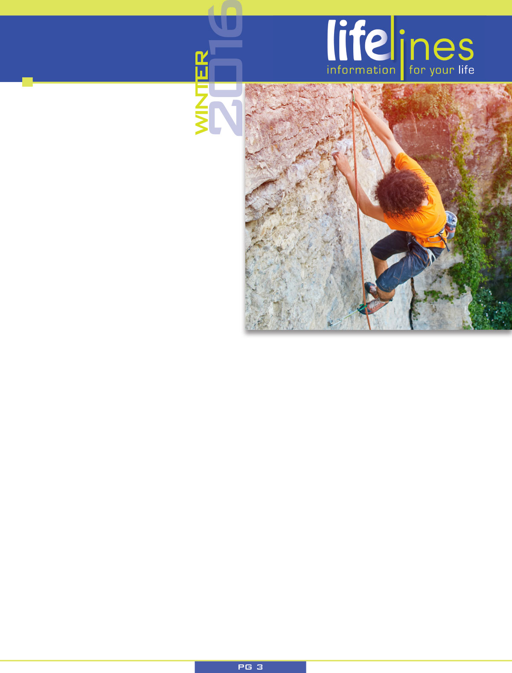

**What is** Resilience?

continued from page 2

And like many things in life - the more we practice, the more we learn. The more we find out about resilience and certainly the more we do of it, then the more   
resilient we become.

Resilient people are able to adapt to stress, crises, and trauma. They find ways to bounce back from the ups and downs of life and move forward. Some people are born with a strong sense of resilience. Others may need to learn skills and develop resilience. If you would like   
to become more resilient, these tips and information can help. Remember that resilience is a skill, like riding   
a bike. The more you practice, the better you’ll be.

**Ways to become more resilient:**

Resilience isn’t about “toughing it out” or reacting to every setback with a smile. Resilient people still feel   
sad, angry, or frustrated when faced with a setback.   
But they find ways to move forward, to tackle chal-  
lenges with creativity, hope, and a positive attitude.

**Here are some ways to increase your resilience:**

**• Maintain a sense of perspective.** Ask yourself, “How big is this problem really?” and “What do I need to do?” Remember not to blow things out of proportion or catastrophize, remind yourself of the good in your life and that things really will change.

**• Recognize that you have a choice in how you handle challenges.** You can’t control what happens to you,   
but you can choose how you respond. You can choose to react to changes and problems with hope and a positive attitude.

**• Accept change.** Change and uncertainty are part of life. When you accept this, you’ll be better able to react to change with flexibility.

**• Anticipate challenges** by focusing on the positive   
ways in which you can meet them rather than   
possible negative outcomes. This will help you   
feel more in control and less overwhelmed.

**• Learn how to calm yourself.** When you feel yourself reacting   
to a challenge with escalating stress and anxiety, take steps to calm yourself (deep breathing, replacing negative thoughts).

**• Overcome your fear.** All of us feel fear, especially when we’re faced with a change. But fear can hold us back from new   
experiences and opportunities for growth. If you are faced   
with a challenge that feels scary or overwhelming, start with the simplest thing you can do that takes you in the direction you want to go. Ask yourself, “What’s the smallest thing I   
can do to get started?” Once you’ve thought about it, do it.

**• Let go of your anger.** A difficult challenge can cause us to feel angry and upset. These feelings are normal, but they won’t   
help us move forward. Work through your anger and try to   
let go of negative feelings by writing about them or talking   
with a trusted friend.

**• Take action.** Avoid dwelling on problems. Focus on solutions instead. Figure out what you can do and then do it, one step   
at a time.

**• Laugh.** Even when things seem to be falling apart around   
you, try to find time to smile and laugh. It’s very healing and   
it will help you forget your worries for a few moments. Rent   
a movie that makes you laugh or spend time with a friend   
who has a good sense of humor.

State.gov. What is resilience? Retrieved June 30, 2016 from http://www.state.   
 gov/m/med/dsmp/c44950.htm.

Learning **to Relax**

continued from page 4

• Fatigue

• Decreased concentration

• Stiff or aching muscles

• Increased irritability or impatience

• Headache

**What do I do if my boss catches me doing a relaxation exercise?**

Most supervisors realize employees need occasional breaks, so you can explain that you use yours to do relaxation exercises rather than hang around the water cooler. You also can mention that the exercises improve your mental agility and attitude.

**How can I relax when I have so much on   
my mind that it’s hard to concentrate?**

It’s natural at first to have difficulty refocusing your thoughts toward relaxation—especially when you have a lot on your mind. For most of us, relaxation is a skill that takes some practice. When you’re learning, try practicing at a time when you’re relatively calm and free of major distractions. When distractions do creep in, tell yourself to put them gently aside until your relaxation time is over. You will be better able   
to handle them afterward.

**I tried relaxation once or twice, and it made me feel anxious. What’s up?**

That can happen sometimes. Try using a very structured approach like progressive muscle relaxation. If it’s still a problem, you may want to consult a relaxation therapist for advice or training.

Needham, S. (Reviewed 2015). *Learning to relax.* Raleigh, NC: Workplace Options.

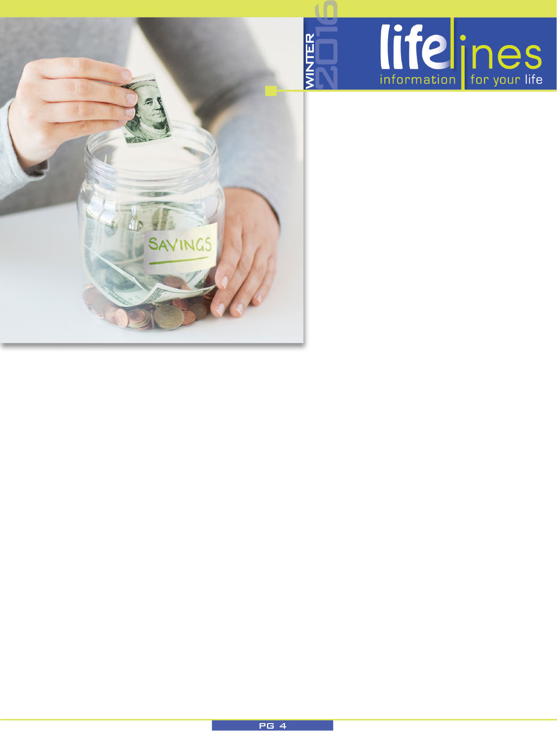

How to Build  
**a $1,000 Emergency Fund   
in 10 Months**

**Do you have $1,000 set aside for emergencies? If you already do, you could probably use another $1,000 in that account. Experts recommend keeping at least 3 months of expenses in   
a reliable, liquid account—though even an extra $1,000 can   
be a lifesaver. But finding $1,000 to save isn’t always easy.**

**Get started with these four steps.**

**1. Find a safe place to save your money.** You will want to save your money in an account that you can access easily in case of an emergency. That means you should probably not keep these savings in a U.S. Savings Bond or in mutual funds. Choose a traditional savings account or a short-term certificate of deposit (CD), currently the most attractive accounts. Early withdrawal penalties on a CD rarely lower the yield below that of a savings account. Consider opening a new account or subaccount for this money so you’re   
not tempted to spend it. Most importantly, do not keep savings in a checking account, which pays no or low interest and is too easy to access.

**2. Save $100 a month.** If you are already saving   
$100 a month, great! Skip to step 3. If not, you need to either earn $100 more a month or cut   
back in order to find that $100 to save. It can   
also help to pay yourself first and save the   
$100 at the beginning of the month instead of waiting to see if you have money left over to   
save at the end of the month.

**3. Automate your savings.** Setting up an automatic way to save is one of the best ways to save. Once you set it up, then it happens without your having   
to think about it. Here are two ways to automate your savings. Every pay period, ask your employer   
to deduct $100 from your paycheck and transfer it to a savings account. Ask your HR representative for more details and to set this up. Or, ask your bank   
or credit union to transfer $100 from your checking account to a savings account every month. Talk   
to your local bank or credit union to set this up.

**4. Watch your savings grow for 10 months.** The final step is to sit back and watch your savings grow. How often do you look at the calendar and realize it’s half way through the year already? The same will apply to your savings. Before you know it you will have that $1,000. The key is not to touch the money unless you have an emergency—that’s what the money is there for, after all.

*Once you have at least $1,000   
in your emergency account,*

continue your savings success, and continue to   
build your emergency savings or apply that  
 money to a new savings goal. Perhaps you have   
debt you need to pay down or want to save for   
a car or home.

USA.gov Blog. (2014, July 22). *How to build a $1,000   
emergency fund in 10 months.* Retrieved July 28, 2014,   
from http://blog.usa.gov