Setting up your Preferences
You are able to add “shortcut” boxes to your main screen by changing “My Prefs”. These boxes below are boxes that must be checked to have full functionality, but feel free to add any other options to customize your TutorTrac profile. For many, all of these boxes will be checked as a default.

- Click on the trac symbol (The man with his arms raised to the left of the “Trac Navigation” search box), and select “My Prefs.”

- Make changes by section as follows:

- Main Menu Options: Select the “Quick Visit,” “Wizard,” and “Color Picker” boxes.

- Every Page Options: Select AdvisorTrac Ticker Sound On, your preferred font size, and select “Log Student (at the top of every page).

- Scheduling Menu Options: set your end-time for 11:59 PM
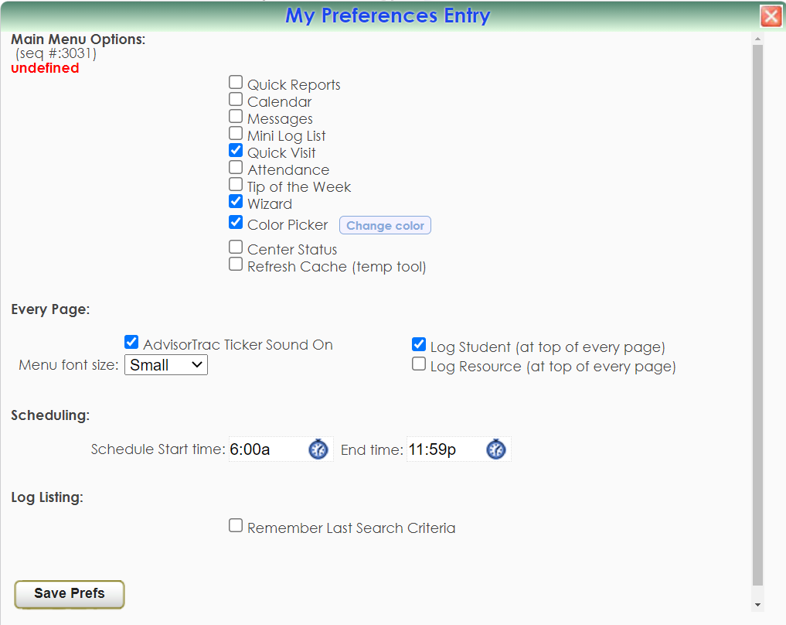

After you’ve checked the boxes as shown above, don’t forget to hit “Safe Prefs”!

