Program Application

McNair Scholars Program

Due November 20, 2020

Location: Science Center, L146
Office: 781-283-2903
Email: amccoy3@wellesley.edu

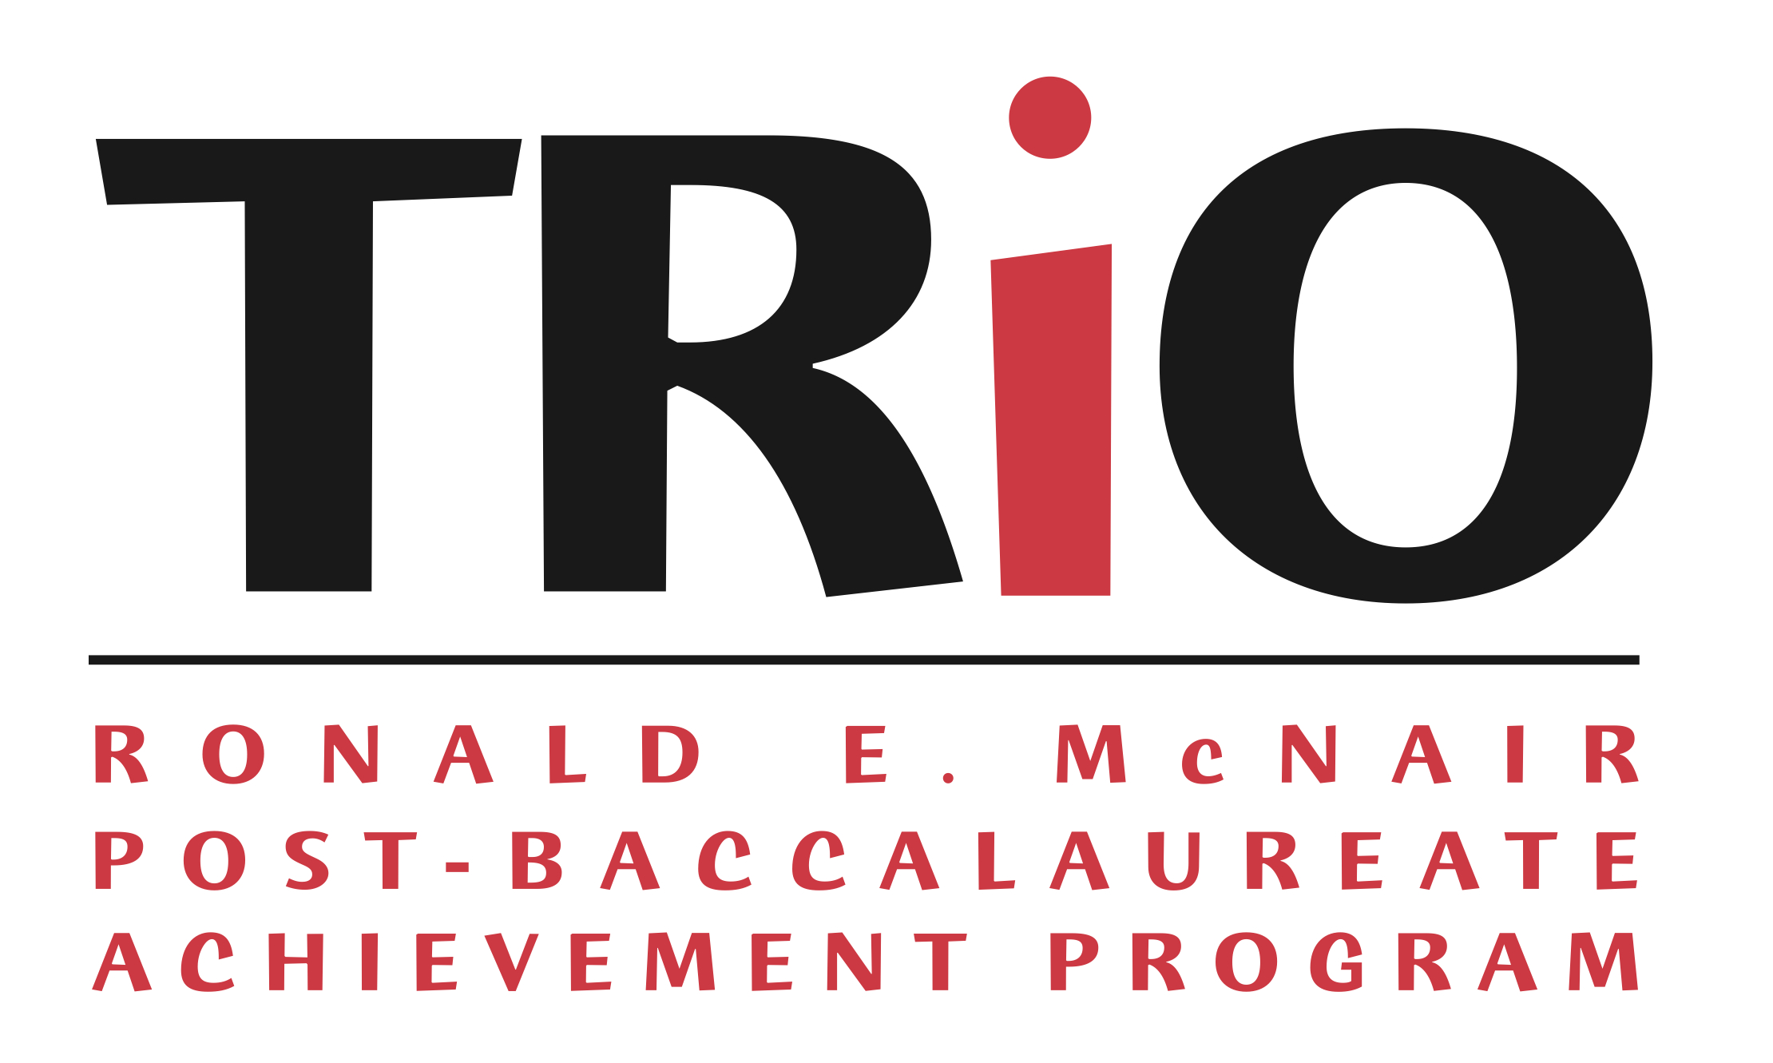

Name: FULL NAME HERE

APPLICATION CHECKLIST
Due Friday, Nov 20th at 5PM ET

To be completed online through the Registration Portal:
- Registration, including
  - Eligibility Requirements
  - Part I: Demographic Information
  - Part II: Eligibility Information
  - Part III: Education Information
  - Part IV: Previous TRiO and Program Participation

To be completed online through the Enter Your Recommenders Portal:
- Contact Information for your Two Recommenders

To be completed online through the Materials Upload Portal:
- Upload Application Materials, including
  - Part V: Application Essays
  - Part VI: Release Form
  - Part VII: Waiver Form
  - Part VIII: Resume
  - Part IX: Unofficial Transcript

To be uploaded by your two recommender:
- Two Letters of Recommendation

PART V: PERSONAL AND RESEARCH STATEMENT
In the space below, please compose an essay of 500 words or less describing:
- Your academic and career goals
- Your plans after graduation in regards to furthering your education and your career goals
- Timeline for achieving your academic and career goals

PART V: PERSONAL AND RESEARCH STATEMENT
In the space below, please compose an essay of 200 words or less describing:
- Your reasons for choosing to participate in the McNair Scholars Program.
- How you will benefit from and contribute to the McNair Scholars community.

In the space below, please compose an essay of 200 words or less describing:
- Your previous research experience, if any.
- If no previous research experience, describe the research project you hope to do as a McNair Scholar.

In the space below, please compose an essay of 100 words or less describing:
- Extenuating circumstances that may have affected your GPA, if any.

PART VI: RELEASE FORM
Please read and sign the following statement:

The McNair Scholars Program at Wellesley College is a federally funded project designed to increase the number of underrepresented individuals pursuing doctoral education. I, the undersigned, do hereby confirm that the information appearing in my application and materials submitted to Wellesley College Ronald E. McNair Post-Baccalaureate Achievement Program is factually true and understand that any and all components including but not limited to: the Wellesley Collage Ronald E. McNair Post-Baccalaureate Achievement Program Application, 2021 McNair Application – Registration, 2021 McNair Application – Enter Your Recommenders, 2021 McNair Application – Materials Upload are required and strictly confidential.

By typing my name below, I, (i) authorize Wellesley College Ronald E. McNair Post-Baccalaureate Achievement Program to share my essay responses, academic records, test scores and income and other information with faculty, staff, graduate school personnel, fellowship committees and McNair funders in order to make the best possible match of my research interests and future graduate school admission and enrollment, (ii) grant permission to Wellesley College Ronald E. McNair Post-Baccalaureate Achievement Program to access information such as transcripts, enrollment information, financial aid information, graduation information, etc. while I am in the program and for the purpose of follow-up and tracking purposes after my participation in the program. I hereby certify that the information on this application is true, complete, and accurate to the best of my knowledge.

(your signature) | (date)

PART VII: WAIVER FORM
WAIVER FOR LETTERS OF RECOMMENDATION

TO THE APPLICANT:

Please discuss the issue of confidentiality, or right of access, with the person whom you will ask to write a letter of recommendation on your behalf. This form applies only to letters which will be held on file for you in the McNair Scholars Program Office. Please note that all application materials for unsuccessful applicants are destroyed after three years. Print your name and that of your recommender, check whether you do or do not waive your right of access, sign and date the form, and include it with your application to the McNair Scholars Program.

“Pursuant to the Family Educational Rights and Privacy Act of 1974, as amended, I, ,
do / do not waive my right of access, as provided by law, to the letters of recommendation written on my behalf by and .”

(your signature) | (date)

Entering your name here affirms this waiver choice.

