Submitting a Requisition for Punchout Suppliers

- In the Workday search bar, type “Create Requisition” and select this option from the pull down menu.
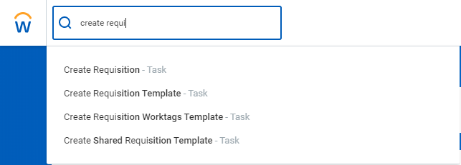

- The “Default Deliver-To” address should ALWAYS REMAIN Wellesley College. Change the “Ship-To” field to your building location (or the building you want the ordered delivered to) by typing into the field, or using the 3 bars on the right-hand side to search. Click into the “Requisition Type” field and select “Punchout to Supplier Website.”

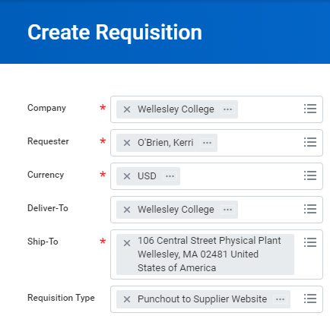
- If the default cost center is not the fund covering your purchase(s), change it by entering the appropriate Gift, Grant, or Cost Center by typing into the field, or using the 3 bars on the right-hand side to search. When you are finished, click “OK” at the bottom.
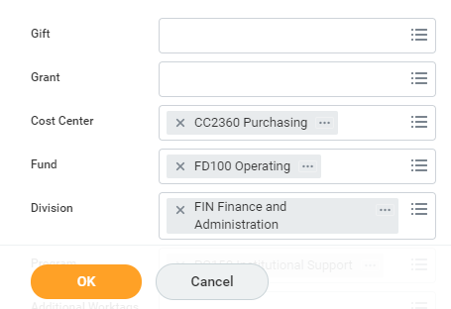

- A new screen will appear. Select “Connect to Supplier Website.”
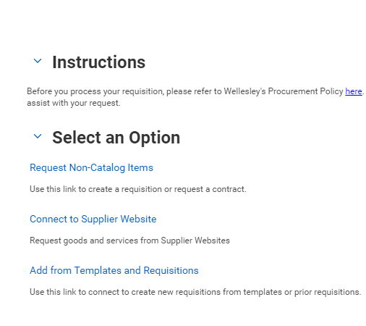
- A list of suppliers will appear. Click “Connect”, on the far right-hand side of the supplier’s site you want to shop. (You may not have access to all of the suppliers listed below) It is important to note that each supplier site will have a different look and feel. In this example, we will use W.B. Mason.
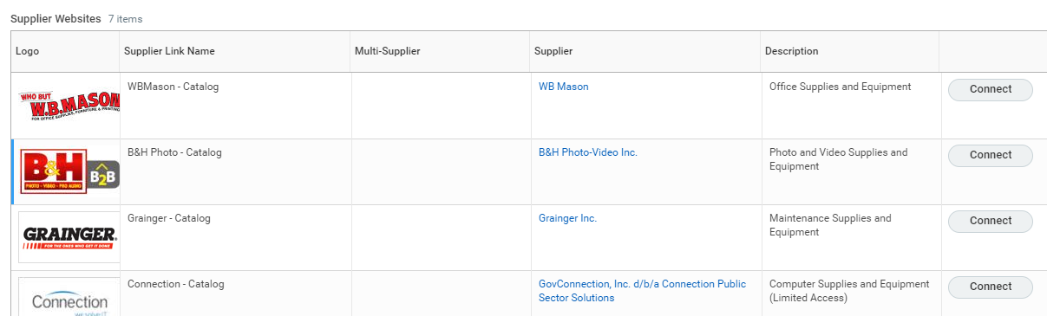

- It may take a moment to load the page/connect to the supplier site. When you are connected, you can search for the items you need by typing into the search bar, or by clicking the “Shop” button for a list by department.
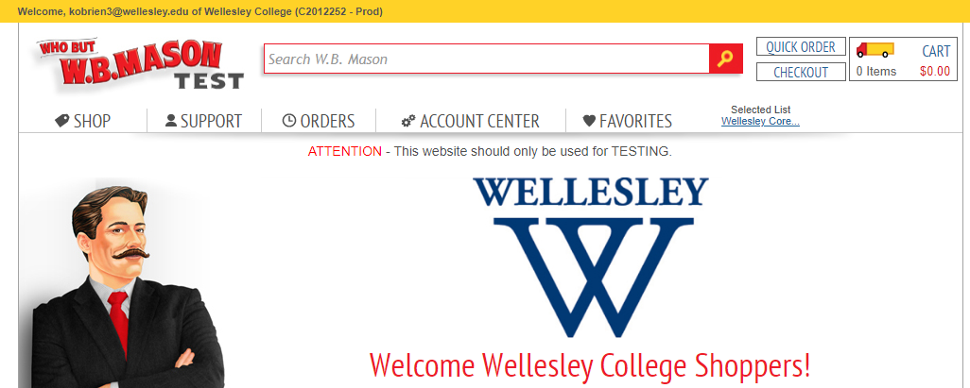

- For this example, we will purchase paper clips. Underneath the item you want to buy, enter the quantity, and click “Add To Cart.”
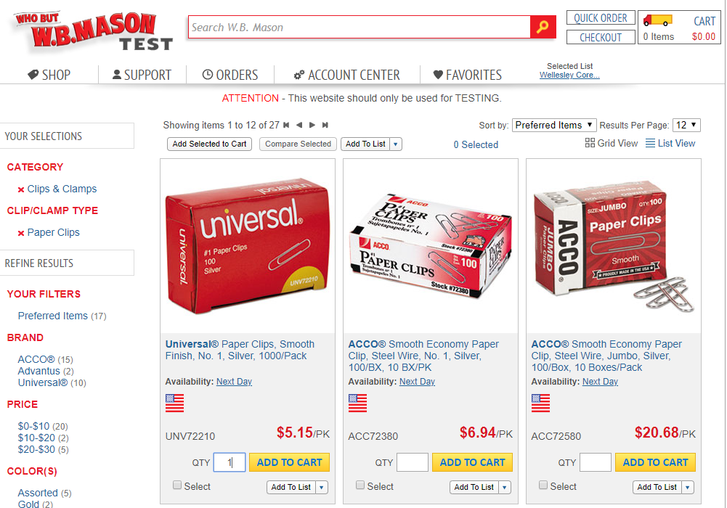

- A new window will appear letting you know that your item has been added to your cart. You have the option to check-out, or continue shopping. We are going to click on “Continue to Checkout.”
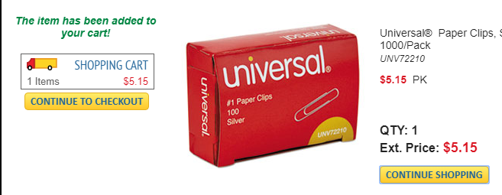

- After clicking “Continue to Checkout”, you will be routed back Workday in the “View Cart” step of the checkout process. Take this opportunity to ensure you have selected the appropriate quantities, etc. If you need to delete an item, click on the trash can on the right-hand side of the screen. If everything is correct, click “Checkout” at the bottom.
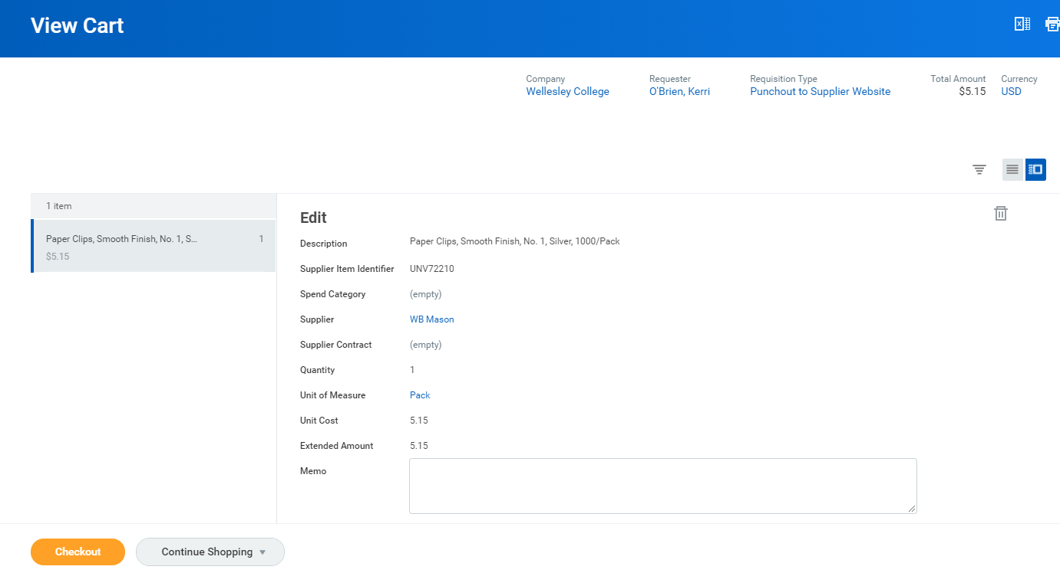

- The “Deliver-To” address is always Wellesley College.

FOR ON-CAMPUS DELIVERIES: The “Ship-To Address” should be your building (or the building you want the order delivered to). (You selected the “Ship-To” address during Step 2 of this process).

In the “Memo to Suppliers” you need to provide detailed delivery information. You should include the name of the person receiving the order and their exact room location. You are limited to 35 characters in this field, so it is important to be specific and brief.

If you are not adding an off-campus delivery address, please skip ahead to Step 11.

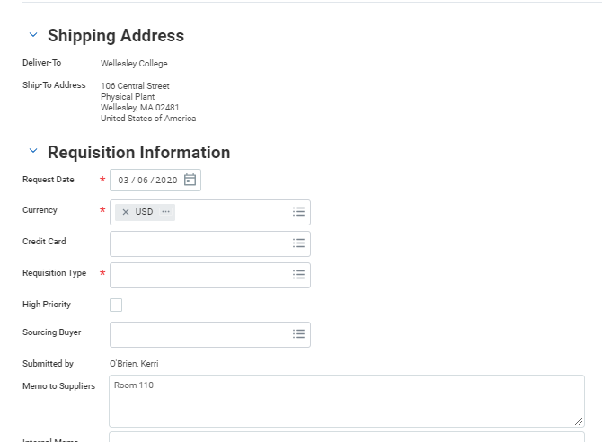
FOR OFF-CAMPUS DELIVERIES:
Before you can add an off-campus delivery location, you need to choose a spend category and adjust the quantity field (if necessary) under the transaction details section. If you do not complete this step first, you will get an error message!
When you have completed the transaction details, click the 3 dots at the bottom of the screen, to the right of the “Continue to Shipping” button. Then, click “edit address”.

Click the box to the right of “Use Alternate Address.” Once clicked, a grey “Add” button will appear. Click the add button.
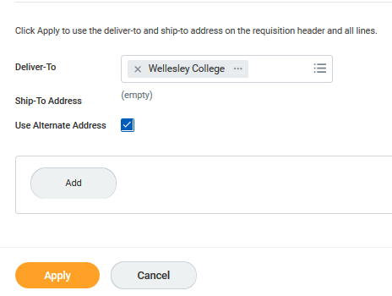
Now, you can enter in the address where you need your items shipped to in the appropriate fields. Please note, the delivery address field will stay Wellesley College. You are editing the Ship-to address.
When you have finished entering in your address, click apply. You do NOT need to change the date, or unclick the Visibility Box. Only enter your address and click Apply!

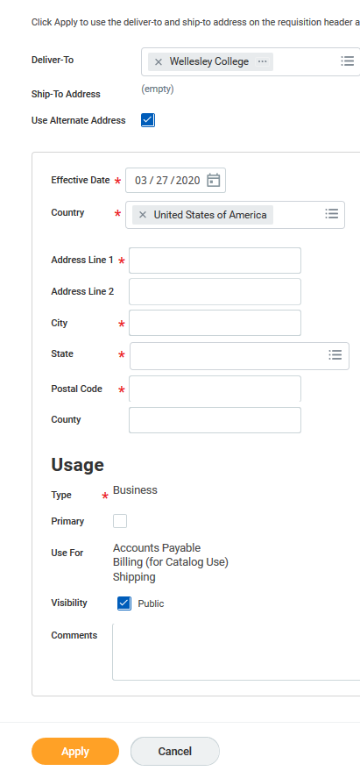

- Under “Goods”, you will need to select a “Spend Category” by typing it in, or using the 3 bars on the right-hand side of the field to search. If you need to change the Gift, Grant, or Cost Center for an item, scroll over to the right to do so by using the bar at the bottom.

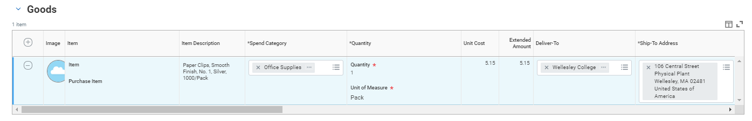
- In some instances, you may need to split a charge between two different funding sources. To do this, scroll over to the far right of the transaction detail information and click on the zero below “splits”.
You will then be prompted to select how to split the transaction, by “amount” or by “quantity”. We recommend selecting by amount.

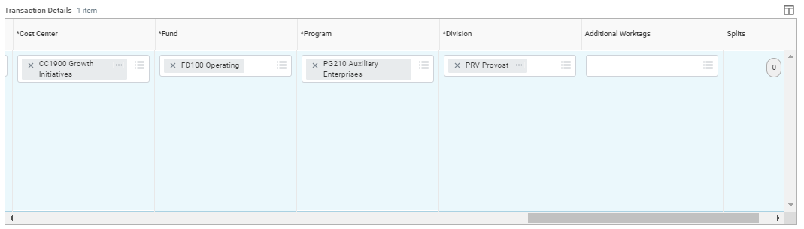

- After clicking the zero and splitting by “amount”, a new window will open. First, you need to add an additional line by using the plus sign in the top left corner of the split screen.

Once you have the number of lines you need, you can begin entering the dollar amount per line. (the system will calculate the remaining balance for you in the top right-hand corner)

When you have finished entering the amounts, scroll over to the right. If necessary, change the default cost center to the appropriate Gift, Grant, or Cost Center you are splitting the transaction between.

When you have finished entering the amounts and funding information for the split, click “done” at the bottom and you will return to the verification screen.
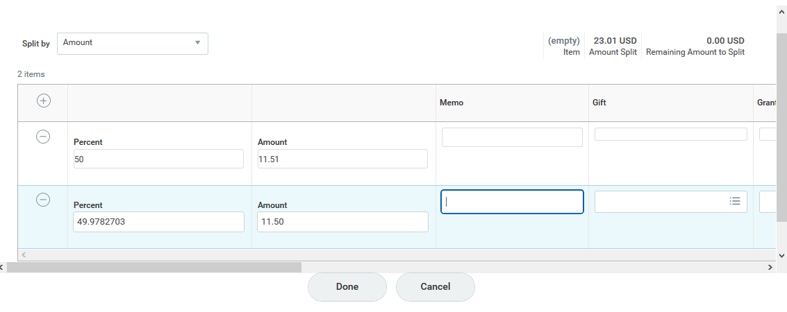

- When you are finished, click “Submit” at the bottom of the Screen to submit the requisition. If you are the Cost Center Manager, for the Cost Center used to cover the order, it will not need approval. However, if you are NOT the Cost Center Manager for the funding you selected, your order will be routed to the appropriate cost center manager for approval before being processed.
You will receive an email acknowledging the order from the supplier when they receive the approved order.
