VERIFYING PROCUREMENT CARD TRANSACTIONS IN WORKDAY
- Log into your Workday account and under Applications, click “Purchases”.
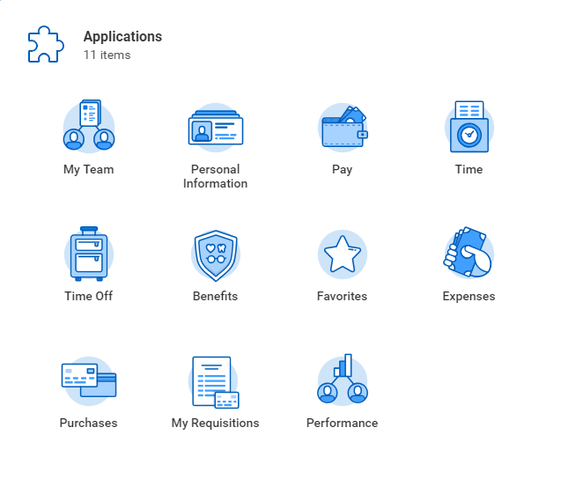

- Under “Actions” in the left-hand column, select “Verify Procurement Card Transactions”
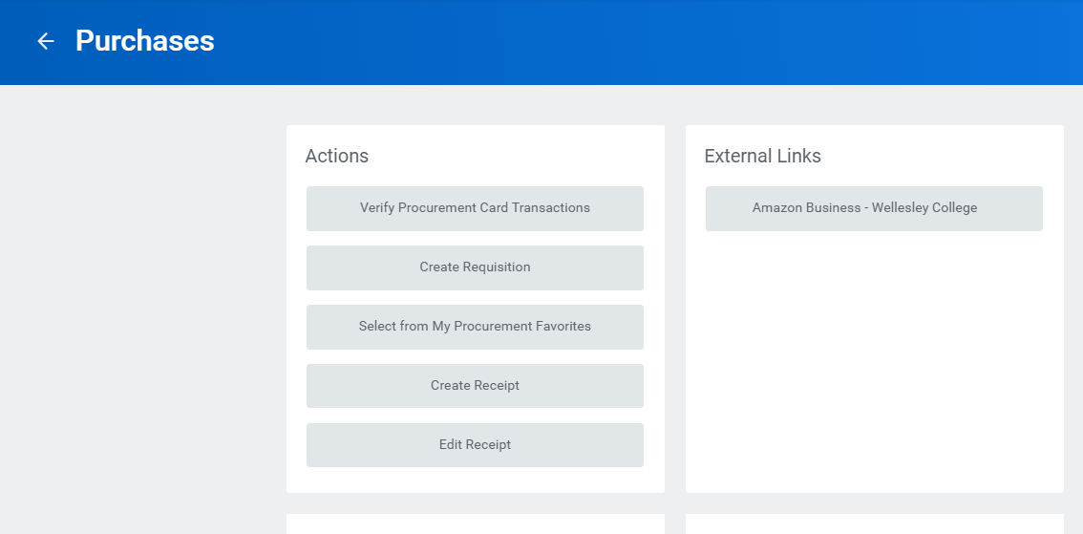

- A list of your “New” transactions will appear. You have the option to “Select All” of the transactions in the box above, or select them individually below. (It’s never a good idea to batch too many verifications together, a few at a time is okay!) Once you have selected your transactions, click “OK” at the bottom of the page. Your selections will open up on a new page.

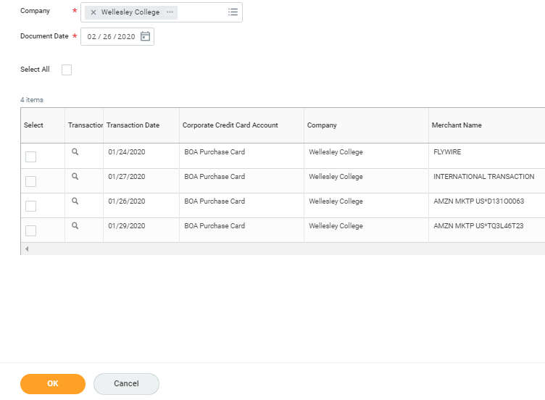

- If you need to backdate the transaction, click into the information tab….
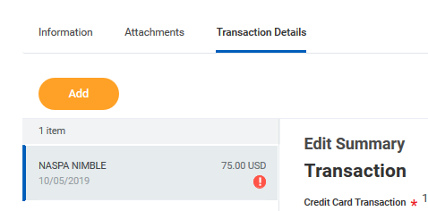

Once you are in the information tab, click the grey “edit” button. Change the date. Click Save.

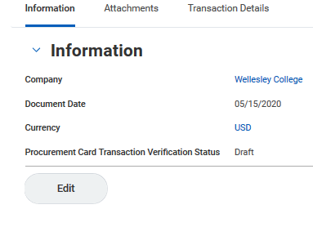

- Next, click into the Transaction Details tab. Click on the first item listed
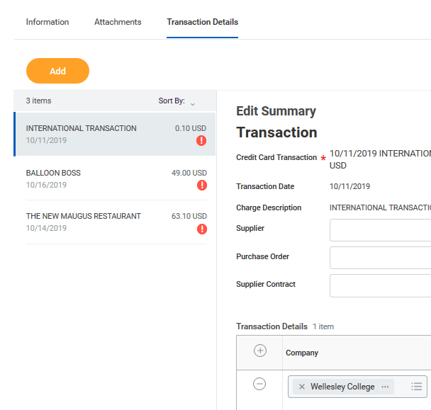
- For each transaction, you will need to type in a business purpose in the box below “Line Item Description” field. The business purpose simply needs to say what the item was, and what it was purchased for. For example, if you purchased pencils for students to use during final exams, then you would type “pencils for student use during final exams” into the “Line Item Description” field.

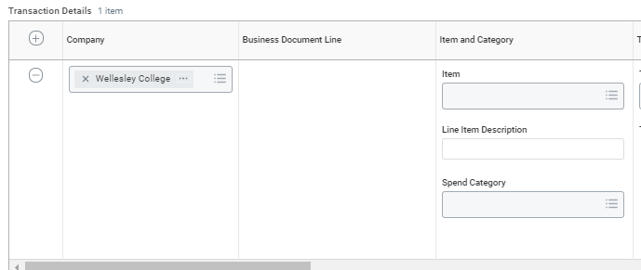

- Next, you will need to select a “Spend Category” from the drop down menu by clicking on the 3 bars on the right-hand side of the Spend Category field. If you know the spend category, simply type it into the field and hit “enter”. In this example, we chose office supplies. After you have selected a spend category, you will need to scroll over to the right using the scroll bar at the bottom of the Transactions Details box.
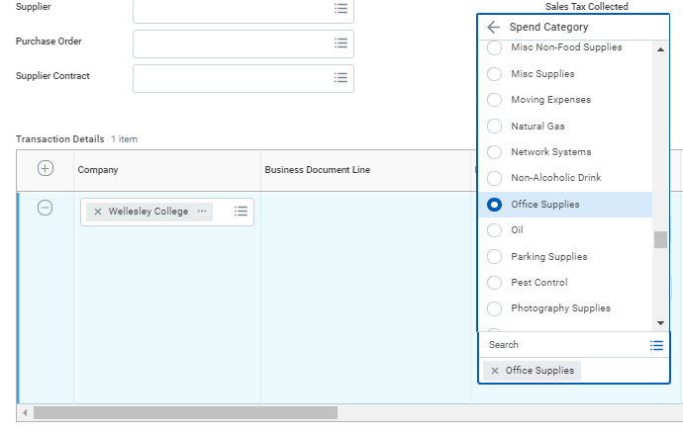

- All of your pro-card transactions will always automatically default to the cost center assigned to your position/role with the college.

If necessary, reallocate the Gift, Grant or Cost Center your purchase should be charged to. If you know the EN, FF or CC number, you can type it into the box; otherwise use the 3 bars on the right-hand side of the appropriate field to search for it.
  - Note: If you are reallocating to a different Cost Center other than your default, please select the new Cost Center first and the rest of the fields (Fund, Program, Division) will auto-populate.

- In some instances, you may need to split a charge between two different funding sources. To do this, scroll over to the far right of the transaction detail information and click on the zero below “splits”.

You will then be prompted to select how to split the transaction, by “amount” or by “quantity”. We recommend selecting by amount.

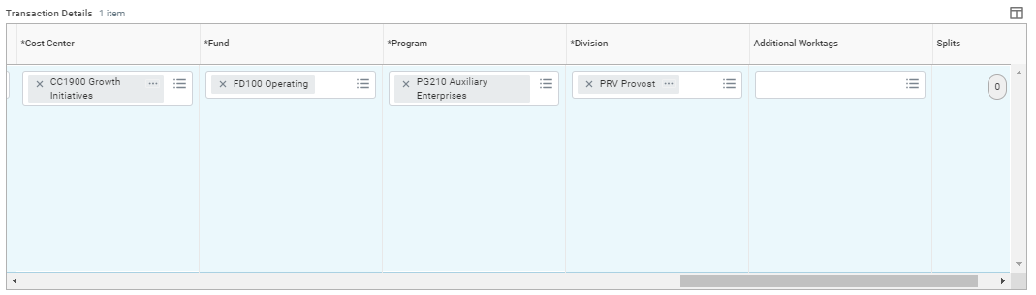

- After clicking the zero and splitting by “amount”, a new window will open. First, you need to add an additional line by using the plus sign in the top left corner of the split screen.

Once you have the number of lines you need, you can begin entering the dollar amount per line. (the system will calculate the remaining balance for you in the top right-hand corner)

When you have finished entering the amounts, scroll over to the right. If necessary, change the default cost center to the appropriate Gift, Grant, or Cost Center you are splitting the transaction between.

When you have finished entering the amounts and funding information for the split, click “done” at the bottom and you will return to the verification screen.
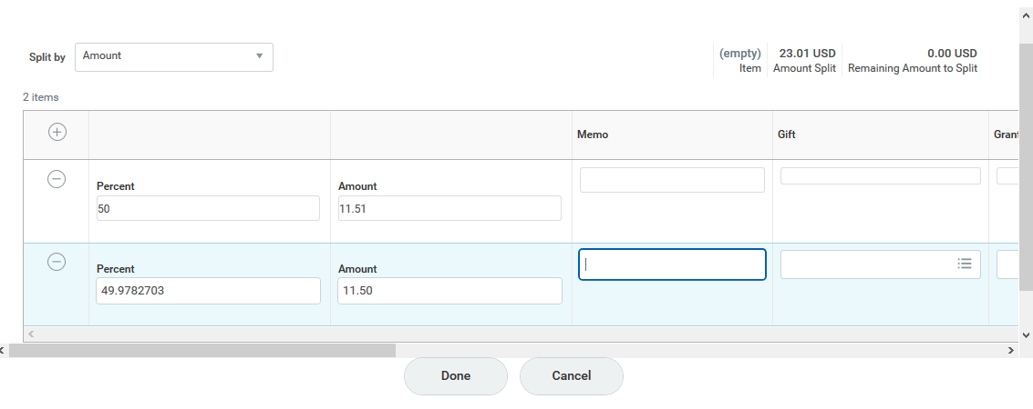

- Receipts are required for all purchases made with the p-card. Receipts need to be uploaded per transaction at the line level. Receipts for p-card transactions cannot be loaded in “bulk” at the header level for Procurement Card transactions. Workday will accept gif, jpg, png., or pdf files. You can drag-and-drop, or upload the receipt by clicking on the “Select Files” button.
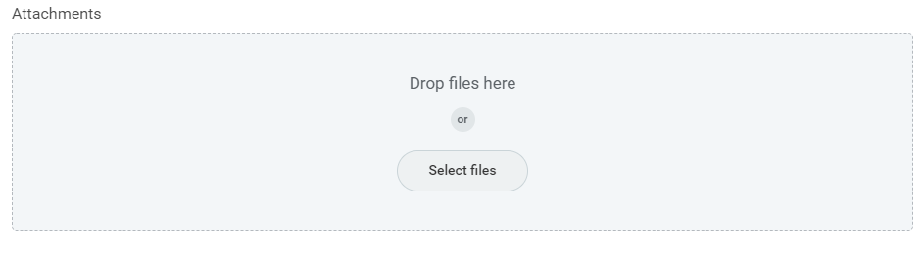

- SUBMIT: After reviewing that all entered information is correct and accurate, click “submit”. Your verification will be routed to your cost center manager(s) for review and approval.
SAVE FOR LATER: The verification will be saved as a “draft”.
CLOSE: By clicking close, your work will not be saved, and the transaction will move to a “draft” status.

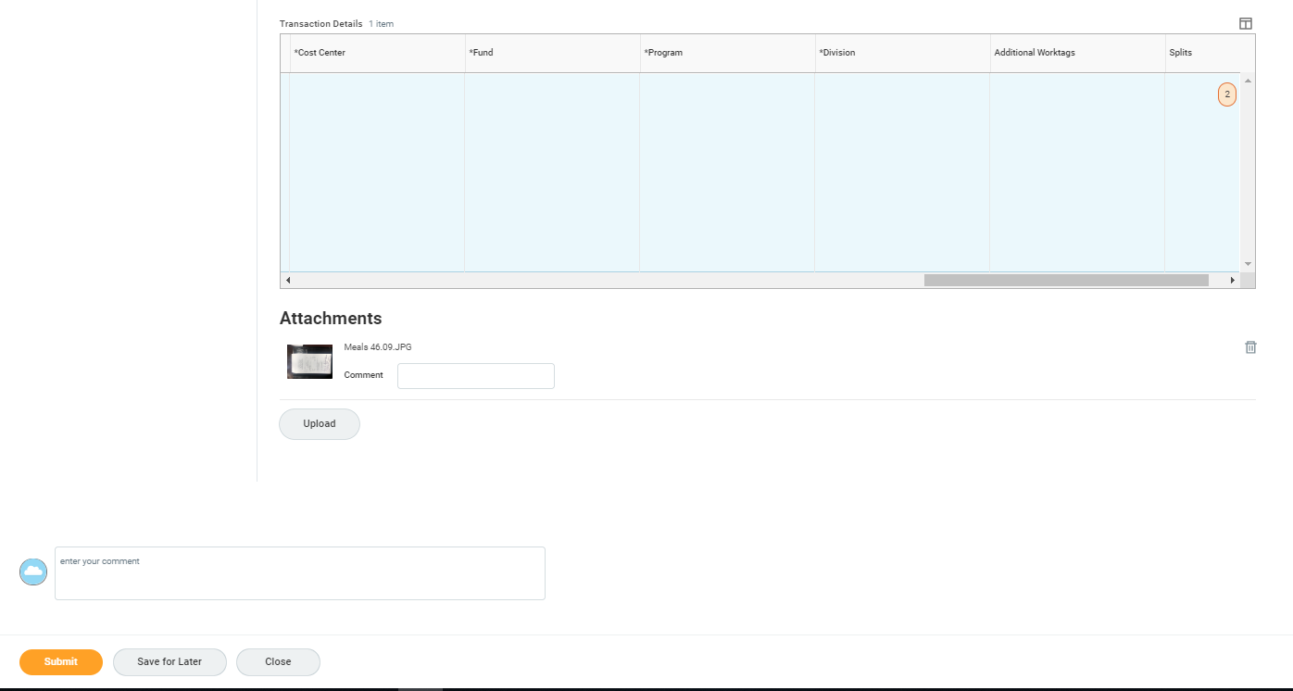

- You can view who the verification is awaiting action from, by clicking “Process” in the “Up next” window.
