VERIFYING PROCUREMENT CARD TRANSACTIONS IN WORKDAY
Please follow the steps below for verifying card transactions on your new BoA Procurement card:
- Log into Workday
- On your home page, if you already have this worklet saved, click on “Purchases”
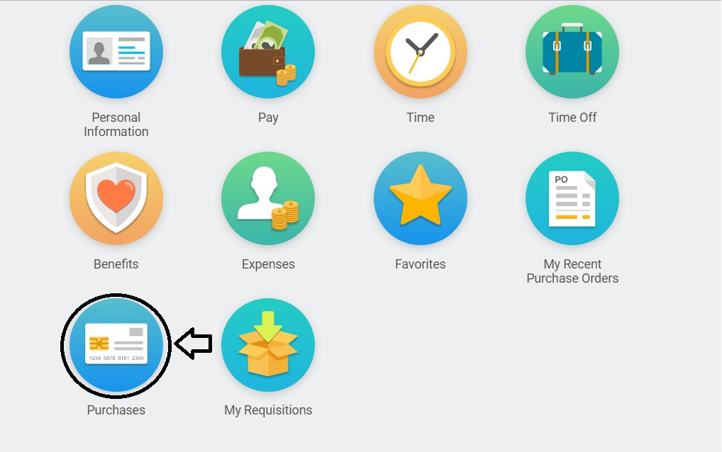

- Under “Actions” in the left-hand column, select “Verify Procurement Card Transactions”
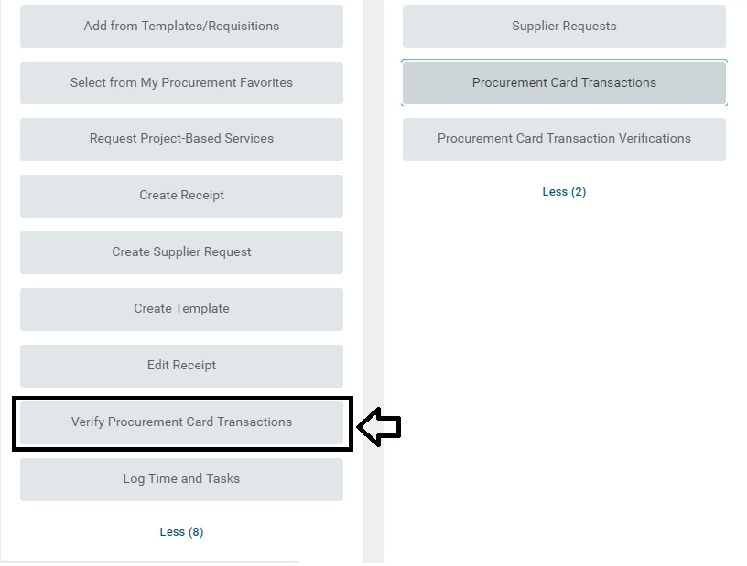
- On your home page, if you do not have any worklets saved, type “Verify Procurement Card Transactions” into the search bar
- The Company will default to “Wellesley College” and the document date will default to today’s date
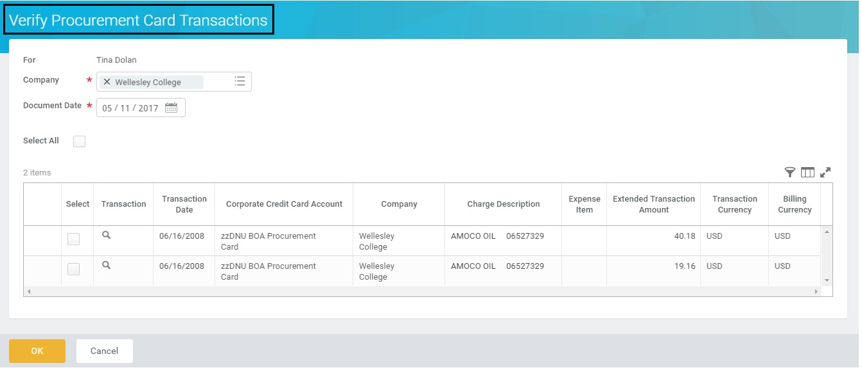
- All of the posted Procurement Card transactions will be listed below. Select the transaction(s) you’d like to reallocate by clicking on the box(es) under the “Select” column. You may also choose to reallocate all charges at the same time by clicking the “Select All” box. Click OK to continue.
- Enter your business expense description in the “Item Description” field
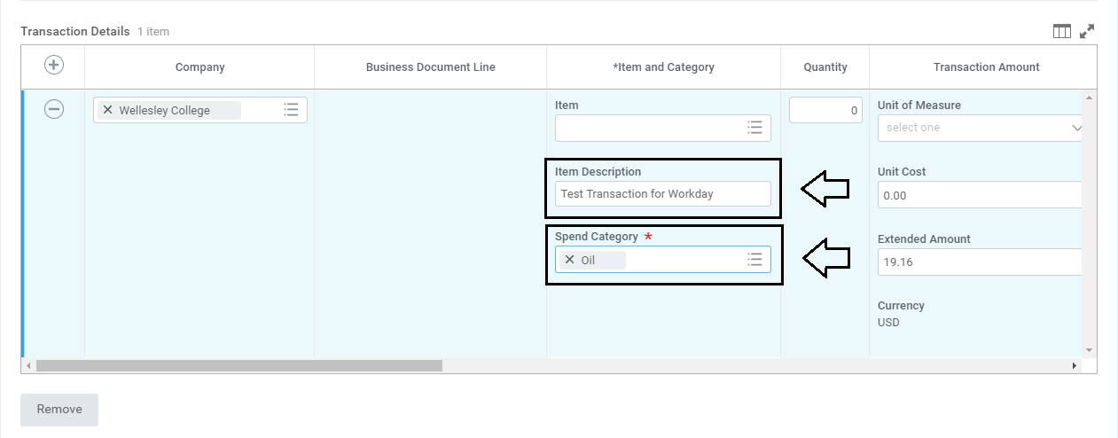
- Select the correct “Spend Category” (this was previously the “Account” in Banner) from the drop-down list

- Your default “Cost Center” (this was previously the “Org” in Banner) and your default Fund are automatically populated. Enter the correct “Division” and “Program” numbers.
  - Helpful tip: If you use the available drop-down list, there is only one division and one program associated with your Cost Center that can be selected.
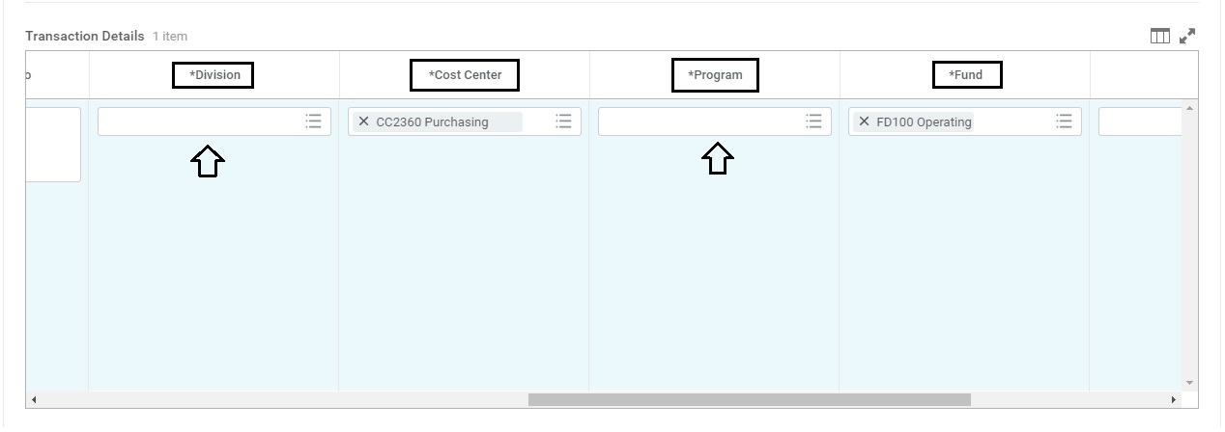
  - Note: If you are reallocating to a different Cost Center other than your default, please select the new Cost Center first and the rest of the fields will auto-populate.
- There is also the ability to split a charge by amount or by quantity. Scroll to the far right of the transaction detail information and click on “Splits”. Select if you want the transaction to be split by amount or by quantity.
  - If you split a transaction by amount, you can select the percentage you want it to be split by
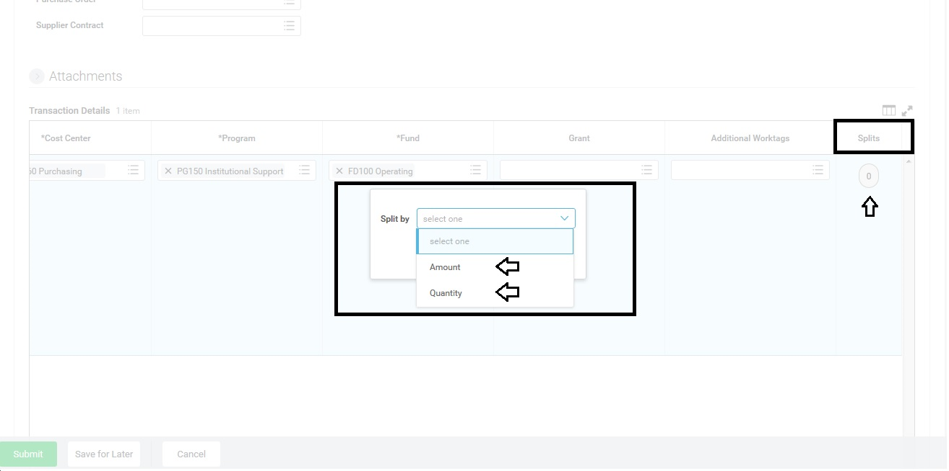
- You may attach your receipts by clicking on “Attachments” and selecting or dropping a file from your computer
  - Note: Receipts need to be uploaded per transaction, they can’t be loaded in bulk at a header level for Procurement card transactions
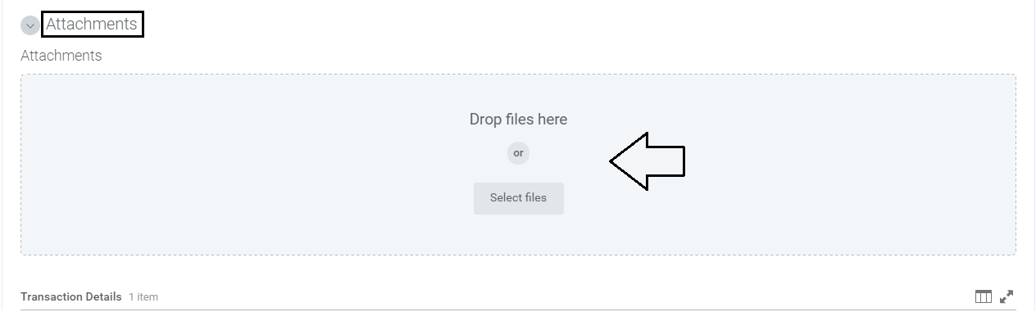
  - ATTENTION: For all Grant-related purchases, receipts are required. Your Cost Center Manager and the Grant Manager will be reviewing them prior to approval and will send back any transactions that don’t have a receipt included.

- After reviewing that all the entered information is correct and accurate, click “Submit”
- The “Next Step” is for the transaction to be routed to your Cost Center Manager for review

