VERIFYING TRAVEL & ENTERTAINMENT CARD TRANSACTIONS

- Log into Workday and Click the “Expenses” application.

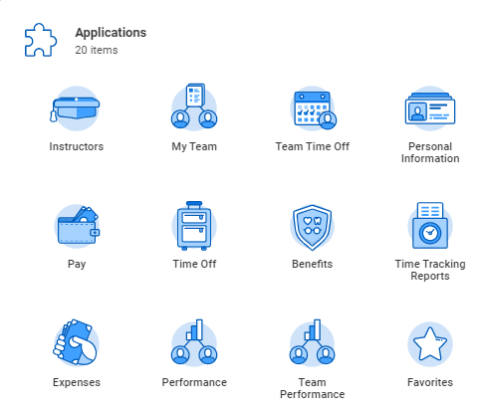

- In the Actions Column, click “Create Expense Report”.
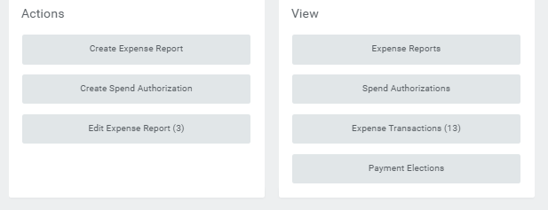
- Under Expense Report Information, you will need to complete the following required fields:

- MEMO-provide as much information as possible-where you went, why, and the dates, etc.
- Expense Report Date-if need be, you can back date the report to match the transaction date.
- BUSINESS PURPOSE-use the 3 bars located on the right-hand side of the field to search for the appropriate business purpose
If necessary, reallocate from the default Cost Center, to the appropriate Gift, Grant, or Cost Center that is covering your expenses.
Once you have completed the required fields, scroll down on the page.

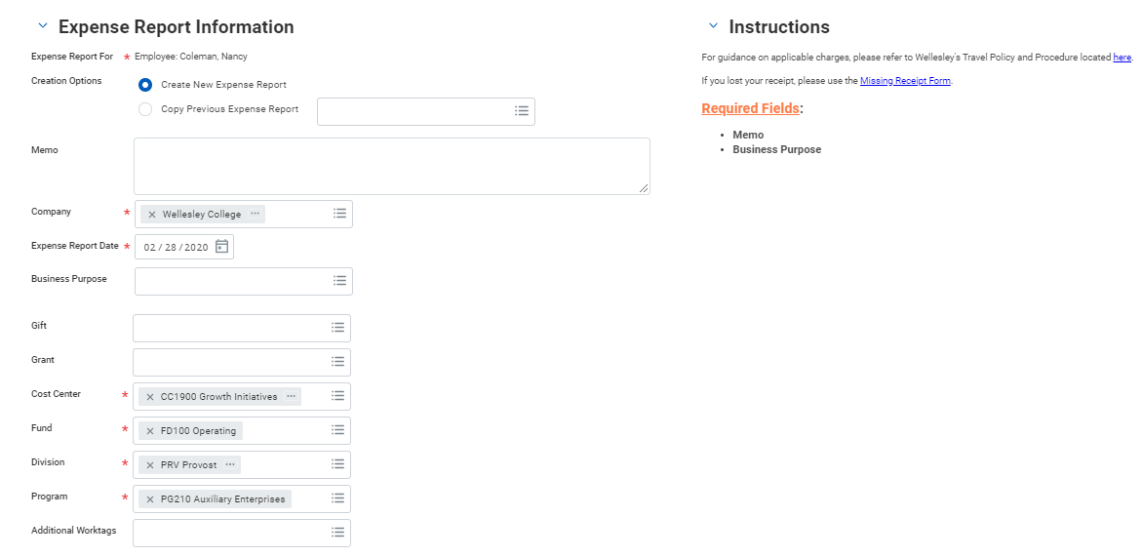

- At the bottom of the page, you will find all of your “New” T&E card transactions. You have the option to “Select All” at the top; or select the charges related to the trip you are creating the Expense report for, by clicking into the individual boxes below. Click “OK” at the bottom after you have made your selections.

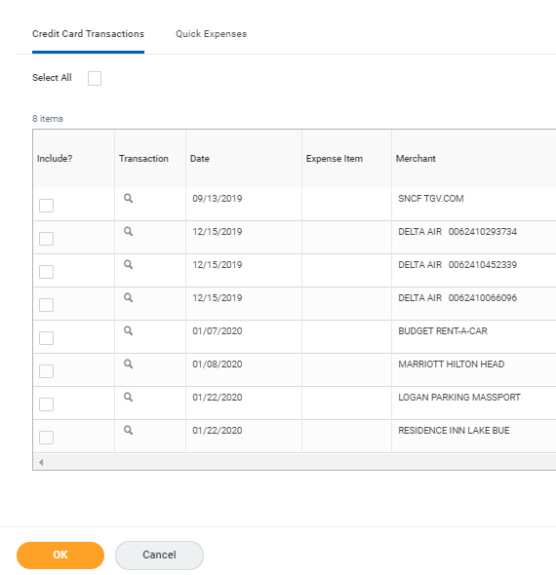

- Now you are in the Expense Report, and the transactions you selected will appear on the left. (You will also see errors, that is normal!) The errors will go away, as you complete the report!
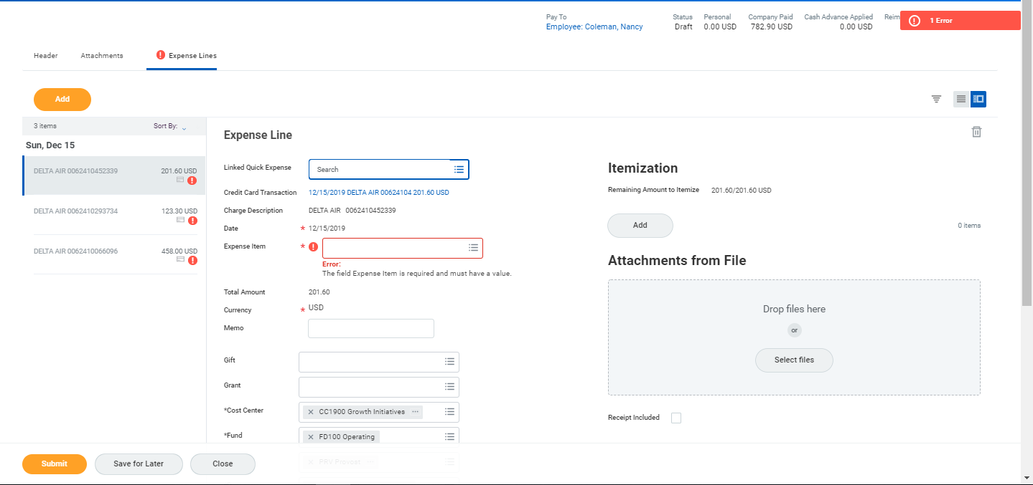
- In the Expense Item field, use the 3 bars on the right-hand side of the field to search for your expense, or type it in. In the example below, we typed “air” into the field and hit the “enter” key.
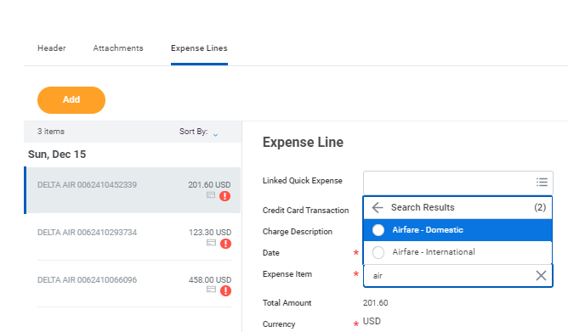

- After you select “Airfare-Domestic or –International”, you may be prompted to enter more information to the right of the Expense Item underneath “Item Details”. (depending on the Expense Item you selected) Use the 3 bars on the right-hand side of the field(s) to search and select, or type into the field and hit “enter” to search that way.
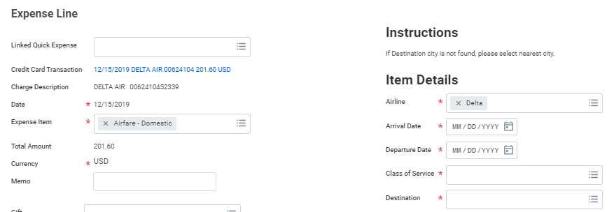

- If you do not need to split a charge, you can skip ahead to step 9. If you need to “split” a charge between two different funds, click on “Add” under “Itemization”.
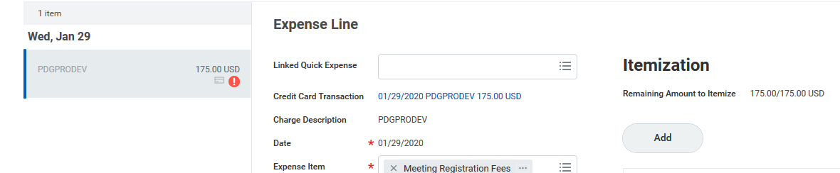
A new window will open. Click “add” again to add a second line. Enter the amount, Expense Item and funding source for both lines and then click “done”.
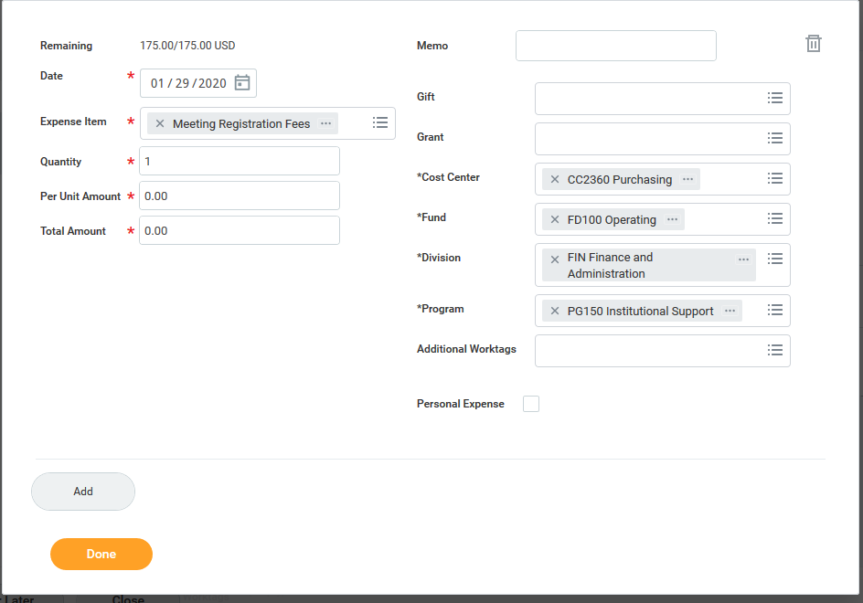

- Directly below the “Item Details” section, you will need to attach a receipt for the item. You can click on the “Select Files” button to search for and upload the receipt, or you can drag and drop it from your desktop.

Note: The receipt MUST show what you bought (itemized), the date, and how you paid (the last four numbers of the card used).

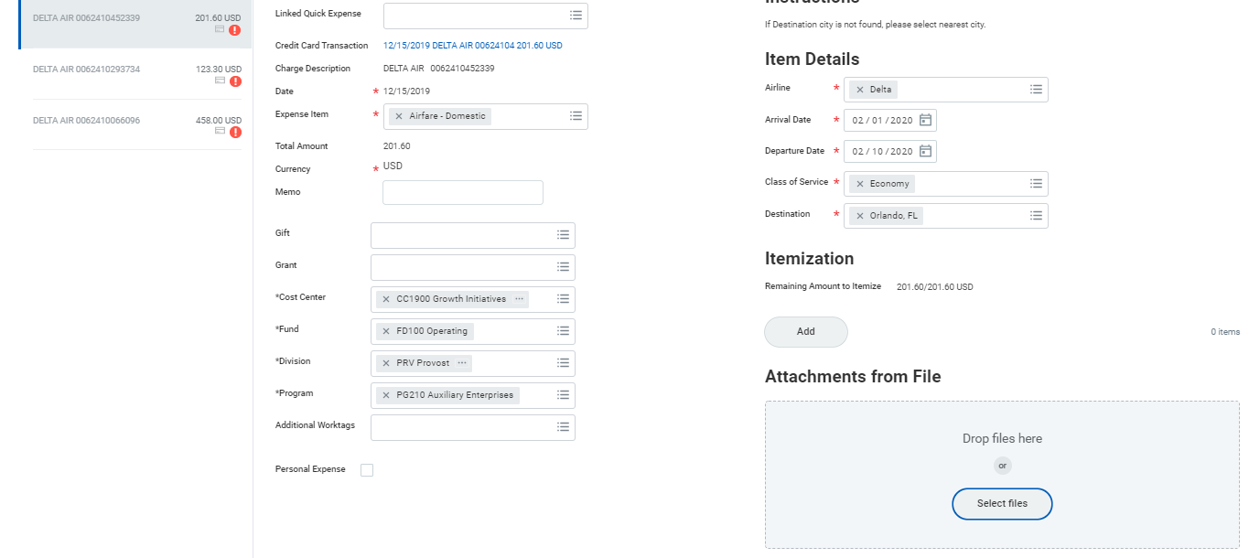

- After you have attached the receipt for that line, scroll up to the top of the page, and click into the next line. As you can see below, the error for the first line that you completed has cleared. Now, you will repeat steps 5-9 until you have completed all of the expense lines.

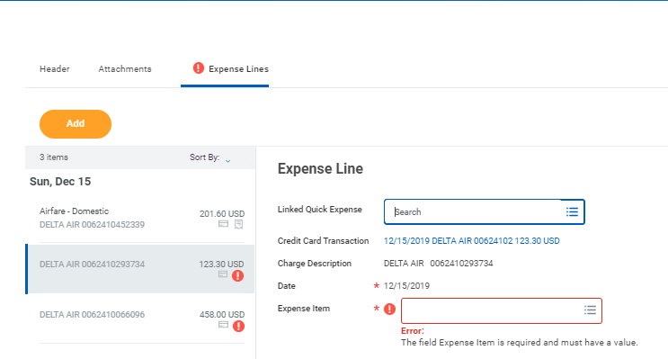

- When you have completed the Expense Report, click “Submit” at the bottom of the page. After clicking “Submit”, be sure your screen reads “Success! Event Submitted”.

