Catalog Management Tool
Smart Catalog’s IQ

An Abbreviated Step by Step Guide
to Editing Curriculum Content

This process is necessary for any items (courses, etc.) with a change for the upcoming curricular year. If there are no changes to an item for the new academic year, then no action is required on that item.
Step 1. Getting into the tool

- Open MyWellesley and log-in to Aministrivia> Catalog Management Tool (Smart Catalog IQ).
- Click on the Sitecore button.

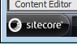

- Click on Content Editor.
- Click on My Toolbar.
- Click on Favorites
- Choose an item in the drop down window.
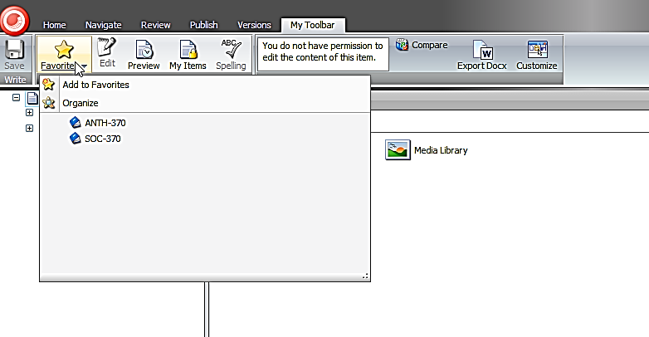
Step 2. Edit an Item
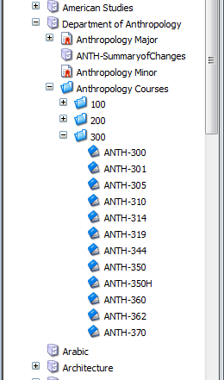
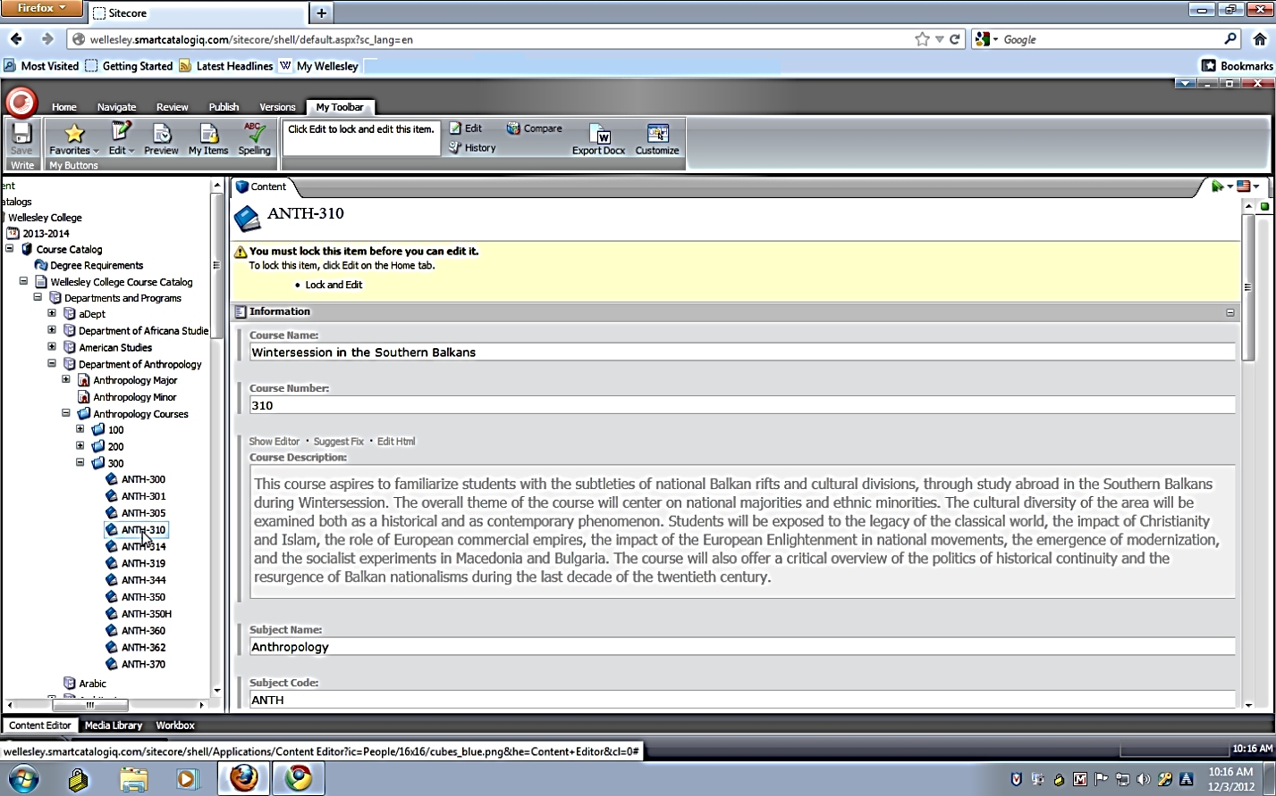

- In the navigation tree, click once on the item (course, etc.) you wish to edit
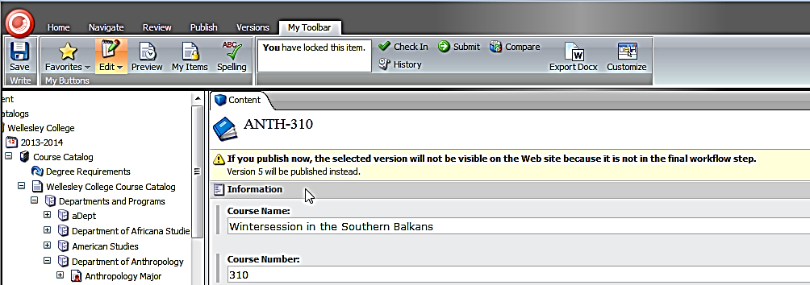
- Click the Edit button on MyToolbar.

- Make necessary edits to each field.
Tip: For long text fields you must first double-click in the space to open the long text editor. Click ACCEPT button.

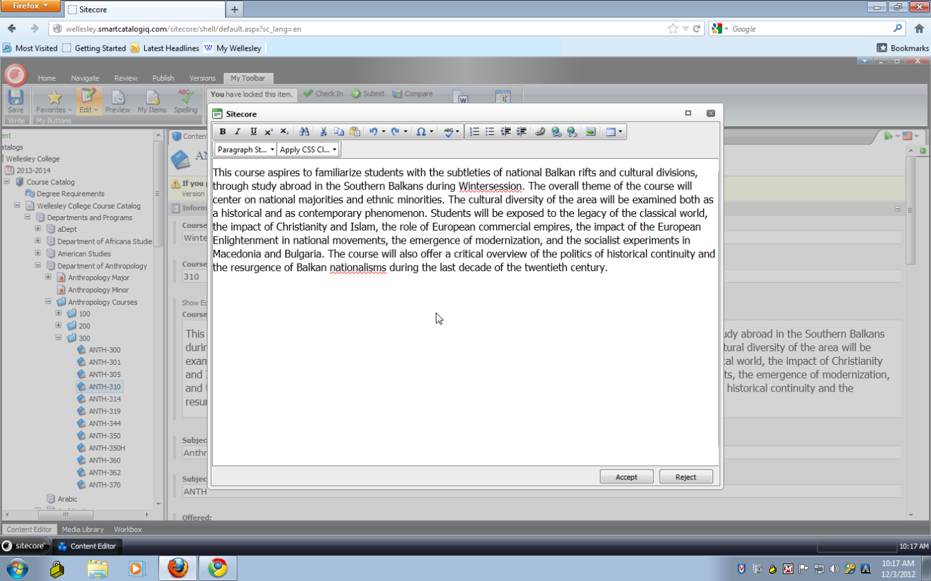

- Once your changes are complete, click the Edit button on My Toolbar.
Step 3. Managing Workflow
A. Course Submission

Once your changes are complete, you will need to submit the changed items to your Department Chair or Program Director for their approval.

You do this in the “Workbox.”

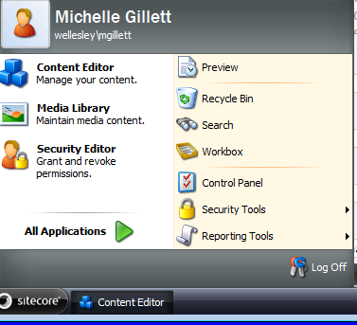
- Click the Sitecore button in left corner of screen and select workbox.

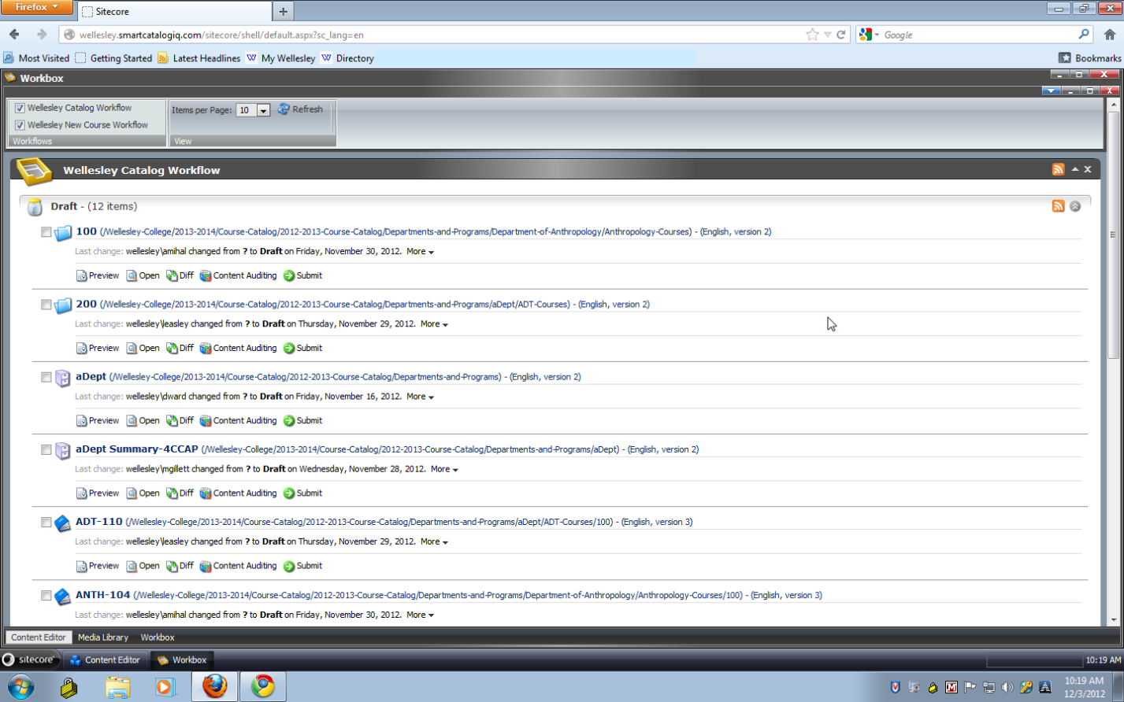
- All edit and/or submitted items will appear in the workbox.
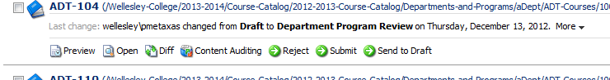

- Click Submit on the item(s) ready for Chair/Director review
- A dialog box pops up for you to make a note.
- We recommend that you enter your initials & brief comment for the approver.
- Click OK.
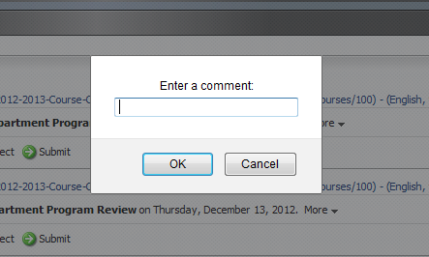
If you decide to wait until each and every item is complete before submission, you can, once ready, click the Submit (all) button to move all items in your Draft level up one level.
Please proceed with caution as items submitted inadvertently will require that the Chair/Director manually find and send that item back down the workflow for further editing. Also note, the comment box will not be available if you choose this option.

4. The “Summary of Changes” Item

Every department/program has an item called “DEPT-SummaryofChanges” in their content tree under the major and/or minor items.

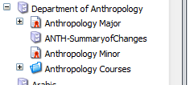

You are responsible for updating this item (through the Content Editor) and submitting it through your workbox to CCAP.

Tip: We recommend that this be the final item you submit up the workflow. This will signal to CCAP that you are finished with your curriculum changes.

5. Log Out
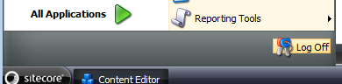
To log out of Sitecore button in bottom left side of screen and select log off.

