Accessibility & Disability Resources (ADR)  Wellesley College | Welcome Packet  For new students looking to register their disabilities or apply for accommodations.

Table of Contents

Letter from Accessibility and Disability Resources 1
Requesting Services for the First Time 2
Assistive Technology Resources 4
Student Access Advocates (SAAs) 5
Timeline of Important Dates 6
Contact Us 7
Accessible Wellesley Map 8

Letter from Accessibility and Disability Resources

Dear New Students,

On behalf of the office of Accessibility and Disability Resources, welcome to Wellesley College!

The following packet is intended to serve as a guide to registering with our office and receiving accommodations. While we believe this will be a helpful resource for you, we always welcome your questions and comments. If you would like to reach out to us, please see our contact information on page 7.

We are eager to hear from you and get to know you over the course of your time at Wellesley.

Thank you,

The Accessibility and Disability Resources Staff

Return to Table of Contents 1

Requesting Services for the First Time

Once you have been issued your official Wellesley email and login information, you will be provided with the Incoming Student Checklist. This checklist is an overview of all the actions you should take to get yourself prepared for your first semester at Wellesley. Accessibility and Disability Resources (ADR) provides the link to our online portal system, AIM, on this list.
AIM is used to collect information about your individual situation and to maintain an ongoing line of communication with students wishing to disclose disabilities. It is the starting point for all accommodation requests. You can sign on to AIM here.
You will then login with the same username and password that you use to login to MyWellesley and your other existing Wellesley accounts.

If you have never applied for accommodations before, you will be brought to a screen that will give you the option to begin an application for the accommodation process.
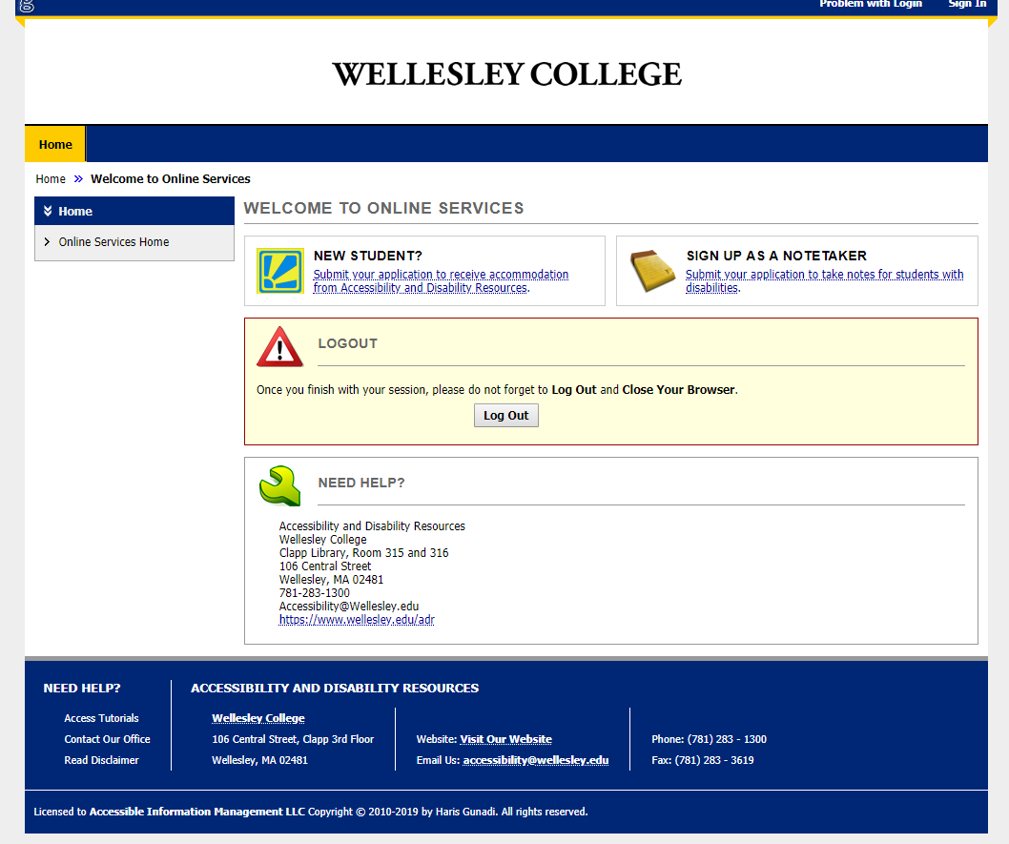

Return to Table of Contents 2
Students looking to request accommodations for the first time should select the link in the “New Student?” box on the left-hand side of the screen. Doing so will open an Initial Student Application, which will allow you to provide our office with several key pieces of information that we will use in order to reach out to you and begin the dialogue process. It is required that you meet with an ADR staff member after completing an application. Depending on the circumstances, this may be by phone, video call, or in person.
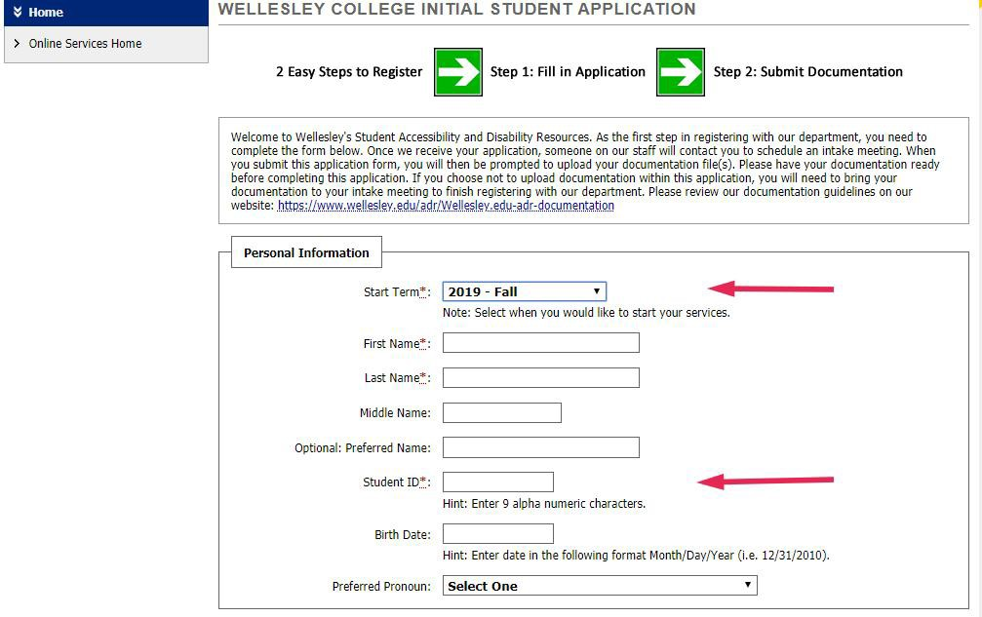

Please take note of the following:
- The application times out after 30 minutes

- You should use your Wellesley email in the “Personal Information” section.

- Your “Student ID” is your nine-digit Wellesley ID.

- If you do not initially submit any documentation (see guidelines here), you can return to your application to do so by using a link provided in the confirmation email that you receive after completing your application. If you have any problems finding this link, please reach out to our office and we will provide alternative methods for sending your documents. You may also bring your documentation to your intake appointment, if this is easier.

Return to Table of Contents 3

- If approved for academic accommodations, you are responsible for sending out accommodation letters to your professors each semester. This is a quick process that allows you to customize which accommodations you’d like to use per class. See how to use AIM to send your professors accommodation letters here.
Further guidance on filling out the Initial Student Application can be found here.

Assistive Technology Resources

ADR staff can assist you to identify useful assistive technology for the classroom and elsewhere. Below you will find resources ADR staff most frequently refer to those who have disabilities and others that do not.
This list is not exhaustive. Please reach out to ADR staff for more helpful tools.
Available as an Accommodation
- SmartPen – A special pen and notebook that can record the audio of a lecture while simultaneously linking it with written notes taken down. Anything that may be missing from the written information is then augmented by the audio content when reviewed.
Widely available to the Campus
- Kurzweil 3000 – A text-to-speech program that will read textbooks, text files, and even web content aloud. It offers dozens of options for reading voice and speed. It can also be used to dictate drafts of notes or longer writing projects.
- Speech Notes – a free app that can assist with speech-to-text dictation.
- Sensus Access – A service that can convert documents into a different media, including MP3 and accessible PDF files or photos.
For more information on how to download or use these tools and others, please visit our Assistive Technology web page.

Return to Table of Contents 4

Student Access Advocates

The Student Access Advocates (SAAs) are a group of students who work with Accessibility and Disability Resources to spread information about assistive technologies and the accessibility features offered by both the office and the Wellesley campus at large.
If you would like to meet with one of the Advocates to go over any of these tools or being a student with a disability at Wellesley, please feel free to reach out to StudentAccessAdvocates@wellesley.edu !

Return to Table of Contents 5

Timeline of Important Dates

- May 2020
  - You will receive your Wellesley credentials (your Wellesley email, ID, and the password of your choice) in May. After you have your official email, you should visit the AIM portal to disclose a disability and kick off the accommodation request process (see pages 2 -3 for initial request instructions)

- By June 15, 2020
  - Please fill out an AIM application, meet with staff, and upload supporting documentation by June 15, 2020 to request accommodations for Fall 2020.

- Two weeks before classes begin *
  - Use AIM to send letters to your professors that explain what accommodations you’re eligible for.
*Note: If you’re strongly considering changing your course registration, you can hold off until you have your desired schedule locked in. Sending letters to your faculty can be done at any time, but it is strongly recommended that you provide as much time as possible for the professor to prepare (at least two weeks before you need to use your accommodations in class).

If your application is received after these dates, we will do our best to review your documentation in a timely manner, but there may be a delay in receiving accommodations or, in some cases, an inability to provide services, especially for requests that involve significant advance preparation, such as housing, sign language interpreting, or alternative format readings.

Return to Table of Contents 6

Contact Us

Jim Wice
Director of Accessibility and Disability Resources
Clapp Library 316
781-283-2434
jwice@wellesley.edu

Jessica Washak
Administrative Assistant
Clapp Library, third floor, PLTC area
781-283-1300
jw4@Wellesley.edu

Return to Table of Contents 7

Accessible Wellesley Map

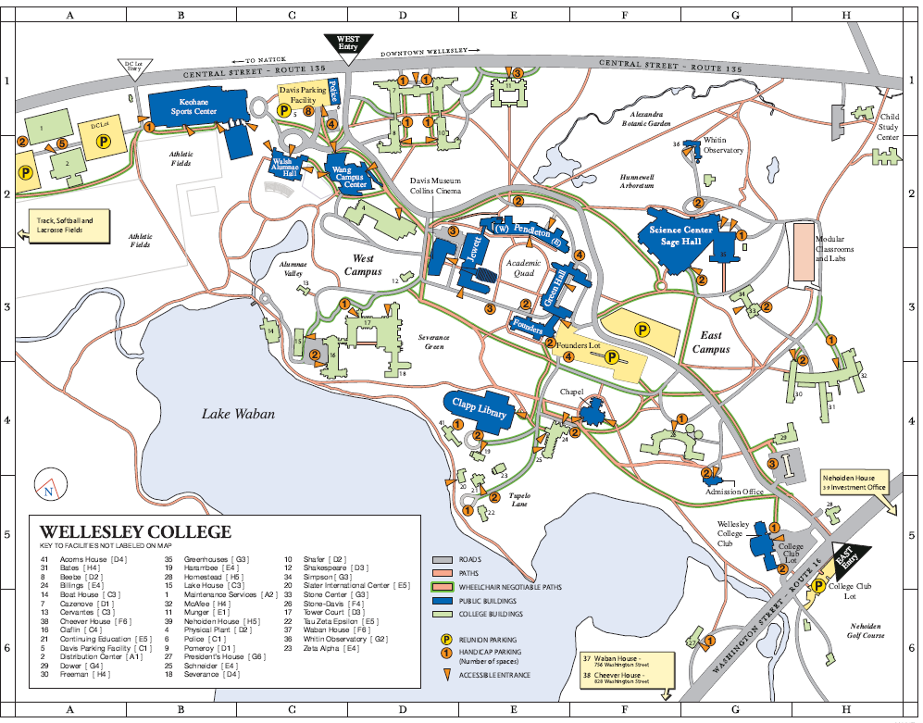

See PDF version here

Return to Table of Contents 8

